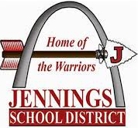

Jennings School District in Partnership with St. Louis Community College at Florissant Valley

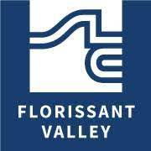
- Earn an associate degree while in high school - Students earn both high school credit and college credit while attending classes full-time at St. Louis Community College (STLCC) at Florissant Valley (Flo Valley) during their junior and senior year and earn an associate degree. Eligible classes (CORE 42 courses*) are also transferable to any public, Missouri four-year college or university.
For More Details: Contact: Dr. Debbie Jones Fowler-Early Start & Secondary Programs Administrator jonesfowled@jenningsk12.us

  - 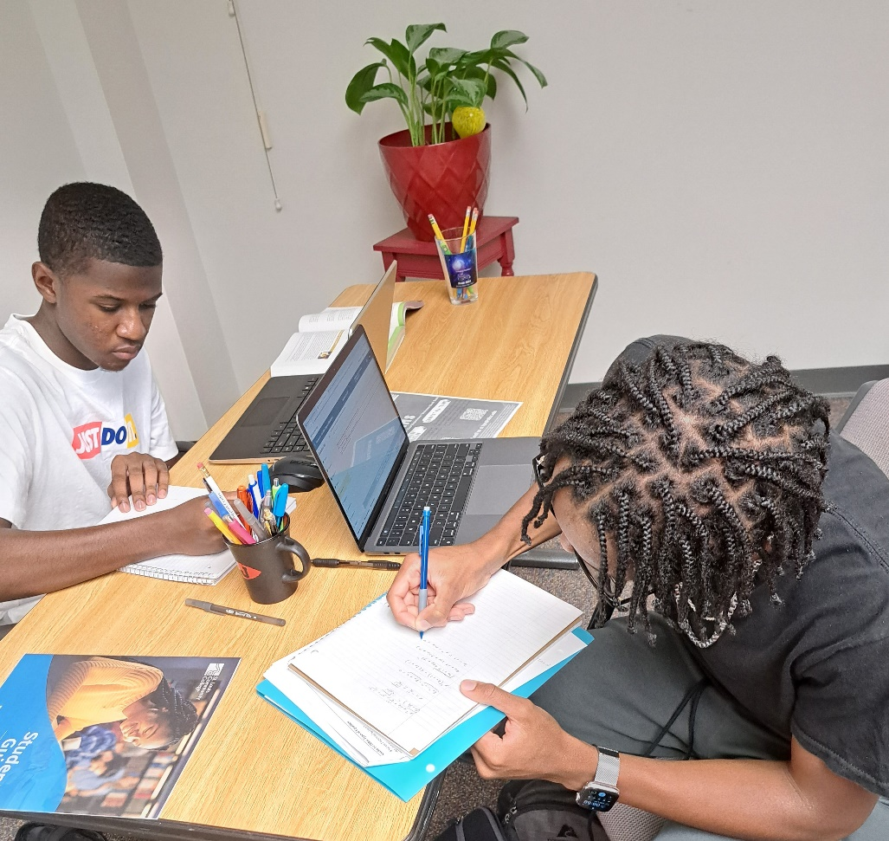

- The Early College Academy (ECA) Program is a dual enrollment program that enables a limited number of qualifying Saint Louis Public School (SLPS) juniors and seniors to take college courses at St. Louis Community College’s (STLCC) Florissant Valley Campus. The ultimate goal of ECA is for JHS students to graduate with a high school diploma as well as earn an associate degree from STLCC.

