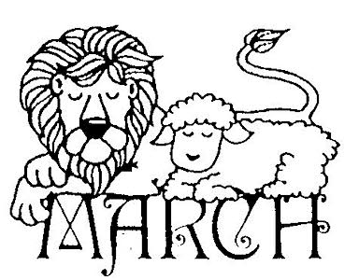

CLASS NEWS
Mrs. Williams
Date: March 2, 2026

Math: telling time to quarter hour/5 minutes

Science/Social Studies: begin economics unit

Upcoming Events:
March 1 - Read Across America – Spirit Week
March 30 – April 6 - Spring Break

