First Grade Handbook
2023-2024
Mrs. Michele Boswell
Room 204
michele.boswell@fcstn.net
Ms. Callie Basham
Room 205
callie.basham@fcstn.net

Meet The Teachers:
Welcome to First Grade at Broadview Elementary School!! Thank you for allowing us the
opportunity to work with your child this year. We are looking forward to getting to know you and
your child better! We hope this handbook helps you understand a little about first grade, but do
remember this year all things are subject to change very quickly.
Mrs. Michele Boswell
I was born and raised in Pennsylvania. My family moved to Tennessee in 1996. My husband Jon was born and raised in the Broadview Community. Jon and I have been married for 11 years and have two sons, Andrew (9) and Luke (5), and one daughter, Hannah (7). We attend Marble Plains Baptist Church. Some of my favorite things to do include anything outdoors, gardening, biking, walking/running, hiking, and working with our goats and beef cows. I especially enjoy spending time with my family and playing with my children. I fulfilled my student teacher requirements at Broadview back in the Spring of 2002 and am thrilled to now be a first grade teacher at Broadview.
Educational Background:
Middle Tennessee State University- Bachelors of Science Degree in Education (K-8)
Tennessee State Univeristy-Masters Degree in Curriculum and Instruction with an emphasis in Reading
Tennessee Tech University-Educational Specialist Degree in Instructional Leadership
Teaching Experience: This year is my 21st year.
Decherd/North Lake: 1st & 3rd Grade=1 year
Sewanee Elementary: Kindergarten=2 years
Huntland School: Kindergarten=8 years/First Grade=4 years
Broadview: Kindergarten=3 years/First Grade=Current

I fulfilled my student teaching requirement at Broadview back in the Spring of 2002, and I am thrilled to now be a First Grade Teacher at Broadview.

Educational Background:
* Middle Tennessee State University- Bachelors of Science Degree in Education (K-8)
*Tennessee State Univeristy-Masters Degree in Curriculum and Instruction with an emphasis in Reading
*Tennessee Tech University-Educational Specialist Degree in Instructional Leadership

Teaching Experience: This year is my 19th year.
Decherd/North Lake: 1st & 3rd Grade=1 year
Sewanee Elementary: Kindergarten=2 years
Huntland School: Kindergarten=8 years/First Grade=4 years
Broadview:

Mrs. Hollee Smith
I was born and raised in Franklin County, Tennessee. I attended Broadview Elementary from Kindergarten until fifth grade, and I am excited to be back “home” teaching first grade this year! In my free time I enjoy reading, fishing, hiking, being in the mountains, spending time on the farm, and spending time with my family and friends!
Educational Background:
Motlow State Community College-Associates of Science Degree
Middle Tennessee State University-Bachelors of Science in Interdisciplinary Studies K-5
Arkansas State University-Currently working towards a Masters Degree in Curriculum and Instruction
Teaching Experience:
Decherd Elementary-5th Grade
Broadview-First Grade

Welcome to First Grade
Our morning begins at 7:45. This gives your child 15 minutes to unpack, sharpen pencils, turn in their folder, go to the bathroom, and get a drink. At 8:00 our instruction begins. Our days will include Phonics, Reading, Grammar, Writing, Spelling, Math and Specialty classes.
As you can tell from this list we have a FULL day. We strive to keep every child engaged in learning from 8:00-2:50. It is important that your child attend school when they are healthy and stay the entire day.

ELA
Our Reading instruction teaches comprehension, phonemic awareness, phonics, vocabulary, grammar and reading/writing strategies. through the use of children's literature. Within the series, we will be giving weekly assessments to monitor your child's progress.

Math
Our math instruction is I-Ready. Within this curriculum, we will be completing patterns, learning numbers 0-120, fluently adding, fluently subtracting, working with fractions, comparing numbers, identifying place value of numbers, composing and decomposing numbers, measurement, telling time, algebra (finding the missing number) and graphing.

GRADES
93-100 E
92-85 G
75-84 S
70-74 N
Below 70 is Failing.

Fun Stuff...
Birthdays:
You may send in a treat to celebrate your child’s birthday. Please let your child’s teacher know ahead of time so that she can adjust her schedule. Birthdays will be celebrated at the end of the day. You may send in birthday snacks with your child, or you may drop them off at the office.

Book Orders:
Each month, Scholastic book orders will be sent home. Ordering is always optional, though all points
received from student orders allows for more free books to be ordered for our classroom. Keep in mind
that books make great gifts for kids (and teachers)! Orders may be placed online or by returning a
check made out to SCHOLASTIC. No cash will be accepted.

Afternoon Snack: We will have an afternoon snack each day.
Please send a small snack from home. (Preferably a healthy one; no
candy, please.) Your child may bring juice or water to drink with their
snack. Your child may also bring a water bottle from home to keep in
his/her cubby. This will be a good alternative to drinking from the water
fountain. Please do not send juices and sport drinks for your child to sip on throughout the day.

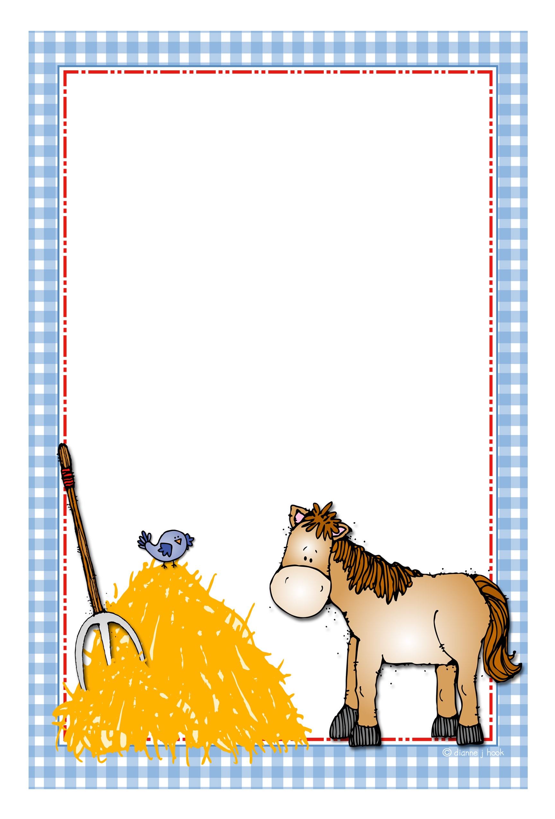
Curriculum Content…
Curriculum Content…

Reading/Phonics:
Our current ELA Program is CKLA. The series teaches comprehension and grammar skills, vocabulary, and reading/writing strategies. This program also has a phonics component that will teach sounds and spellings of sounds. Within the series, we will be giving frequent assessments to monitor your child's progress.

Math:
Our Math series is I-Ready. Within this curriculum, we will be sorting, classifying, completing patterns, learning numbers 0-30, adding, subtracting, working with fractions, comparing numbers, and graphing. Students will also frequently work on I-Ready lessons that are computer generated and are assigned based on their strengths/weaknesses.

Specialty Classes:
Your child needs to wear appropriate clothes and tennis shoes on P.E. days.
Our specialty class time is from 11:30-12:20 daily.
A list of our specialty classes is below:

Boswell’s Schedule: Smith’s Schedule:
Monday-P.E. Monday- Art/Music
Tuesday-Library/Guidance Tuesday-P.E.
Wednesday-Art/Music Wednesday-Library/Guidance
Thursday-P.E. Thursday-Art/Music
Friday- Art/Music Friday-PE
Recess:
FIRST
GRADE
AHEAD!!
We will be outside daily, weather-permitting from 1:45-2:15
Please dress your child appropriately to play. It's best for girls
to wear shorts under their skirts. Please do not allow your
child to bring toys to school. We will use equipment provided
at school.

Nurse:
If your child is taking any medicine that needs to be administered at school, you will need to see the
school nurse, Mrs. Kim Buchanan, to fill out the necessary documentation. Her office is located across
from the 5th grade classrooms. All medicine must remain in her office. We, the classroom teachers,
are not allowed to dispense any medication to any children.
Other Information...
First Grade Supply List: Please keep extra supplies on hand to replace as needed.
- Backpack
- Scissors (Fiskars brand work best)
- Small School Box
- #2 Pencils (box of Ticonderoga)
- 4 Dry Erase Markers-for student use
- 2 boxes of Crayons (24 count)
- 4 glue sticks
- 2 containers of CLOROX WIPES
- 2 pocket folders with brads
- 1 pair of Headphones
- 3 Boxes of Kleenex
- 1 Box of Ziploc gallon bags= Boys
- 1 Box of Ziploc sandwich bags= Girls
Money:
In order to get your child's money to the correct place, all money needs to be in the zipper pouch in your child’s Eagle Folder and it should be enclosed in an envelope or Ziploc bag labeled with their NAME and PURPOSE OF THE MONEY. (Ex.: Jane Doe, Lunch Money Ex.: Bob Smith, ESP money.)
Lunch Information:
Your child will receive a lunch number. Please practice this number at home. Your child will be entering that number each time a purchase is made from the cafeteria.
Your child will be able to purchase ice-cream and extra items each day during lunch. Ice cream and most extra items are $0.50 each. If you wish to limit their purchases, please see Ms. Renee (962-2320). She will be able to "flag" their account for daily purchases. We cannot keep a student from buying items during lunch.
Breakfast is free for all students. Breakfast is served daily from 7:00-7:45. The cost of lunch is $2.25. Milk is part of the regular lunch, however, if your child brings lunch from home, milk is extra. A monthly lunch menu will be in your child's Eagle Daily Folder. You may send cash or a check to pay for extras. Money will be deducted from the student account as it is used.
Please visit www.myschoolbucks.com and set up an account to view your child's cafeteria purchases and balance. This is a great way to stay connected to your student's cafeteria account.

HOMEWORK…
Homework is practice for skills taught in class. Your child should know how to complete this homework
with minimal assistance from parents. First grade homework will
primarily be reading/phonics and math practice. Watch your child's front folder pocket for homework.

Please help us assist your child in being responsible and independent. The VERY most important
homework is for your child to complete the work, place it in the Eagle Daily Folder and immediately
place it in their backpack. We check these folders daily. We ask that you monitor these folders as well.
If your child says that he/she has no homework (there may be nights like this), please check the front
pocket and zipper pouch to confirm that there is no homework.

Homework promotes responsibility that will follow your child through school and life. Thanks in advance for helping with these responsibility tasks.

PARENT INVOLVEMENT…
There are a variety of ways to help out in our classroom and school.
- Donate items from our classroom wish list/Amazon wish list
- Donate slightly used toys or new Dollar Store and Dollar Tree items to our TREASURE CHEST. Please
keep us in mind when cleaning out rooms in your home.
- Donate "Emergency Snacks" for children without a snack or drink.
- Get involved in our Broadview Parents Organization (BPO). Check out the Facebook page.
- Give extra time to your child at home to enjoy one another (this can be the most educational of all!)

Communication:
- Our school system has an automated call center to deliver information to parents. Please make sure your
phone numbers are kept up to date. Please contact the office if you have changes throughout the year.
- First Grade uses REMIND text messaging to send you reminders and information about our class. We will
use your cell number to send you an invitation to join.
- Newsletters will be sent through email.

Eagle Folders: Please check and return your child's Eagle Folder each day. Inside your child’s Eagle Folder
you will be able to monitor your child’s daily classroom behavior choices by looking at the monthly calendar. Homework will be sent home in the Eagles Folder daily. Eventually a list of spelling words will also be in
your child’s Eagle Folder. This folder is a very important communication tool and must brought back and
forth from home to school each day.

Reviewing Classwork and Assessments When you look through the Monday Folder, remove the graded papers, and sign the form, you WILL know areas of strength and weaknesses to work on at home. By going over the missed items, you are reinforcing the skills taught. Monday Folders will be sent home on Mondays, unless there is no school on Monday (and on those weeks, it will usually be sent home on Tuesday.)
Report Cards: Will be sent home each 9 weeks. Please sign & return.
Conferences: County-wide Parent Teacher Conferences will be held in the fall and spring, however, please contact your child’s teacher at any time if you have any questions or concerns.

Arrival & Dismissal…
Morning Arrival:
A teacher will always be on duty in the gym with your child. Students can be dropped off at the gym door beginning at 7:00. Students will remain in the gym until the 7:45 dismissal bell. School will begin at 8:00. If you arrive after 8:00, you will need to enter through the office and fill out a tardy slip for your child to bring to class.

*On Wednesdays, students will be dismissed at 2:30 to allow for Teacher PLCS.

Afternoon Dismissal:
Each student will receive a Pick-Up Number. ANYONE picking up your child in the pick-up line must have a copy of their assigned number. Please remember that anyone with this number will be able to pick up your child. The pick-up number must be displayed in the front windshield of your car. As you pull into school, a teacher will call your child's number to the gym and have them ready and in line to be picked up. Please keep your number displayed until your child enters your car. At that time, remove your number. This lets all the teachers helping with pick up duty know your child is inside the car. If your number is still displayed, it signals the adults that you are still waiting for your child. IF YOU DON'T HAVE YOUR CHILD'S NUMBER, YOU WILL HAVE TO PICK UP YOUR CHILD AT THE OFFICE.

BEHAVIOR EXPECTATIONS…
Our goal is for us to work together in making each day a positive experience for your child. If certain frequent behaviors become problematic for your child's learning, please assist me in working with your child to find a solution. Please keep in mind that your child's behavior affects everyone's learning environment. First Grade has high expectations for behavior. Your child has completed kindergarten and will be expected to know many of the procedures such as hallway, cafeteria, and bathroom behavior. We will spend a lot of time in an instructional setting. We will have non-structured physical activities during the day that allow for socialization. Instructional time will not be used for visiting. Our standards are numerous and instructional time is fast-paced.
*BE RESPECTFUL to everyone in our school.
*Keep your feet, hands and objects to yourself.
*Be a good listener when others are speaking.
*Treat others as you want to be treated.
OUR FIVE CLASSROOM RULES:
Rule #1: Follow Directions Quickly
Rule #2: Raise Your Hand for Permission to Speak
Rule #3: Raise Your Hand for Permission to Leave Your Seat
Rule #4: Make Smart Choices
Rule #5: Make Your Dear Teacher Happy
REWARDS/CONSEQUENCES: Behavior Clips- Every student begins each day with his/her clip on Blue: “Ready to Learn.” Students who make wise choices and exhibit appropriate behavior have the opportunity to move their clips up to show their positive behavior choices.
Positive Behavior #1 Move clip up to Purple: Excellent!!
Positive Behavior #2 Move clip up to Pink: Exceptional-Soar Ticket!!
Though we are sure no one will need to worry about this option, we still need to lay out the results of poor choices:
Poor Choice #1 Move clip down to Light Green: WARNING
Poor Choice #2 Move clip down to Dark Green: Two laps/5 minutes
Poor Choice #3 Move clip down to Yellow: 10 minutes
Poor Choice #4 Move clip down to Orange: 15 minutes
Poor Choice #5 Move clip down to Brown: 20 minutes
Poor Choice #6 Move clip down to Red- Separation/Phone Call

We look forward to helping and encouraging your child to progress developmentally academically and socially. We are anticipating a wonderful school year for all of us!
Please be patient and flexible during the 2022-2023 school year. Many things will be different and we anticipate that changes could occur at any time. We will all do our best and look forward to returning to a “normal” school year soon.
Please don't hesitate to call us or send us a message on Remind with any joys, questions, or concerns.

Sincerely,

Mrs. Michele Boswell
michele.boswell@fcstn.net
School-967-0132

Mrs. Hollee Smith
hollee.henson@fcstn.net
School-967-0132

