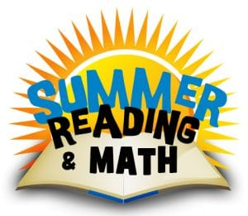
To Our Future Fantastic 4th Graders,
We hope you have a great summer and enjoy your time off! However, we want to make sure that you continue to keep your reading and math skills fresh over the summer months. Please work on the following reading and math activities this summer:
Read Fourth Grade Rats by Jerry Spinelli. Then write one paragraph (4-5 complete and thoughtful sentences) sharing your opinion of this book. Please include details about what you liked about the book. If you did not like the book, then you can share that, too!

Read an additional chapter book of your choice (NO graphic novels). Then write a summary of the book. Your summary should be at least two paragraphs in length. Be sure to include the title of the book and the author’s name.

These paragraphs will count as your first quiz grade in reading class. Bonus points will be given if you use cursive.
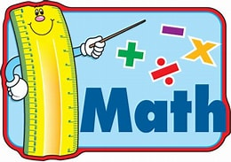
___________________________________________________________
For math, practice your addition, subtraction, multiplication, and division facts throughout the summer. Fourth graders will have timed math facts quizzes starting the first week of school. The end of the year goal for 4th graders is less than 2 seconds per math fact. You may also sharpen your math skills by completing IXL’s Summer Boost Math for rising fourth graders which consists of 20 IXL exercises.

Students who finish all 20 IXL Summer Boost Math exercises to a 90 or higher AND complete their three paragraphs for reading will be invited to a special ice cream party in August.

These assignments are due the first week of 4th grade!
Enjoy your summer!
4th Grade teachers,
Mrs. Sabetti and Miss Dempsey

