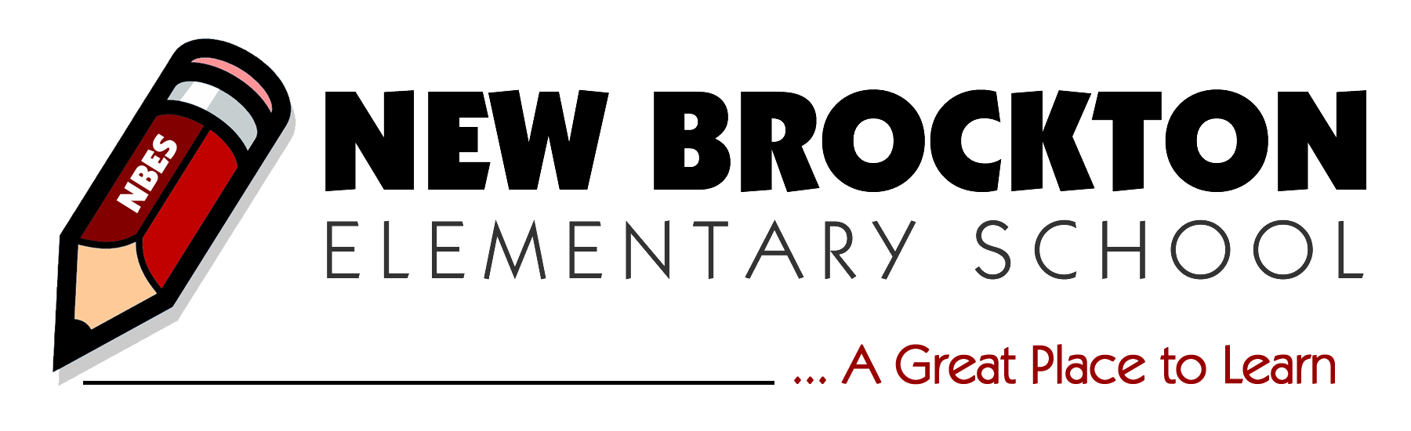
Holli Richardson, Principal  Jared Robison, Assistant Principal | 504 North John Street  P.O. Box 489  New Brockton, AL 36351 | Phone: 334-894-6152  Fax: 334-894-0058

Welcome to New Brockton Elementary School. The following documents are required for enrollment:

- Proof of age (Ex: birth certificate)
- Current Certificate of Immunization of the state of Alabama
- Two forms of proof of residency- The following are the ONLY documents that we can accept as proof of residency:
-Property tax records
-Mortgage documents or property deed
-Apartment/home lease
-Current Utility bill (electric, water, and/or garbage)
-Driver’s license
-Voter precinct ID
-Automobile registration
- Copy of ID of the parent or legal guardian
- Custody documents (if applicable)

*If you are not the parent listed on the birth certificate, you must also show legal documentation of custody in order to enroll.
*If you have withdrawal papers and grades from your previous school, please include those as well.

Once you have obtained the required items, you will need to complete a registration packet available at the school.

Assistance:
If you need assistance getting a birth certificate or immunization records, please contact the Coffee County Health Department in Enterprise, Alabama at (334) 347-9574.
Voter precinct ID’s can be obtained at the Coffee County Board of Registrars in New Brockton, Alabama. They can be reached at (334) 894-5347.
Driver’s license and automobile registration can be obtained at the Coffee County Courthouse in Enterprise, Alabama. They can be reached at (334) 347-2519.

We look forward to working with you and your child. If you have any questions, please do not hesitate to contact me by phone at (334)894-6152 or by email at bowersh@coffeecounty.k12.al.us.

