Santa Maria Joint Union HIgh School DIstrict  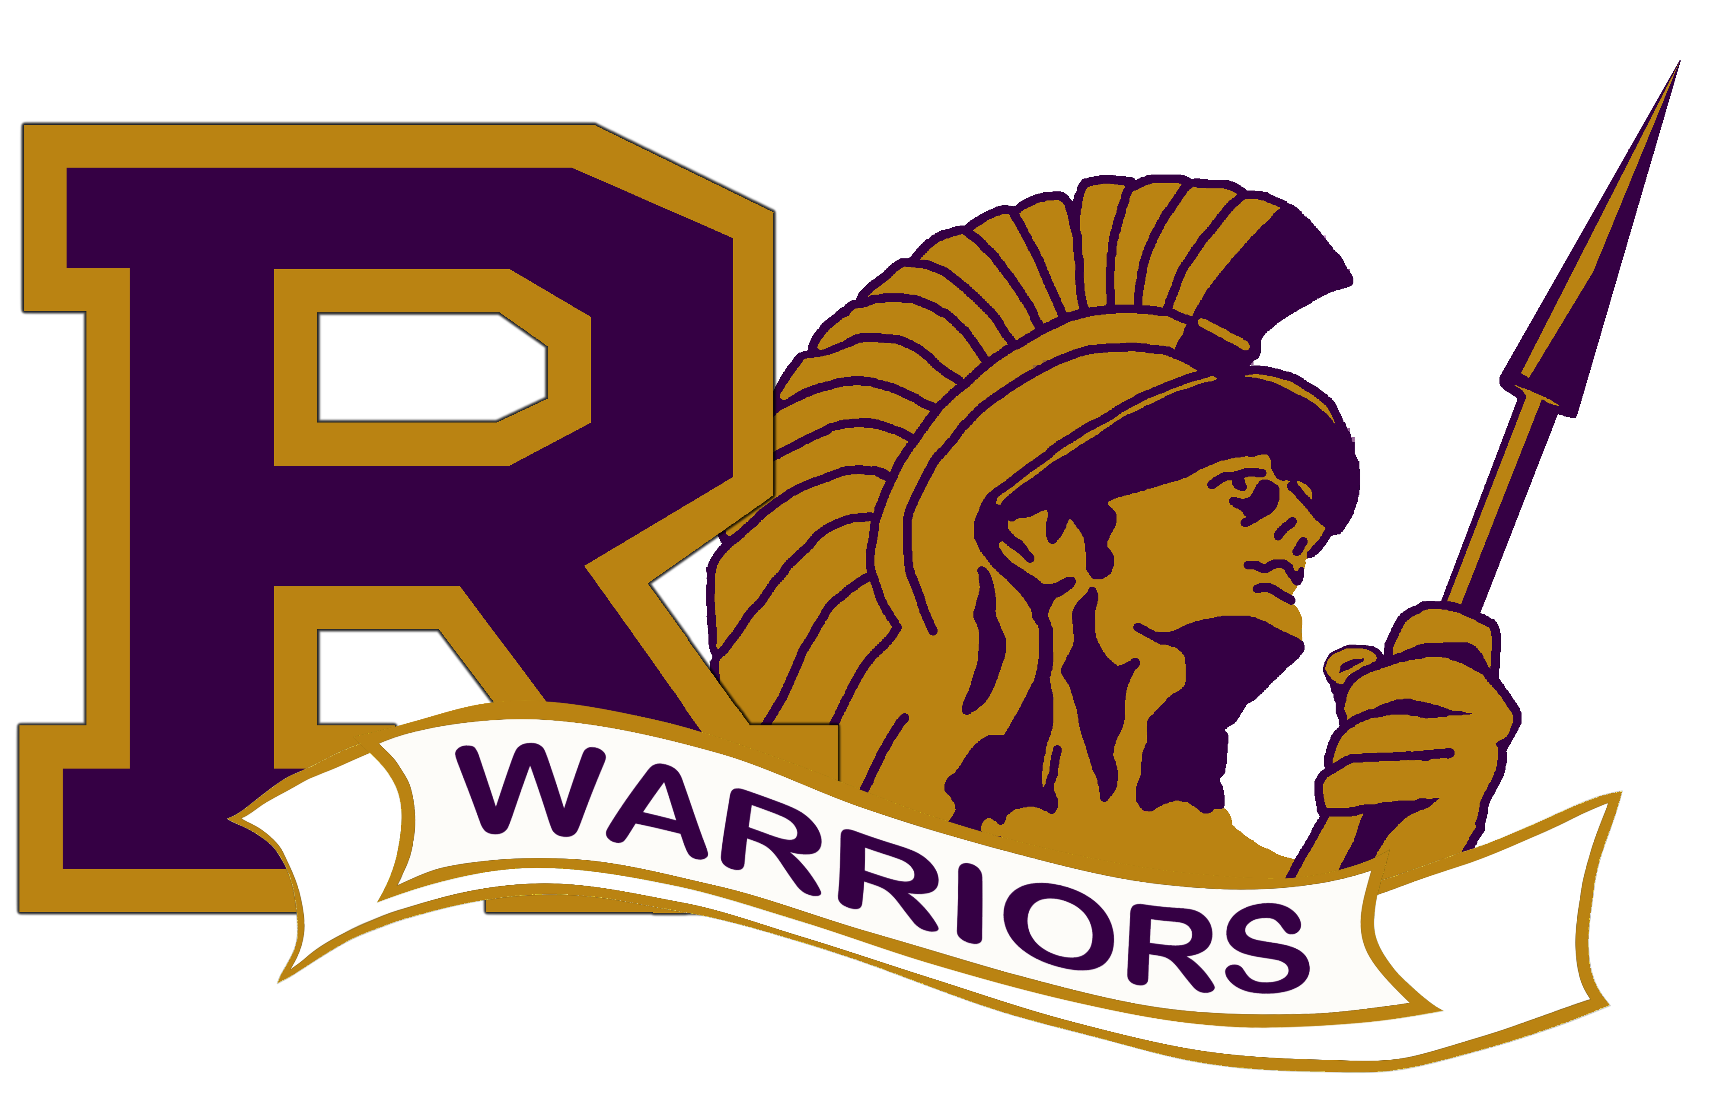 | 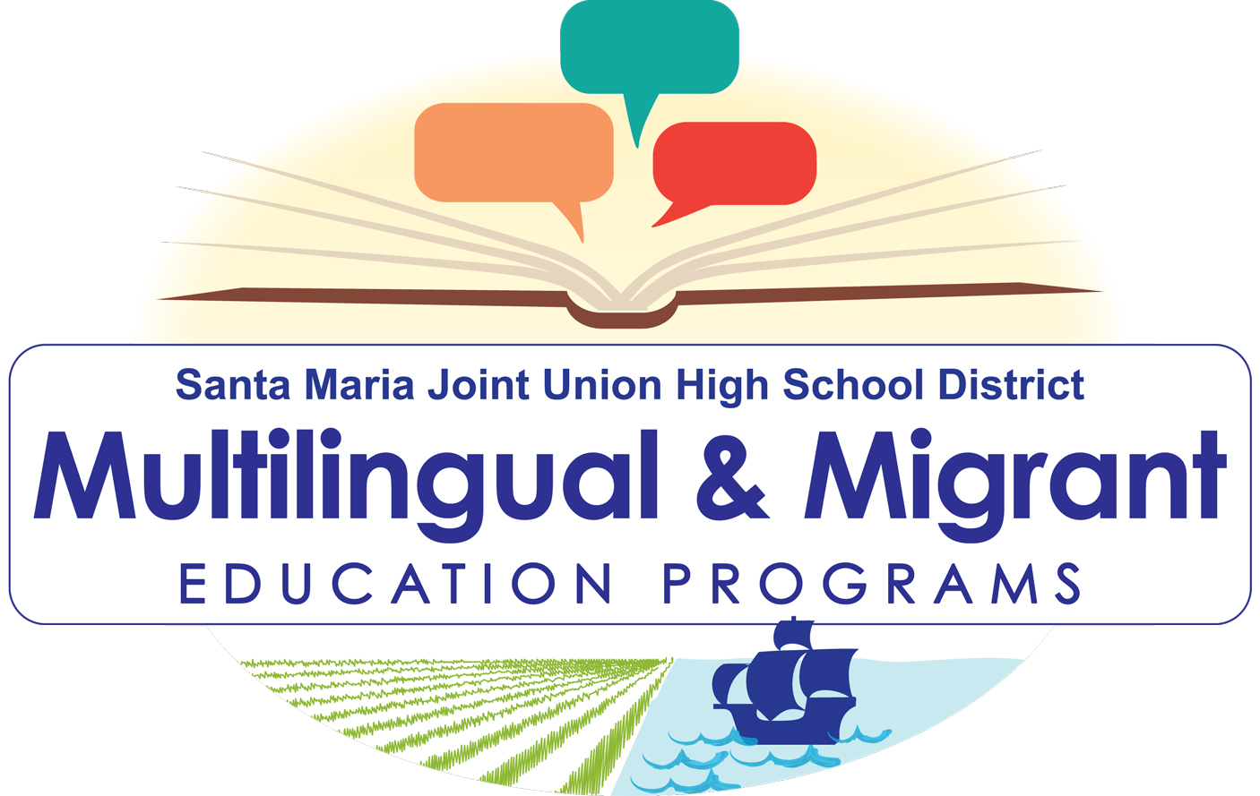
District english learner advisory coMMITTEE  SEPTEMBER 28, 2022  6:30pm  Lincoln Center-Room 904  829 S0. Lincoln St. santa maria, ca. 93454  AGENDA  - Welcome- Elyssa Rodriguez-Chavarria, Director of Multilingual and Migrant Education Programs (MMEP)  - Call to Order  - Acknowledgment of DELAC Members present-Elyssa Rodriguez-Chavarria, MMEP Director  - Agenda review and approval-SMJUHSD Interpreter  - Reading and approval of minutes from April 27, 2022- SMJUHSD Interpreter  - Presentations  - English Learner Roadmap- Maritza Olguin, E.L. Coordinator  - English Learner Pathway- Maritza Olguin, E.L. Coordinator  - Reclassification Criteria & District Progress- Maritza Olguin, E.L. Coordinator  - Nomination of DELAC Officers-Elyssa Rodriguez-Chavarria, Director of MMEP  - Reports  - Annual Census Data-Elyssa Rodriguez-Chavarria, MMEP Director  - Consolidated Application-Elyssa Rodriguez-Chavarria, MMEP Director  - Annual Parent Notification-Elyssa Rodriguez-Chavarria, MMEP Director  - General Announcements/ Public Input  - Family Engagement Programs  - Important of School Attendance  - Tutoring Programs  - Adjourn  **Next DELAC Meeting**  October 26, 2022  6:30PM | Unlocking Potential, Shaping Futures-Together  The mission of the Multilingual and Migrant Education Program is to promote equity and opportunity for all English learner, Immigrant, and Migrant students. Success is built on the engagement of our students, staff, parents, and community in collaborative learning experiences that lead to high levels of academic achievement and social empowerment.  For more information:  Elyssa Rodriguez Chavarria  PH: (805) 922-4573 ext. 1601  echavarria@smjuhsd.org

