PHONICS/READING | GRAMMAR/WRITING | MATH | SCIENCE/SOCIAL STUDIES
- Vowel Patterns: a, ai, ay  - Compare & Contrast  - Inferring | - Possessive Nouns  - Practice Cursive Handwriting | - Fluently Add Within 100  - Addition & Subtraction Facts | - Landforms  - Identify Historical Figures and Inventors  - Matter: Solids, Liquids, & Gases
Mrs. Sharpe’s Class •Keisha.Sharpe@acboe.net
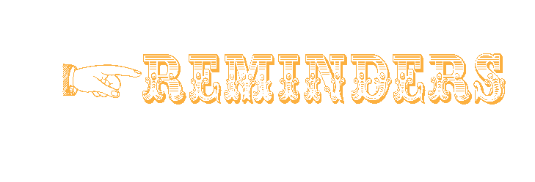

- main 7. paint
- away 8. tray
- brain 9. say
- today 10. raise
- wait 11. stay
- play 12. tail

BONUS WORDS Small treat given for correctly spelled bonus words.
explain playing crater
If your child is a car rider in the mornings, be sure to get him/her to school before 7:45 to ensure he/she has time to eat breakfast before 8:00. Please send a bottle of water to school with your child daily. Also, allow your child to read for at least 20 minutes each night. Homework is due on Fridays.
Our school website is: pinelevelelem.com

One Good Turn
Spelling Words
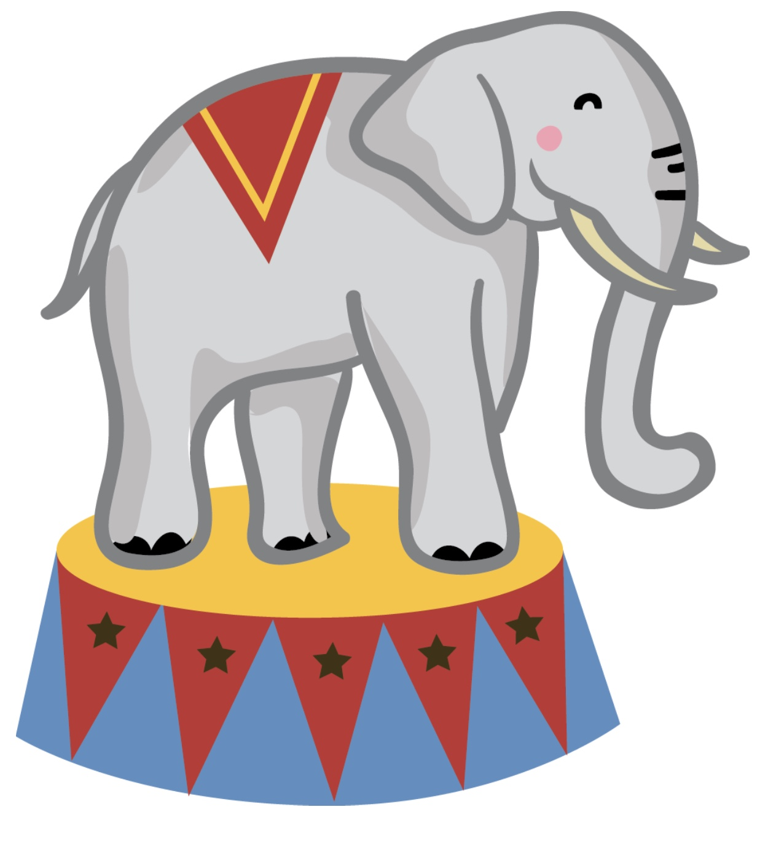Look at what we are learning!

Ladies & Gentlemen!

Every Journey Has a Great Story!

- 10.25: Book Fair
- 10.25: Nerds Are Cool Day
- 10.26: Camouflage Day
- 10:27: Red Day
- 10.27: Reading & Grammar Tests
- 10.28: Spelling & Vocabulary Tests
- 10:28: Math Test
- 10.28: Mismatched/Crazy Outfit & Hair Day
- 10.29: Fall Fun Day/Wear Costumes

One Good Turn
High Frequency Vocabulary Words
behind everybody promise
brought minute sorry door

October 25 , 2021

