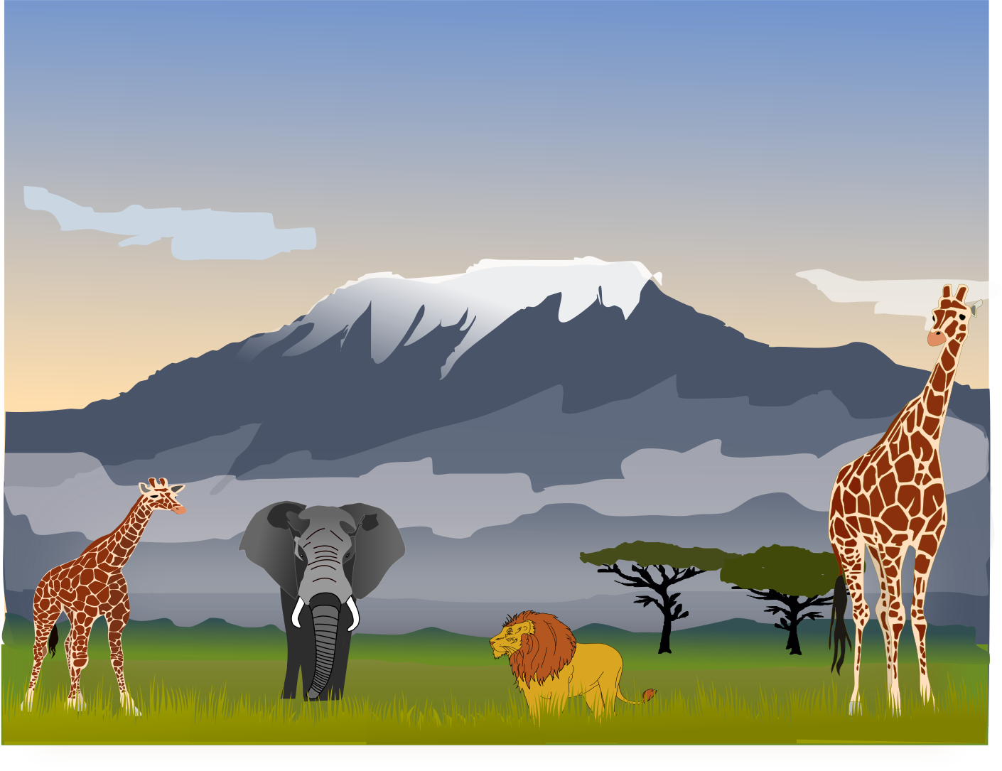
CLASS NEWS
Mrs. Williams
Date: April 29, 2024

Math:
-measure inches and centimeters; weight to nearest pound
-test on Wednesday

Science/Social Studies:
-animal habitat research

Upcoming Events:
Friday, May 3 – Field Trip to Luray Caverns

