Updated: 7/14/25

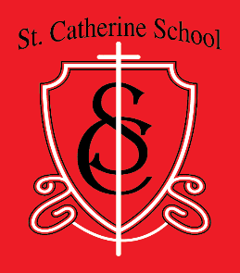

St. Catherine School

*Inspiring excellence through faith, learning, and service*

540 3rd Avenue NE

Valley City, North Dakota 58072

Dear Parents,

It is our intent to utilize our counselor with students on a one-to-one basis as well as in the classroom. Students may be recommended by classroom teachers and other staff to aid them in areas that pertain to being a successful student. If such a recommendation is made the parent will be notified. In addition, if you feel there is a specific topic you would like addressed with your child, please contact his/her teacher. Such topics could include: self-esteem, organization, social skills, respect for authority etc.

I give permission to see the school counselor outside of the regular class time.

I DO NOT give permission to see the school counselor outside of class at this time.

Parent/guardian signature _____________________________Date _

Topics to address (optional) ________________________________________________