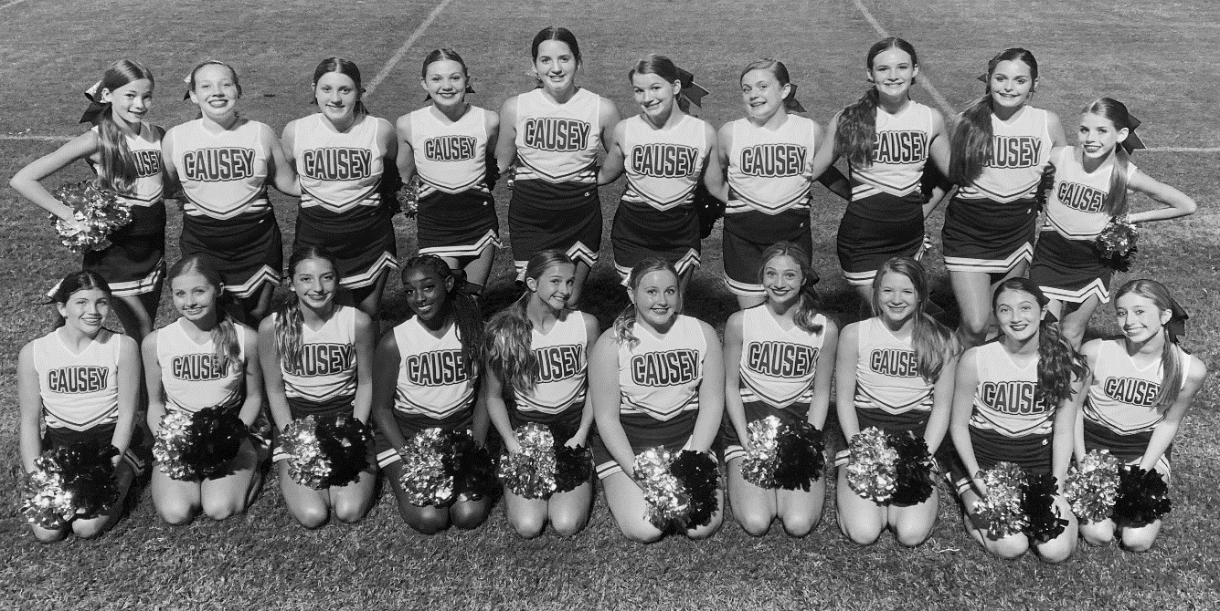
CLINIC DAY: MONDAY, NOVEMBER 15th
K-8th Grade Dancers
5:00pm-7:30pm
Pre-Register by Friday, November 12th

Where: Causey Middle School Gym ^{Check in: 4:30pm-5:00pm}
^{When: Monday, November 15th} ^{Clinic Time: 5:00pm-7:30pm}
Dancers will perform at Causey Middle School on Thursday, November 18th at 5:00 pm
Cost: $25 per dancer (Includes t-shirt for performance)
Please complete this form below and send in cash or check.
**Please make checks to the Causey Dance Team**
Same day Registration: $30
*A confirmation email will be sent with
more information once your registration is received*

Dancer’s Name: _________________________________ Grade: ________ Age: ________
School: ____________________________________ T-shirt Size: _______________ (YS-AXL)
Parent Name: _______________________________ Parent Phone: ____________________
Parent Email: __________________________________

