Mobile County Public Schools is conducting a climate and culture parent survey and a community engagement survey. We value your opinion and ask that you please take time to complete these surveys. Please be assured that your responses to this survey will be anonymous. Please select the school/schools that your child/children currently attend. These are very short.

Climate & Culture Parent Survey
https://eprovesurveys.advanc-ed.org/surveys/#/action/228596/p524

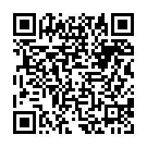
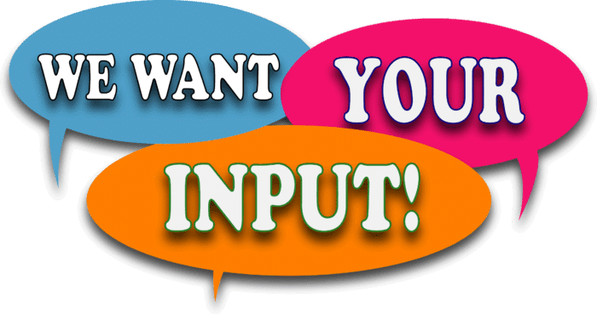

Community Engagement Survey
https://eprovesurveys.advanc-ed.org/surveys/#/action/228601/524/1

