Exeter Turkey Trot Scholarship @ Wyoming Area

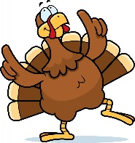
The Exeter Events team, a 501c3 organization, under the tutelage of Mayor Denise Adams, will hold the first EXETER BOROUGH TURKEY TROT on Saturday November 26, 2022, a community event aimed at getting our community more active, giving our residents and neighboring residents an opportunity to come out the Saturday after Thanksgiving to see friends and family and enjoy the run/walk in our borough.

Wyoming Area Seniors who participate in the walk or run will be placed in a pool to receive one of two $500 scholarships. We are excited to join the wonderful Wyoming Area Scholarship family in supporting our graduating Warriors as they enter into the next chapter of their lives.

This group is joining over 118 scholarship donors in a program that began some 14 years ago. The Turkey Trot/Exeter Events committee will select the recipients of these very generous scholarships.

This is an example of another community group joining this prestigious program which honors Wyoming Area seniors each year with generous awards and has been doing this for the past 14 years.

The scholarship chairs applaud this group as it does so many others for thinking of our “KIDZ” and honoring them in such a generous way.

No application needed. To qualify register to run in the Turkey Trot on Saturday, Nov. 26, 2022.

