REQUEST FOR DIRECT DEPOSIT

INSTRUCTIONS:
- Fill out form completely and return to the Payroll Department at pony code #8004.
- Return to the Payroll Department no later than two weeks prior to your payday.
- All pay dates can be found on the school district website at HCBE.net
- If your account has closed, please call the Payroll Department immediately.
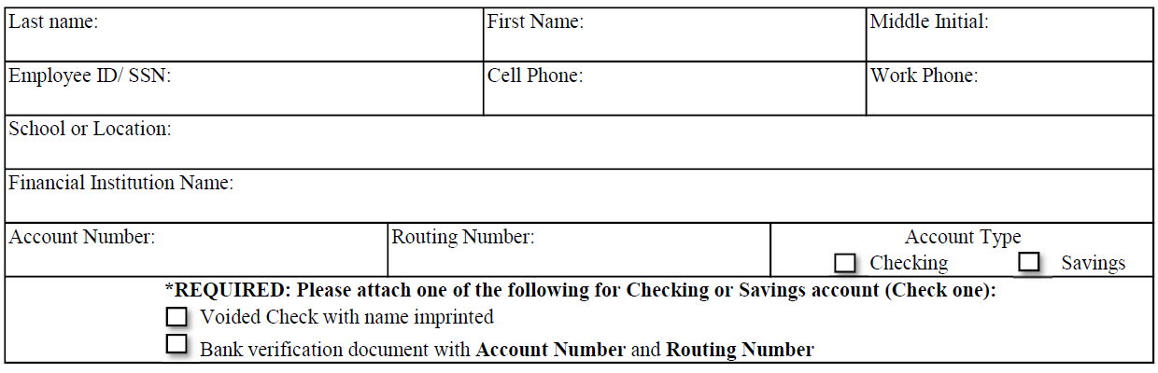

I hereby authorize the Houston County School District to deposit my monthly salary paycheck to the above-named financial institution. I understand that Houston County School District has the authority to make adjustments, if necessary, for any entries made in error to my account. I understand that it is my responsibility to notify the Payroll Office of any changes to my direct deposit information.

SIGNATURE: ____________________________________DATE: ____/____/____

