
Master Gardeners of Central Georgia
715 Oglethorpe Street
Macon, GA 31201
478-751-6338
email: education@mgcg.org

Macon-Bibb County Cooperative Extension
715 Oglethorpe Street
Macon, GA 31201
478-751-6338

Houston County Cooperative Extension
2030 Kings Chapel Road
Perry, GA 31069
478-987-2028

About Us
Master Gardeners of Central Georgia (MGCG) is a non-profit, service-oriented educational organization operating within the bounds of Section 501(c) (3) of the Internal Revenue Code. The organization was founded on June 14, 1994. Our members are trained and certified by the University of Georgia Cooperative Extension to assist in providing unbiased and research-based horticultural information to the community. Activities include our popular spring and fall plant sales at the Macon Farmers’ Market in Macon, GA. Funds raised through these activities enable MGCG to offer academic scholarships and grants to support community projects.

Scholarships
Applications
online at
mgcg.org
Information & Applications
online at
mgcg.org
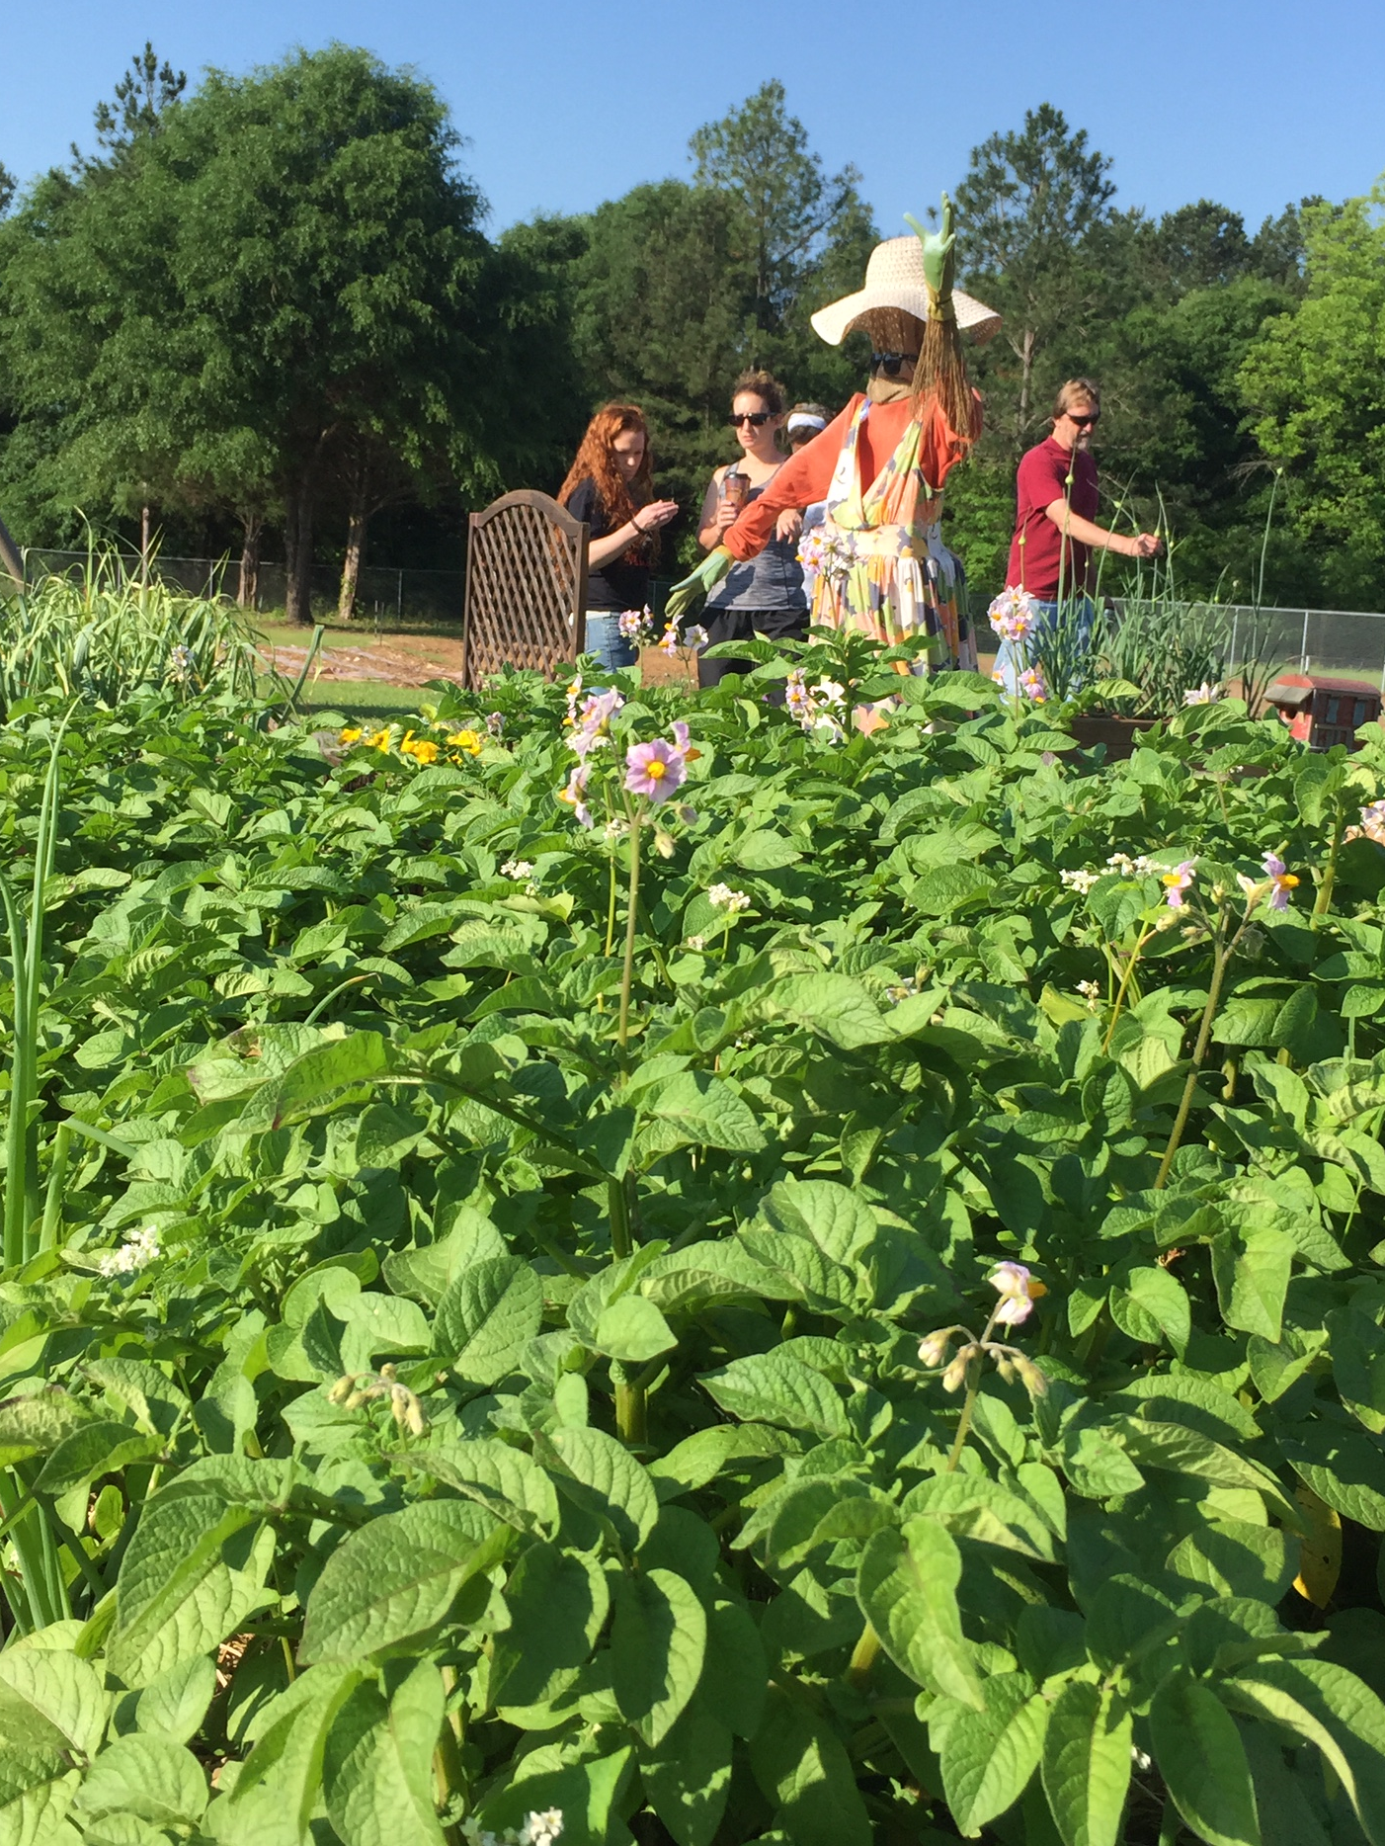
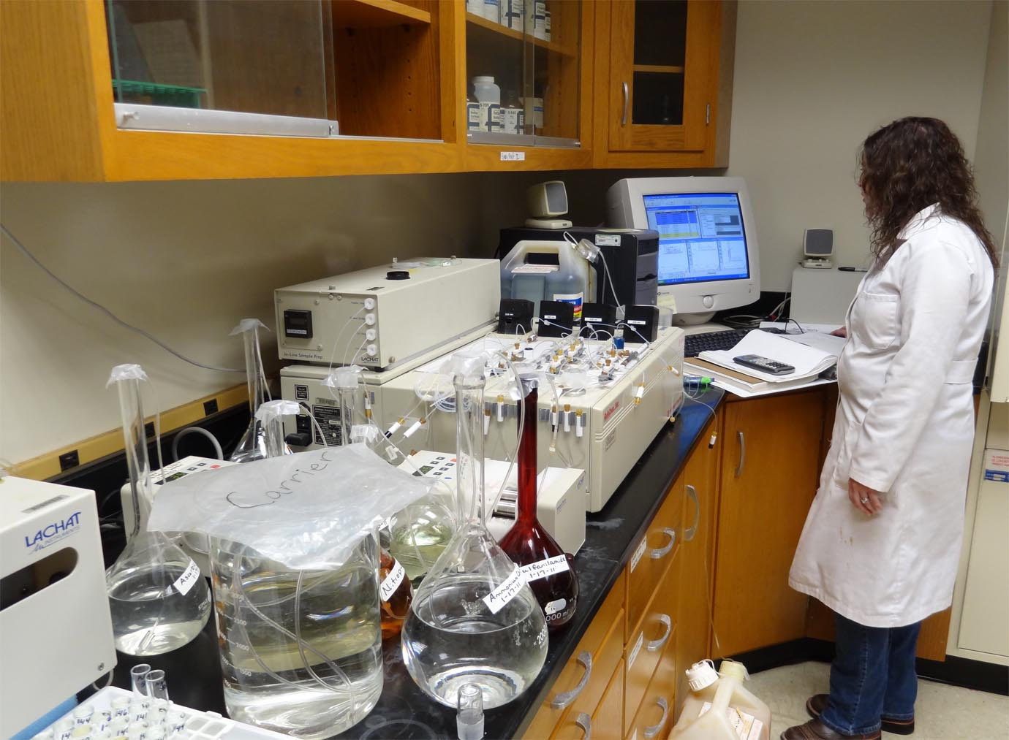
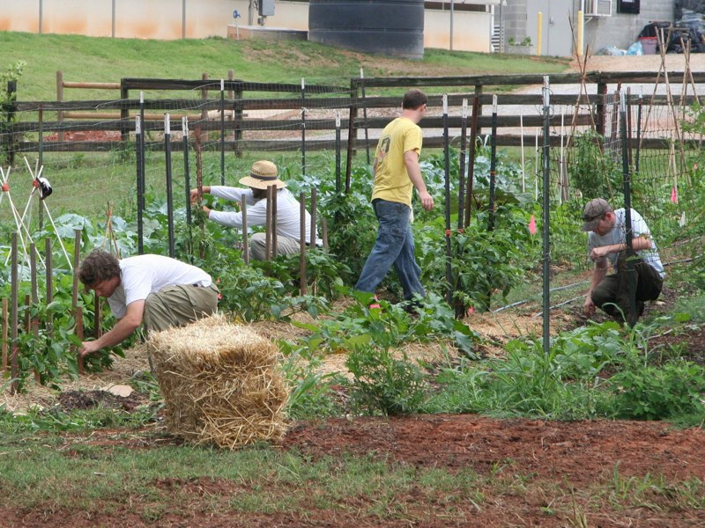

Full information and applications are online at mgcg.org
Junior or senior applicants must have declared a major in one of the following disciplines: Agriculture, Botany, Environmental Sciences, Horticulture, Landscape Architecture or Design, or a related field. All applicants must also be a legal resident of one of the following counties: Bibb, Crawford, Houston, Jones, Monroe, Peach, or Twiggs.
Rising College Junior/Senior Scholarship
A one-time $1000 scholarship is offered to a rising junior or senior who has maintained an outstanding scholastic record while pursuing higher education, and has participated in school and community activities.
Rising College Sophomore Scholarship
A one-time $1000 scholarship is offered to a rising sophomore who has maintained an outstanding scholastic record while pursuing higher education, and has participated in school and community activities.
High School Senior Scholarships
Up to two $1000 scholarships are available to graduating high school seniors based on scholastic achievement. Grade point average, SAT scores, and other academic honors are all considered. These are one-time scholarships, and applicants must be a legal resident of one of the following counties: Bibb, Crawford, Houston, Jones, Monroe, Peach, or Twiggs. Preference is given to applicants who participated in 4-H, Future Farmers of America (FFA), or related activities during their high school careers and who are intending to major in Agriculture, Botany, Environmental Sciences, Horticulture, Landscape Architecture or Design, or a related field.

Each year, Master Gardeners of Central Georgia (MGCG) awards scholarships to as many as five deserving individuals who have maintained outstanding academic records and are planning or have declared a major in the fields of Agriculture, Botany, Entomology, Environmental Sciences, Horticulture, Landscape Architecture or Design, or a related field.

