
Quail Run Elementary School

Title I Handbook
2025-2026
Dr. Amanda Miliner, Principal
250 Smithville Church Rd.
Warner Robins, GA 31088
Revised September 1, 2025
A Parent’s Guide to Title I
What is Title I?
Title I, Part A is a federally funded program under the Every Student Succeeds Act (ESSA). The purpose of Title I under ESSA is to ensure that all children have a fair, equal, and significant opportunity to obtain a high-quality education and reach, at a minimum, proficiency on challenging state academic achievement standards and state academic assessments.
Which Houston County schools are Title I schools?

CB Watson Primary Northside Elementary Shirley Hills Elementary
Centerville Elementary Northside High Thomson Middle
David Perdue Primary Northside Middle Tucker Elementary
Eagle Springs Elementary Parkwood Elementary Warner Robins High
Huntington Middle Pearl Stephens Elementary Warner Robins Middle
Miller Elementary Langston Road Primary Westside Elementary
Morningside Elementary Russell Elementary Quail Run Elementary

What supports are provided through Title I?
The Title I Program offers a variety of supports, which may include, but are not limited to, additional teachers, support staff, instructional materials and supplies, technology to support student learning, tutoring, professional development for school staff and capacity building events for families.

What role does family engagement play in Title I?
Family engagement is an integral part of the ESSA law. Districts and schools receiving Title I funding must:
- Ensure that high-quality academic assessments, accountability systems, teacher preparation and training, curriculum, and instructional materials are aligned with challenging State academic standards so that students, teachers, parents and administrators can measure progress against common expectations for student academic achievement.
- Afford parents substantial and meaningful opportunities to participate in the education of their children.

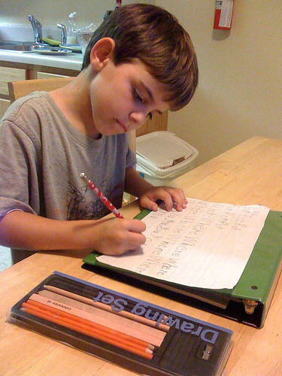
Families,
You can have a tremendous influence on your child’s success in school. By partnering with the school and participating in the Title I program, you will:
- show your child that you support and value his/her education.
- be able to closely monitor your student’s progress.
- build stronger relationships between home and school.
- provide valuable input about schoolwide programs.
Research shows that students whose families are engaged perform better academically, socially and behaviorally. Be sure to become involved in your child’s school by:
- communicating regularly with your child’s teacher.
- attending academic-based family events and parent-teacher conferences.
- volunteering at the school.
- joining the Parent Action Team or School Council.
- providing input concerning the Title I program at the school.

Quail Run Elementary School

The Connection
Family-School Engagement Plan and Compact
2025-2026



Dr. Amanda Miliner, Principal
250 Smithville Church Rd.
Warner Robins, GA 31088

https://qres.hcbe.net/

What is Title I?
Quail Run Elementary School is identified as a Title I school as a part of the Every Student Succeeds Act (ESSA). Title I is designed to support State and local school reform efforts tied to the challenging State academic standards to improve teaching and learning for students. Title I programs must be based on effective means of improving student achievement and include strategies to support family engagement. All Title I schools must jointly develop with parents and family members a written parent and family engagement plan and compact.

The Connection
What is it?
The Connection is a comprehensive document joining our School-Family Engagement Plan and Compact together with the purpose of strengthening the bond between school and home. The Engagement Plan describes how our school will provide opportunities to improve family engagement that will support student learning at school and at home. All students and their families are invited and encouraged to fully participate in the opportunities described in this plan. The school will provide information and as many opportunities as possible for the participation of all family members. The Compact explains what teachers, parents and students each will do in an effort to work together to make sure that our students reach grade level standards. The Compact is discussed with families during parent-teacher conferences throughout the school year.
How is it revised?
The Connection is jointly developed and revised by our school’s stakeholders. All families are invited to attend our annual Shared Decision Making Meeting (SDM) held each spring. Families are asked to review and give feedback on the Engagement Plan, Compact, and budget including the 1% set aside. All feedback forms from the SDM Meetings are collected, reviewed and used to revise this document and to improve program planning for the next school year. Families who are not able to attend the SDM Meeting have the opportunity to provide input by completing an online feedback form and completing the Title I Parent Satisfaction Survey that seeks suggestions regarding the plan, compact and budget.

Who is it for?
The Connection is for all students attending a Title I school and their families. We encourage and invite families to fully participate in the opportunities described in this document. Our school will provide full opportunity for the participation of parents and family members with limited English, with disabilities, of migratory children and caretakers of students served in Neglected and Delinquent Centers.

Where is it available?
The Connection is included in our Title I Handbook that is provided to all parents and families at the beginning of the year or whenever a new student enrolls. The Connection is also available on our school website and in our Parent Resource Center. Families can request a copy at any time during the school year.

Let’s Stay Connected

Quail Run Elementary School believes that family engagement means the participation of parents and family members in regular two-way, and meaningful communication involving student academic learning and other school activities. Here are the ways to stay connected and informed.

- Progress Reports and Report Cards
- Houston County School District App
- Digital Newsletter
- School Website
- Social Media
- Call-outs messages
- Emails
- Parent-Teacher Conferences

Access to Staff

- Our school has an open-door policy.
- All teachers and staff are available through email. See the school webpage for contact information.
- Conferences may be scheduled directly with your child’s teacher or through the Main office at (478) 953-0415.

Activities to Build partnerships

Quail Run Elementary School plans the following events to build the capacity for strong parent and family engagement and to support a partnership among school, parents, and the community to improve student academic achievement. Meetings and events are scheduled at various times and in different formats to accommodate the needs of our families. These events may be held in person or virtually.

Event | Focus | Date
Meet and Greet | Welcoming | July 2025
Open House | Curriculum | August 2025
Parent Teacher Conferences | Curriculum | October 2025
Annual Title I Meeting | Informational | October 2025
Family Read-In | Curriculum-Literacy | October 2025
ESOL Parent Workshop | ESOL | November 2025
Technology Tools Workshop | Technology | January 2026
Title I Parent Satisfaction Survey | SDM | February 2026
Loving Math | Curriculum-Math | February 2026
3rd-5th Don’t Stress the Test, GMAS Information Session | Testing/Assessment | March 2026
Shared Decision-Making Meeting | SDM | April 2026
5th Graders: Welcome to 6th Grade | Transition | May 2026
Kindergarten, Here We Come | Transition | May 2026
Quail Run Elementary School wants to help all our families participate in our family engagement activities. If you need assistance with childcare or transportation in order to attend the events listed in this plan, contact our Family Engagement Liaison for more information and assistance.
Eric Baker
Eric.baker@hcbe.net
478-953-0415

Family Engagement Liaison
Our FEL is Eric Baker. He is available to assist families in a variety of ways from finding resources, connecting with teachers and administrators, navigating Infinite Campus and providing opportunities for you to learn how to help your student at home.

Office Phone: 478-953-0415
Email: eric.baker@hcbe.net

Parent Resource Center
Visit the Parent Resource Center to get pamphlets, brochures, and other resource materials to use at home with your child.

Resource Center - 001
Monday – Friday, 7:45 am to 4:15 pm


- We welcome and encourage parental engagement. All volunteers are required to have a background check in order to participate in some areas.
- There are several ways for parents to give of their time working. Opportunities such as chaperoning events, tutoring small groups of students, assisting to make copies, and proctoring for tests are just a few.

Our Pledge to our Parents and Families

Quail Run Elementary School will take the following measures to promote and support parents as equal partners in their child’s education. In order to reach our goal of the highest quality of student achievement, Quail Run Elementary School pledges to support our students and their families as the foundation of the school. We will:

- Ensure that all information related to school and parent programs, meetings and other activities is published in both English and Spanish and posted on the website or on social media.
- Provide training for staff on the value and contribution of parents, on ways to improve communication, on ideas to build strong partnerships with families, on providing information in a friendly format and on responding to parent requests four times during the school year.
- Partner with early learning centers to provide resources to help prepare families and their students for successful school transitioning.
- Share information/materials related to school and parent engagement activities, meetings and workshops in English and Spanish.
- Communicate with all families and the community on a regular basis regarding school-wide events through school messenger, social media, school website, newsletters and flyers.
- Work with parents to develop relevant trainings and helpful presentations to educate our staff on the importance of parent and family engagement and how to support student learning.
- Provide information for parents to better understand Georgia Standards of Excellence and assessments for all grade levels.
- Collaborate with stakeholders and community/business leaders to increase awareness of family and community engagement programs.
- Connect families to classes or support groups to help further enhance our parent’s various educational levels.
- Collect feedback from parents and family members after academic events in order to respond to parents’ request for additional support for engagement activities.

2025-2026 District Goals

Increase by at least 2 percentage points the number of students performing at or above proficiency in core content areas in grades 3-11 as measured by Milestones assessment scores.

Increase the percentage of parents who feel their child’s school provides various opportunities for engagement.

2025-2026 School Goals

- Increase academic achievement in all content areas and grade levels.
- Have a safe and orderly school.
- Plan, implement, and monitor processes and procedures for organizational effectiveness.

Grade Level: K
Focus Areas

- Read grade-level decodable text
- Letter and Sound Identification
- Recognize and Write Numbers 0-20; Match numbers to the correct number of objects
- Count to 100 by ones and tens
- Recognize and create 2D and 3D shapes
- Add and subtract up to the number 5
- Recognize and read in context the UFLI high frequency words.

Teachers will

- Provide students with a “Bag of Books” for their student to share at home.

- Provide students with a Heart Word
List to increase student’s understanding of letters and words.

- Provide a list of items that parents can find at home and use as manipulatives, to increase student understanding of numbers, shapes, addition and subtraction.

- Provide and encourage parents to attend academic workshops and utilize strategies learned to assist students.

- Provide students with additional resources (websites, Apps, and newsletters) that will support student learning.

Our Compact: Teachers, Families and Students –Together for Success

Family will

- Read “Bag of Books” with their student nightly.

- Practice Heart Word list with their students nightly, to understanding.

- Collect items for manipulatives and use the items to increase student understanding of numbers, shapes, addition and subtraction.

- Attend academic workshops and utilize strategies learned to assist students.

- Utilize additional parent resources (websites, Apps, and newsletters) that support student learning.

Student will
- Read books from your “Bag of Books” every night.
- Use all reading strategies you learn including reading Heart Words quickly.
- Use manipulatives to work problems and practice at home.
- Bring home and share with parent the QRES Calendar of Events, informational newsletters, invitations, and other school notices regarding parent workshops.
- Work with parents on Apps, websites, video, and other links that will support your learning.

2025-2026 District Goals

Increase by at least 2 percentage points the number of students performing at or above proficiency in core content areas in grades 3-11 as measured by Milestones assessment scores.

Increase the percentage of parents who feel their child’s school provides various opportunities for engagement.

2025-2026 School Goals

- Increase academic achievement in all content areas and grade levels.
- Have a safe and orderly school.
- Plan, implement, and monitor processes and procedures for organizational effectiveness.

Grade Level: 1
Focus Areas

- Reading Comprehension
- Reading Fluency
- Word Problems
- Addition and Subtraction to 20
- Math Fluency to 10

Family will

- Read for 20 minutes each night.

- Practice UFLI Sight Words with their student nightly.

- Attend academic workshops and utilize strategies learned to assist students.

- Utilize additional resources (websites, Apps, video library, and newsletters) to assist and enrich their student’s learning.

Teachers will

- Provide books for the students to read on their level.

- Provide students with weekly UFLI sight words to build fluency.

- Provide and encourage parents to attend academic workshops and utilize strategies learned to assist students.

- Provide students with additional resources (websites, Apps)
Our Compact: Teachers, Families and Students –Together for Success

Student will

- Read each night for 20 minutes.
- Practice Sight Words nightly.
- Students have access to practice activities at home.
- Students will show their parents their take home folder daily. The folder includes important information.
- Bring home and share with parent the QRES Calendar of Events, informational newsletters, invitations, and other school notices.
2025-2026 District Goals

Increase by at least 2 percentage points the number of students performing at or above proficiency in core content areas in grades 3-11 as measured by Milestones assessment scores.

Increase the percentage of parents who feel their child’s school provides various opportunities for engagement.

2025-2026 School Goals

- Increase academic achievement in all content areas and grade levels.
- Have a safe and orderly school.
- Plan, implement, and monitor processes and procedures for organizational effectiveness.

Grade Level: 2
Focus Areas

- Reading Comprehension
- Reading Fluency
- Place Value
- Addition and Subtraction Fact Fluency to 20

Family will

- Read from the “Bag of Books” with their student, nightly, for at least 20 minutes.

- Work with student on weekly homework phonics lesson sheet.

- Attend academic workshops and utilize strategies learned to assist students.

- Utilize additional resources (websites, Apps, and newsletters) provided to assist and enrich student learning.

Teachers will

- Provide students with a “Bag of Books” –a variety of independent reading level books for their student to share at home.

- Provide students with a weekly homework phonics lesson sheet to practice with their student.

- Provide and encourage parents to attend academic workshops and utilize strategies learned to assist students.

- Provide students with additional resources (websites, Apps, and school newsletters) to assist and enrich student learning.
Our Compact: Teachers, Families and Students –Together for Success

Student will

- Read books from your “Bag of Books” for 20 minutes every night.
- Use all reading strategies you learn, and work with parents weekly phonics home practice lesson sheet.
- Encourage parents to attend academic workshops and utilize strategies learned to assist students.
- Work with parents on Apps, websites, videos and other links that will support your learning.

2025-2026 District Goals

Increase by at least 2 percentage points the number of students performing at or above proficiency in core content areas in grades 3-11 as measured by Milestones assessment scores.

Increase the percentage of parents who feel their child’s school provides various opportunities for engagement.

2025-2026 School Goals

- Increase academic achievement in all content areas and grade levels.
- Have a safe and orderly school.
- Plan, implement, and monitor processes and procedures for organizational effectiveness.

Grade Level: 3
Focus Areas

- Reading Fluency, Comprehension, and writing across content areas.
- Develop multiplication and division fluency and solving word problems using multiple operations.
- Writing proficiently in different genres.

Teachers will

- Provide students with books to read at home.

- Provide communication with parents regularly via school notices, HCSD App, Blue Folders, and parent-teacher conferences.

- Provide and encourage parents to attend academic workshops and utilize strategies learned to assist students.

- Provide students with additional resources (websites, Apps, and links) that will support student learning.

Family will

- Encourage student to read from the books nightly, for at least 20 minutes.

- Check child’s progress weekly via Blue Folders. Read school notices and attend parent-teacher conferences.

- Attend academic workshops and utilize strategies learned to assist students.

- Utilize additional resources (websites, Apps, and links) provided that will support your student’s learning.

Our Compact: Teachers, Families and Students –Together for Success

Student will

- Read books for 20 minutes.
- Bring home and share with your parents all school notices.
- Use all Reading strategies you learn, and work with parents on weekly assignments. Use Math strategies to complete online assignments.
- Work with parents on Apps, websites, and other links that will support your learning.

2025-2026 District Goals

Increase by at least 2 percentage points the number of students performing at or above proficiency in core content areas in grades 3-11 as measured by Milestones assessment scores.

Increase the percentage of parents who feel their child’s school provides various opportunities for engagement.

2025-2026 School Goals

- Increase academic achievement in all content areas and grade levels.
- Have a safe and orderly school.
- Plan, implement, and monitor processes and procedures for organizational effectiveness.

Grade Level: 4
Focus Areas

- Reading Comprehension and Fluency
- Math Computation and Fluency

Family will

- Ensure their student is reading for 20 minutes nightly.

- Review HCSD App daily to check student’s progress. Attend parent-teacher conferences.

- Use HCSD App updates to help their student practice and better understand the processes that they are working on in class.

- Attend academic workshops and utilize strategies learned to assist students.

- Review and return signed papers weekly.

Teachers will

- Provide students with books and digital reading resources for them to read nightly for 20 minutes.

- Provide communication with parents regularly via HCSD App, and Parent-Teacher Conferences, making sure it pertains to student progress.

- Post weekly updates through HCSD App so parents will be aware of current topics and can work with their students.

- Provide and encourage parents to attend academic workshops and utilize strategies learned to assist students.

- Update families on grades weekly via signed papers.

Our Compact: Teachers, Families and Students –Together for Success

Student will

- Read for 20 minutes each night.
- Take home and return signed papers/graded work weekly.
- Use the Math Study Guides posted on Canvas and practice skills being taught in class.
- Encourage parents to attend academic workshops and utilize strategies learned to assist students.

Student will
      - Complete class activities and read 20 minutes each night (iReady and Amira).

- Bring parent information and letters to and from school daily.
- Share with parent their weekly signed papers folder.
Our Compact: Teachers, Families and Students –Together for Success

Family will

- Ensure the student is completing the weekly activities and reading for 20 minutes each night.

- Review HCSD App, newsletters, and signed papers, to check child’s progress. Attend parent-teacher conferences.

- Attend academic workshops and utilize strategies learned to assist students.

Teachers will

- Provide access both physically and digitally for nightly reading & writing activities. This can be with library books, Reflex, Amira, and iReady.

- Provide communication with parents regularly via email, HCSD App, signed papers, class calendars, and Parent-Teacher Conferences, making sure it pertains to student progress.

- Provide and encourage parents to attend academic workshops and utilize strategies learned to assist students.

2025-2026 District Goals

Increase by at least 2 percentage points the number of students performing at or above proficiency in core content areas in grades 3-11 as measured by Milestones assessment scores.

Increase the percentage of parents who feel their child’s school provides various opportunities for engagement.

2025-2026 School Goals

- Increase academic achievement in all content areas and grade levels.
- Have a safe and orderly school.
- Plan, implement, and monitor processes and procedures for organizational effectiveness.

Grade Level: 5
Focus Areas

- Reading Comprehension and Vocabulary for all subjects
- Constructed Response (R.A.C.E. Strategy).
- Writing Process
- Basic Math Fluency
- Use of mathematic strategies accurately including analyzing word problems.

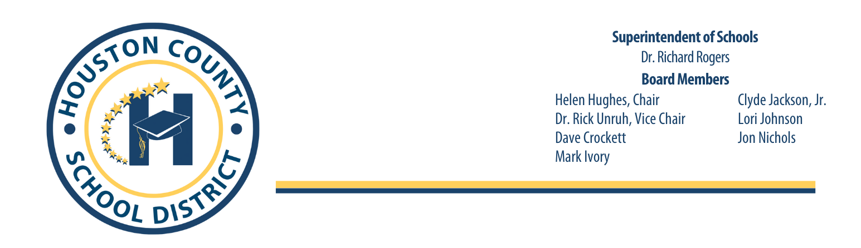

July 30, 2025
Right to Know Professional Qualifications of Teachers and Paraprofessionals

Dear Parent(s) or Legal Guardian(s),

In compliance with the requirements of the Every Students Succeeds Act, the Houston County School System would like to inform you that you may request information about the professional qualifications of your student’s teacher(s) and/ or paraprofessional(s). The following information may be requested:

• Whether the student’s teacher—
- has met State qualification and licensing criteria for the grade levels and subject areas in which the teacher provides instruction;
- is teaching under emergency or other provisional status through which State qualification or licensing criteria have been waived; and
- is teaching in the field of discipline of the certification of the teacher.

• Whether the child is provided services by paraprofessionals and, if so, their qualifications.

If you wish to request information concerning your child’s teacher’s and/ or paraprofessional’s qualifications, please contact your child’s school or you may contact Dana Morris, Director of Federal Programs, at the Houston County Board of Education at (478) 988-6200 ext. 3449 or at email dana.h.morris@hcbe.net.

Thank you for your interest and involvement in your child’s education.

Sincerely,
Dana Morris, Director of Federal Programs
Copyright Piracy Awareness Notification

Title I, Part A, Section 1116 of the Every Student Succeeds Act (ESSA) states that Title I schools shall provide information and resources to help parents and families work with their children to understand the harms of copyright piracy. In keeping with this requirement, definitions of relevant terms as well as links to websites that may be helpful in educating children concerning copyright piracy regulations are included below.

Copyright-a form of protection given to creators and authors of literary, dramatic, musical and artistic works. A copyright means that the author has the right to do or let other do any of the following things:
- Make copies
- Distribute copies
- Perform work publicly
- Display work publicly
- Make modifications or adaptations
Generally, it is illegal for anyone to do any of the things listed above without the creator’s permission. However, there are some exceptions and limitations to this right. One major limitation is the Doctrine of Fair Use.

Copyright Piracy-Unauthorized reproduction for sale or use of a copyrighted work such as a book, lyric or software.

Online Resources:
https://www.commonsensemedia.org/videos/teaching-kids-about-copyright-piracy
http://www.copyrightkids.org/

If additional assistance or more information is needed, the media specialist at your child’s school can help.
Title I Complaint Procedures

Although the below steps are recommended for the most efficient resolution at the lowest level, the parent/student has the right to by-pass these steps at any time and request an impartial due process hearing related to decisions or actions regarding your child’s identification, evaluation, educational program or placement. The parent and the student may take part in the hearing and have an attorney represent you at your own expense. The impartial Hearing Officer will be selected by the district. Hearing requests must be made to the Title Coordinator identified in Step II below.

Step I
The complaint shall be presented orally or in writing to the school principal within ten (10) calendar days after the most recent incident upon which the complaint is based. Any witness or other evidence should be provided at this time. The administrator will conduct an investigation and render a written decision within ten (10) calendar days of the filing of the complaint.

Step II
A complainant dissatisfied with the decision of the school principal may appeal to the System Title I/Title II Coordinator by submitting a written statement of complaint to the System Title I/Title II Coordinator. This statement must be filed within ten (10) calendar days after the complainant receives the decision from the school principal. The complaint should be mailed to:

Mrs. Dana Morris, Federal Programs Director
Houston County Board of Education
Post Office Box 1850
Perry, GA 31069
Phone: (478) 988-6200
dana.h.morris@hcbe.net

Upon receipt of the written statement, the Title I/Title II Coordinator will schedule a meeting to attempt resolution of the concerns. The System Title I/Title II Coordinator will render a written decision within ten (10) calendar days after the meeting.

Step III
A complainant dissatisfied with the decision of the System Title I/Title II Coordinator may appeal to the Houston County Board of Education by filing a written request to the Office of the Superintendent. The complaint should be mailed to:

Dr. Richard Rogers
Office of the Superintendent
Houston County Board of Education
Post Office Box 1850
Perry, GA 31069

The appeal must be filed within ten (10) calendar days after the complainant receives the decision from the System Title I/Title II Coordinator. The Board of Education will act on the complaint at the next scheduled BOE meeting.

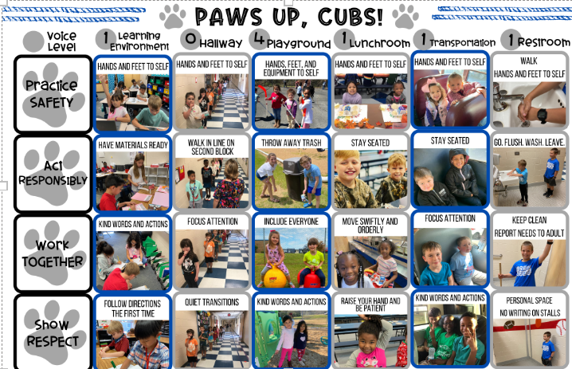
PBIS
Definition of PBIS
What is PBIS?
The Positive Behavior Interventions and Support program is based upon the idea of recognizing positive contributions of students. Our goal is to help each child develop self-discipline. Home and school share the responsibility for developing good citizens. Parents, teachers, and students must work together to maintain a safe learning and positive learning environment. As part of PBIS, teachers, administrators, counselors and support staff will have responsibility to TEACH positive behavior expectations to students. PBIS means students will know exactly what is expected of them. Students who take responsibility will be recognized and rewarded in a variety of ways.
What is PBIS at Quail Run Elementary School?
Quail Run Elementary’s School-Wide Expectations for students are:

Our school’s PBIS Mission
The mission of the Quail Run Elementary’s PBIS team is to foster and promote a safe and positive school environment that enhances student learning through teaching and recognizing positive behavior.

Title I Handbook Acknowledgement Form
Quail Run Elementary School
Dear Families and Students,
For the 2025-2026 school year, our Title I Handbook is available for your viewing on our school website at https://qres.hcbe.net
under the Parents & Students tab/Title I Family Engagement.
The purpose of the Title I Handbook is to provide our families with detailed information regarding what it means to be a part of a Title I school. The handbook is also a critical component in helping to build a strong relationship between home and school. The documents included in the handbook are the Parent’s Guide to Title I, The Connection(Family Engagement Plan and Grade Level Compact), Right to Know Teacher and Paraprofessional Qualifications, Copyright Piracy Awareness and Complaint Procedure.
If you prefer a printed copy of the handbook, please indicate in the space provided and we will gladly provide one for you.
To be completed by school personnel only
Hard copy of Title I Handbook given to _____________________________________________________________________
Student Name

Date_____________________________________ By: ________________________________________________________
School Personnel

Additionally, we ask that you sign and date acknowledging access and agreement to the School-Family Compact then return the form to your child’s school.
Please choose one of the following options:
_______ I will access the Title I Handbook on the school’s webpage. I do not wish to receive a printed copy.
_______ I would like to receive a printed, hard copy of the Title I Handbook. Please send one home with my child.
School-Parent Compact Signatures:
School Representative Signature: __________________________________________________ Date: _________________________________________________________________________

Parent/Guardian Signature: ________________________________________________________ Date: __________________________________________________________________________

Student Name (print): _____________________________________________________________
Date: ____________________________________________ Grade:_________________________

