Family & Consumer Science Pathways  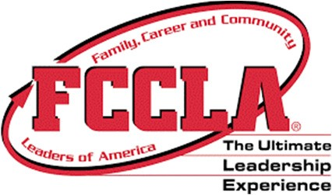 |  | eBusiness & Computer Science Pathways  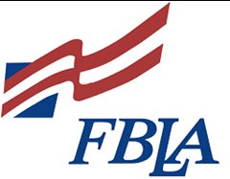 | Agriculture Pathways  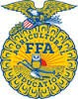
Nutrition & Food Science Pathway |  | Computer Science Pathway | Agriculture Mechanics Pathway
Culinary practices and principals with an emphasis on making healthy food and lifestyle choices. Participate in cooking labs and projects during class while engaging in leadership development through FCCLA co-curricular activities.  Courses  - Food, Nutrition, and Wellness  - Food for Life*  - Food Science* |  | In the computer science pathway, students will learn a variety  of computer skills such as graphic design, animation,  hardware, programming, game design, and robotics. You can  earn college credit. *This pathway can count as a 4th science  credit or foreign language.  Courses:  - Introduction to Software Technology  (formerly Introduction to Digital Tech)  - Computer Science Principles*  - AP Computer Science* | In the Agriculture pathways, students will have the opportunity to learn the fundamentals of agriculture. They will be able to choose to specialize in either mechanics, animals, or plants after the first course.  Courses:  - Basic Agriculture Science  - Agricultural Mechanics I  - Agricultural Mechanics II  CTAE+ eligible program
Early Childhood Education Pathway |  | Graphic Design Pathway | Animal Systems Pathway
Early Childhood Education (ECE) are project-based courses where you study children and how they develop including parenting, discipline, and child directed play. Leadership development activities with FCCLA will provide students with a competitive edge for entry into the marketplace and/or a post-secondary institution.  Courses:  - Early Childhood Education I  - Early Childhood Education II  - Early Childhood Education III |  | In Graphic Design, students will plan, utilize, and create visual  Solutions to communications problems. They find the most effective way to get messages across in print, electronic, and film media using a variety of methods such as color, type, illustrations, photography, animation, and various print and layout techniques.  Courses:  - Introduction to Graphics and Design  - Graphic Design and Production  - Advanced Graphic Design | Courses:  - Basic Agriculture Science  - Animal Science and Biotechnology*  - Agricultural Animal Production and Management
 |  |  | Plant Systems Pathway
Courses:
- Basic Agriculture Science
- General Horticulture & Plant Science*
- Nursery and Landscape
Foreign Language & Fine Arts Pathways   |  | Houston College & Career Academy  The starred courses are dual enrolled with Central Georgia Technical College | ROTC Pathway  
Foreign Language | Fine Arts | - Aircraft Structural Technology*  - Audio/Video  - Automotive Technology*  - Barbering*/Cosmetology*  - Computer Software Engineering (offered through MGSU)  - Criminal Justice*  - Cybersecurity  - Culinary Arts*  - Education/Teaching as a Profession  - Emergency Medical Responder*  - Engineering*  - Fine Furniture and Cabinet Making  - Healthcare Science and Nursing Aid Essentials*  - HVAC*  - Industrial Systems*  - Information Technology*  - Welding* | In Air Force JROTC, students will learn and develop leadership and life skills to prepare them for their future endeavors. Three years of JROTC will fulfill the personal fitness/health graduation requirement.  Courses:  - Aviation History  - Flight Science *  - Exploration of Space  - Aerospace Science: Corps Management  *Can count as a fourth-year science credit
- Spanish  - French  - Latin  *Students must have three years of the same foreign language to be a pathway completer. | - Art  - Theatre  - Chorus  - Band  *Students must have three years in the same fine art concentration to be a pathway completer.

