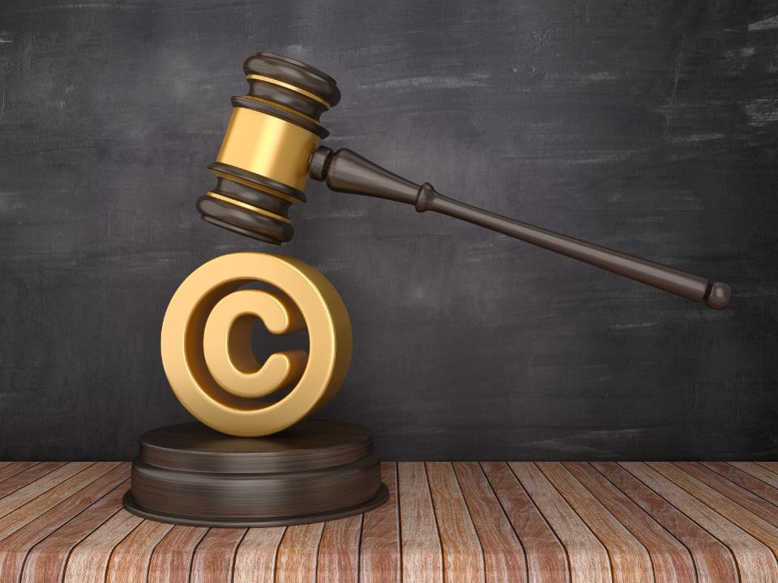

Understanding Copyright, Public Domain, and Fair Use:

https://www.youtube.com/watch?v=XzzkSZ0Jrko

