
St. Edward School
Fr. Todd Petersen, Pastor * Jaci Garvey, Principal
210 W. 4th Street * Minneota, Minnesota 56264
Phone:(507) 872-6391 * Fax: (507) 872-5263
Email: jgarveysteds@hotmail.com
Website: www.stedscatholicschool.com

November 4, 2021

Last week we held our annual Saint’s Day Costume Contest and we had a great turnout. Our 1st place winner overall was Bryce Gorecki and 2nd place went to Sarah Gruenes. Thanks to everyone who helped make this event a success.

Please consider joining our Sunday FIRE activities each and every Sunday after Mass. This week’s adult conversation will be Catechesis of the Good Shepherd for adults! Come join us for is food, fellowship and childcare.

The youth choir will also be singing this Sunday at the 8:30 am Mass. All children 4th grade and up are welcome to join. They will be practicing for their next Mass after Mass.

Our next school Mass is Wednesday, November 10th at 10:30 am. The 7/8th grade will be leading us.

We will be having our Veteran’s Day Program on Thursday, November 11th at 10:30 am in the gym. All are welcome to attend.

The Knights of Columbus will be hosting a French Toast breakfast on Sunday, Nov. 21st from 9 am – noon in support of St. Edward School.

Get your St. Edward apparel soon. Go to: https://stedwardapparel2021.itemorder.com/sale

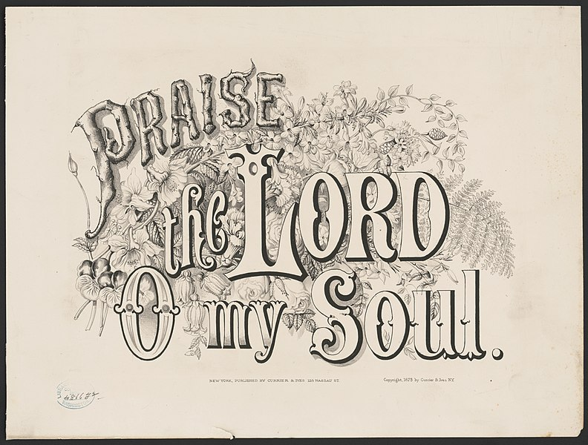
The Flurry of committee is currently seeking and accepting donations for the silent and live auction. Donations can consist of cash, gift certificates or any other items. If you would like to donate the items the committee would be happy to put the baskets together for you.
If you have any suggestions for auction items or contact information for individuals or businesses who would be willing to donate we would be happy to reach out to them. We are always looking for new and improved items for the auctions. If you have any questions, please feel free to contact our Committee: Julie Pohlen 828-7392; Nikki Traen 828-2912; Chassidy DeRoode 530-1835; Laura Hennen 828-0510; Colleen Ludwikowski 401-0044.
May God Bless,
Mrs. Garvey

.

