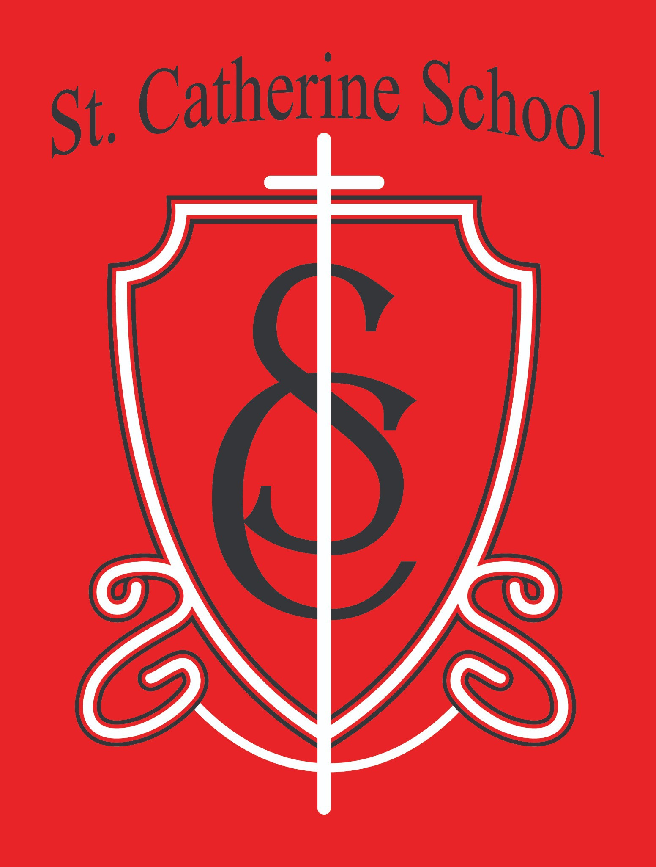

St. Catherine School Weekly Newsletter (Week of October 6-10)
https://www.stcatherine.k12.nd.us/parents

Principal's Message
Dear St. Catherine Families,
A big thank you to Mrs. Gulmon and Mrs. Kjelland for serving as our long-term substitutes while Ms. Busch completed the high school portion of her student teaching these past six weeks. Their generosity and steady presence have been a blessing.
I’m often reminded—especially when I visit with school leaders across the state—how fortunate we are at St. Catherine. Many schools struggle with staffing; we are blessed with a strong culture and family atmosphere that draws people to serve. Thank you for making our staff feel supported and for partnering with us in educating the students of St. Catherine School.

Reminders

Fall Auction Kickoff Breakfast – Volunteers Needed (Sunday, November 2)
Church basement • Free-will offering • Open to all
Serving time: 9:00 AM–12:00 PM
Volunteer shifts (6 volunteers/shift): 8:30–10:30 AM and 10:30 AM–12:30 PM

Chair family: The Kennedy Family

Goal: $3,500
To help, email Mr. Lee or Mrs. Kennedy at janessa.kennedy@k12.nd.us.

Fall Auction – Friday, November 7 at the Valley City Eagles Club
This event typically raises over $100,000 to support teacher salary assistance, operations, student devices and networking, security upgrades, our new reading curriculum/resources, Chess Club, Catholic Schools Week, and more.
Thanks to your support, we keep tuition among the lowest in the Fargo Diocese (2nd most affordable among schools that charge tuition). Please make plans to attend!

No School – Thursday & Friday, October 16–17
Thu, Oct 16: Fargo Diocese In-Service (no school for students)
Fri, Oct 17: Parent/Teacher Comp Day (no school for students)

Parent/Teacher Conference Thank You
Thank you to all the parents who attended Parent/Teacher Conferences—we had 100% participation (in person or via alternate times). Your partnership means the world.

Book Fair Thank You
A portion of sales supports our school and classroom libraries. Special thanks to families who purchased from teacher wish lists—you directly boosted student reading options.

Weather and Dress Code Reminder
With cooler temperatures, remember that after October 1, shorts are not permitted per the handbook. Please send students dressed for outdoor recess.

Support the School – Did You Know?
Clip Our Family labels and drop them at the church or school office. Every label helps. Thank you to the Catholic Daughters for trimming and organizing labels.

Little Saints Childcare – Fall Enrollment Special (October Only)
We’re running a Fall Savings Special: Enroll during October and receive your first two weeks of care free.
All classrooms downstairs are now open, and we currently have room in all age groups.
Please help us welcome Ms. Taryn Brown, our new Lead Infant Teacher. She’s a mom with years of coaching/education experience—exactly the heart and skill set we value. Thank you, Ms. Brown, for answering the call!
If you (or a friend) are exploring childcare, reach out to the office to learn more or schedule a visit.

St. Catherine Spotlight
Mrs. Gulmon and Mrs. Kjelland for outstanding service as long-term substitutes. All Book Fair supporters filling our shelves with great reads.

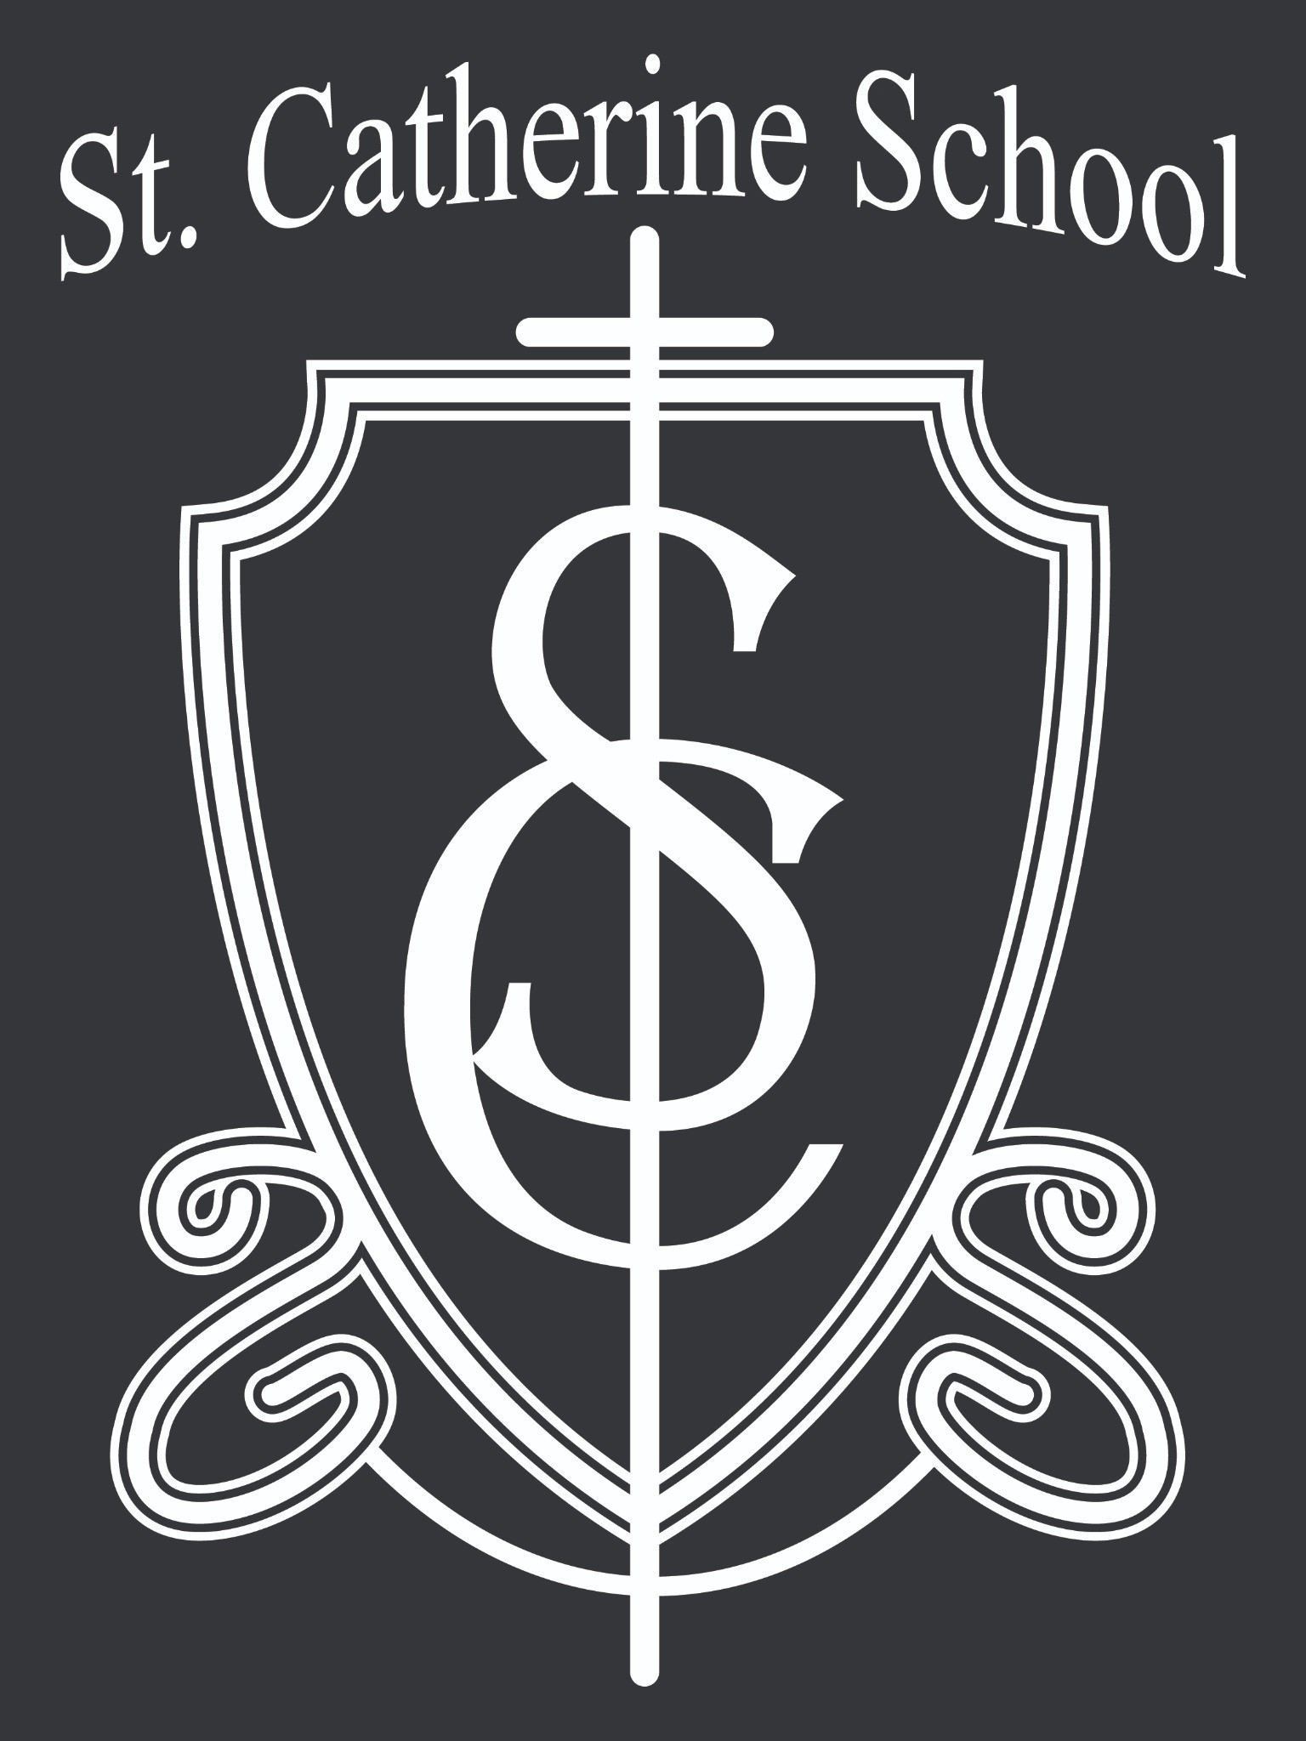
Our families for 100% conference participation—thank you!
Stay Connected with St. Catherine School
📍 Address: 540 3rd Ave. NE, Valley City, ND 58072
Email: nicholas.lee1@k12.nd.us
📧
Phone: 1-701-845-1453
📞
Website: www.stcatherine.k12.nd.us
🌐
📘 Follow Us on Facebook: St. Catherine School on Facebook

“Inspiring excellence through faith, learning, and service.”

