4566 Ed George Road ● Semmes, Alabama 36575 ● (251) 221-2344

Dear Parents:

In accordance with the MCPSS cell phone policy, we will be making Semmes Middle School a phone-free space to improve teaching and learning using a system called Yondr. Yondr has been implemented in over 2,000 schools across 21 countries to facilitate an engaged learning environment.

We believe that phones have great utility. We have also found that learning and social behavior improve drastically when students are fully engaged with their teachers and classmates.

The Yondr Program utilizes a simple, secure pouch that stores a phone, Apple Watch, and Airpods. Every student will secure their phone, Apple Watch, and Airpods in a personally assigned Yondr pouch when they arrive at school. Students will maintain possession of their phones/Apple Watch/Airpods and will not use them until their pouches are opened at the end of the school day. Students are required to bring their Yondr pouch to and from school each day and are responsible for their pouch at all times.

We received responses to our annual surveys from over 1,200 school partners, and after implementing the Yondr Education Program:

- 84% saw a change in student engagement
- 72% saw a positive change in student behavior
- 68% saw a positive change in academic performance

Of our most recent impact survey of over 370 of our school partners:
- 86% saw a positive impact in student safety and wellness

If you have any questions, please contact the school directly at 251-221-2344, or email
Mrs. Holbrook (sholbrook@mcpss.com).

If there is an emergency and you would like to get in contact with your child, please reach out to
Mrs. Kirkland or Mrs. Boles in the front office at 251-221-2344.

In an effort to best serve your child, we appreciate your full support in adoption of the Yondr Program at our school.

Thank you,

Stacey Holbrook
Principal
Semmes Middle School

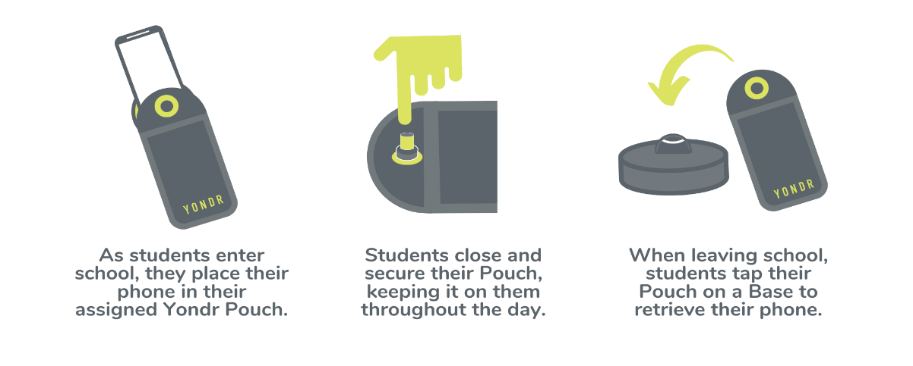
How Yondr Works

Frequently Asked Questions
What if I want to reach my child during the school day?
We want our students to be engaged in their learning. If you need to contact your child during the school day, contact the main office at 251-221-2344.

What if there is a school emergency?
In case of a school emergency, we direct our students to safety first, following our school emergency preparedness protocol.

Will my student’s phone be safe?
Students are in possession of their phone - in their Yondr pouch - for the entire school day. We will advise students to store the pouch in their backpacks where it is completely safe.

What if the Yondr pouch gets damaged or a student is caught on their phone?
The Yondr pouch is the property of Semmes Middle School. If a student damages their Pouch the parent is responsible for replacing it at a $30 charge. If a student is caught with a phone not in their Yondr pouch, Administration will collect the phone and the student could be suspended from school.

● The Parent could be required to come to the school and pick up their child’s phone
● AND/OR Consequences will include Out-of-School Suspension

Note: Damage consists of any signs that the physical integrity of the pouch has been compromised, whether intentional or unintentional, as determined by the school or Yondr staff.

Examples of damage:
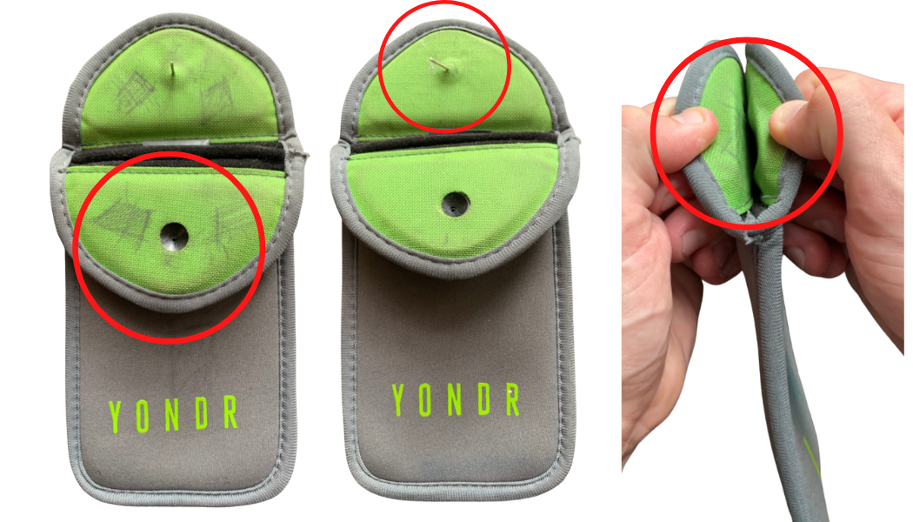 | - Ripped  - Cut  - Torn  - Pen/pencil marks  - Bent/cut pin  - Signs of force to black button on flap

STUDENT PHONE PROCEDURE & GUIDELINES

Phones, smart watches, and air pods are not to be used during school. Every student is assigned a personal Yondr Pouch. While the Yondr Pouch is considered school property, it is each student’s responsibility to bring their pouch with them to school every day and keep it in good working condition.

DAILY PROCESS

As students arrive to school, they will:
- Turn their phone off.
- Place their phone, air pods, and smart watch inside their pouch and secure it BEFORE entering the building.
- Store their pouch in their backpack for the day.

At the end of the day, students will open their pouch, remove their phone, and place back in their backpack. Students must bring their pouch to school with them each day.

*Students arriving late or leaving early will pouch/unpouch their phones in the Main Office.

VIOLATIONS

Pouch Damage / Lost Pouch / Using Phone During School
If a student damages their Yondr pouch or is caught with a phone, air pods, or smart watch, administration will collect the devices/pouch and a parent could be required to pick up the device(s) by 3:00 PM. Students could be suspended if caught with their phone, air pods, or smart watch while on campus during school hours not in a Yondr pouch.
A $30 replacement fee will be charged for lost or damaged pouches. *Student will not be allowed to bring cell phone/Airpods/Apple Watch on campus until a replacement pouch is purchased.

Forgotten Pouch
If a student forgets their Pouch they will need to notify admin immediately, their phone will be collected, and administrators will call home to remind the parent of the policy. The phone will be returned to the student at dismissal.

If a student consistently forgets their Pouch, it is considered Lost.
Refer to the Lost Pouch policy above.

I have discussed the consequences of cell phone usage at school with my child and both my child and I understand the cell phone procedure of Semmes Middle School.

Parent’s Signature: _____________________________________ Date: ________________________

Student’s Name (PRINT): _____________________________________________________________

Enrichment teacher: ______________________________ Pouch #: ___________________________

