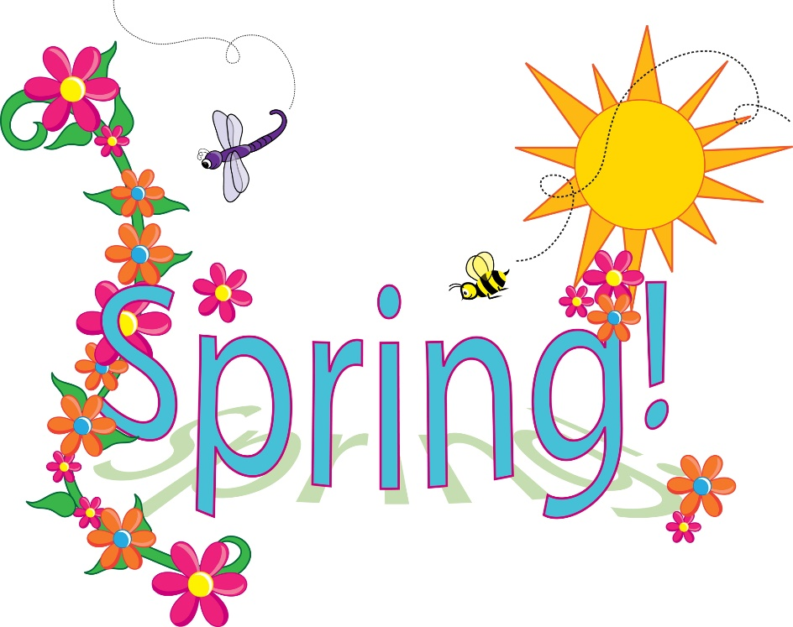
Class News
Mrs. Williams’ Second Grade
March 27, 2023

Reading Skills: helping verbs, main idea/details, syllable patterns

Language: prefixes

Spelling: suffixes –er, -est

Math: fractions

Science/Social Studies: begin plant functions

Upcoming Events:
Report cards go home on Monday, March 27

