Make it Happen-2016
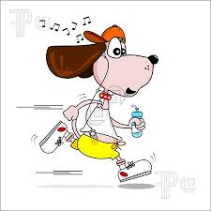
Healthful Lifestyle Contract
We are committed to healthy eating, exercising, getting
enough rest, and many other healthy life style choices.

{Please have each family member sign below and return to school}

Name of oldest student participating:______________________ Homeroom Teacher/Grade:______________________

