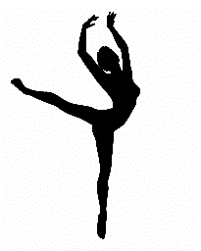Semmes Middle School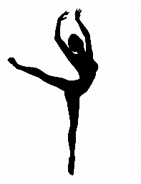
Golden Girls
Dance Tryout Packet 2022-2023

Dear Parents/ Guardians and Dance Team Candidates,
Your child has expressed an interest in becoming a member of the Semmes Middle School “Golden Girls” Dance Team for 2022-2023. This information packet should answer most of your questions. You will find a schedule of clinic dates and tryouts below. If selected, your child must assume specific personal and financial responsibilities and obligations to qualify and remain a good standing member.
Enclosed is a copy of the dance constitution for Semmes Middle School. This constitution is based on system-wide rules required by the Mobile County School Board. Please read it carefully with your child before signing the parental permission form. Attached are necessary documents that must be completed and returned before a candidate can participate in clinic days or tryouts. Please note that there are forms that a notary must notarize, and a Physician must complete a physical. All documents are due completed by Thursday, February 10, 2022, by the end of homeroom with a $30 check (or cash) made payable to Semmes Middle School to cover the insurance fee and to cover the judges’ cost. If you write a check, two telephone numbers and a driver’s license number must be printed on the front. Mrs. Miller and I, Mrs. Kohn, will accept Dance Team Tryout Packages after this date for ANY REASON.
Feel free to email Mrs. Kohn (Head Coach) or Mrs. Miller (Assistant Coach) if you have any questions or concerns at tkohn@mcpss.com or hlmiller@mcpss.com.

Sincerely,
The Dance Team Coaches
Mrs. Kohn and Mrs. Miller
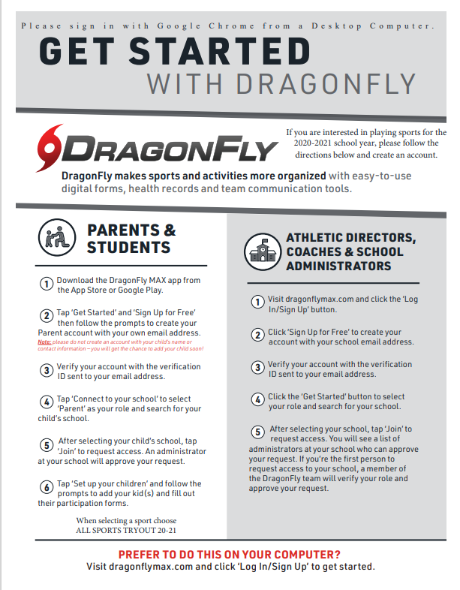

Clinics Tryout Schedule
The dance clinic will be held in the gym until 5:00 pm, as indicated below. Each participant should be appropriately dressed, in black/navy leggings or black/navy shorts (appropriate length), a plain white shirt, and jazz/tennis shoes, with her hair, pulled back in a high pony. The clinic will begin at 3:30 pm sharp, and candidates must attend the clinic every day to be eligible for tryouts. No snacks or cell phones will be allowed during tryouts.
Clinic and tryouts will be closed to the public. Neither friends nor family members are allowed in the school building while these events are taking place. If this rule is not followed for any reason, the candidate in violation will be sent home and not be allowed to continue with the clinic or tryouts.
Clinic Dates: February 22, 2021, February 23, 2021, and February 24, 2020
3:00-5:00 P.M.
Semmes Middle School Gymnasium
CLINIC IS CLOSED

Tryouts: Friday, February 25, 2022
3:00- Until
Semmes Middle School Gymnasium
** All girls should report to the gym**
TRYOUTS ARE CLOSED

Tryout Fee: $30.00- (this covers the cost of judges, choreographers, and
insurance). If paying with a check, please include two telephone numbers and driver’s numbers on the
front (Cash or check made to SMS).

Judged on Group Dance - (taught at the clinic)
the following: Individual Dance- (Girls will need to provide music for their dance)
Right and Left Leap
Left, Right, and Middle Split
Shanae
Leap in second
High Kick Combos

Clinic and Navy or Black shorts, T-shirt, and dance shoes and/or tennis shoes.
Tryout Hair must be in a ponytail.
Attire: ABSOLUTELY NO JEWELRY!!!
NO CELL PHONES DURING CLINIC OR TRYOUTS!

Semmes Middle School
Dance Candidate Information
Parent Section
Please, check that each form is completed. A parent needs to initial each line below before the candidate turns the packet in. It will be helpful if the Dance Try-out packets are in this order. Incomplete Dance Try-out packets will not be accepted.
_____________ Dance Candidate Information Form
_____________Signed parental permission/candidate pledge Form
_____________Financial Obligations Form
_____________Verification of insurance/waiver of
liability
_____________*Notarized medical release Form Health
_____________Completed physical form from a physician
_____________ AHSAA Concussion form 22-23
_____________ MCPSS Covid-19 form 22-23
_____________ MCPSS Consent and Insurance form
_____________Signed Participant Agreement, Consent, Release, And
Venue
_____________ Character Reference Sheet
_____________ Attach $30.00 fee (cash or check). Checks are to include two (2) phone numbers and a Driver’s License Number.

Semmes Middle School
PARENTAL PERMISSION FORM
PARENTAL PERMISSION TO BE A DANCER
I, the undersigned, have read and fully understand the rules and regulations, which will govern my daughter if she is chosen to represent Semmes Middle School as a Dancer. I further understand that this is an extracurricular activity and that attendance at all games, practices, fundraisers, and special events is a requirement of the elected Dance Team.
I hereby give my daughter consent to try out for the Dance Team at Semmes Middle School, and I recognize her responsibilities and requirements as a leader of her school. In addition, I realize that additional extracurricular activities cannot conflict with dance team scheduled practices or events (i.e., volleyball, basketball, soccer, cheer/dance studios, or competitive gymnastic teams).
I have read the Semmes Middle School Dance Team Constitution and understand that my child is bound by all the rules and regulations within it. I understand that if chosen, my daughter will be required to pay for uniform pieces, camp, and additional items. An estimate of these expenditures is $1,875. For those selected as the Dance Team Members, the first $500.00 payment will be due no later than March 14, 2022. All money is due before the first performance, and a payment schedule is listed on paper to follow. Dancers and parents will be required to be at all fundraisers sponsored by the dance team.
I understand that my signature on this form means that I will abide by and support the rules and regulations stated above and those stated in the dance team constitution.

Parent/Guardian Signature Date

DANCER CANDIDATE
I, the undersigned, have read and fully understand the rules and regulations, which will govern me if I am chosen to represent Semmes Middle School as a dancer. I have read the Semmes Middle School Dance Team Constitutions and am bound by all the rules and regulations within it. I further understand that this is an extracurricular activity and that attendance at all games, practices, fundraisers, and special events is a dancer’s requirement. I do recognize the importance of my parents’ responsibilities if I am chosen as a team member. I understand that I am responsible for raising or earning the money needed to be a good standing member. Primarily, I am willing to uphold this dance constitution and the privileges and responsibilities that come with being a Dance Team member at Semmes Middle School.

Dance Candidate Date

Semmes Middle School
Dance Candidate Financial Obligations
Financial Obligations
It is the parent and dancer’s responsibility to make sure all financial obligations are met on time. Uniforms, dance camp, attire for camp, warm-ups, shoes, bags, pom-poms, etc., are purchased by the parents. Throughout the year, other costs may develop (i.e., T-shirts, Big Sister/Little Sister gifts). A payment schedule is set and recorded below for all payments due. Dancers are expected to attend summer camp and are responsible for all fees associated with summer camp. The UDA Dance camp is planned for the Panama City Beach Camp, in Panama City Beach, from May 30, 2022, through June 2, 2022.
▪ Dancers must be current with their payment schedule. Not being current will result in missing dance events, camps, or games.
▪ Dancers who owe a balance on their account will not be eligible to try out for any other sport(s) until the amount is paid in full.
▪ Dance members are required to attend and participate in all fundraising.
▪ If a member is declared ineligible, injured, disciplined, dismissed, or resigns from the team, the member is still responsible for all fees. Refunds will not be issued.
▪ When fundraising takes place, monies are applied 60/40 accordingly to curb expenses and to pay Dance Team Coaches.
The following is a list of estimated expenses:
- Dance Camp $550
- Camp Attire $300
- New Uniform $400
- Dance Shoes $100
- Jazz Shoes $75
- Dance Bag $100
- Sweat suits $150
- Jacket $150
- Pom-poms (x2) $25 (x2)
- Choreographer $100

Balance: $1,975 Approximation
Payment Schedule for 2022-2023 Dance Team
Monday, March 14th- $500
Thursday, April 14th- $275
Thursday, May 12th-$275
Thursday, June 2nd -$275
Thursday, July 14th -$275
Thursday, August 11th - Remaining Balance Due (Last Payment Scheduled)

I am aware of my daughter’s financial obligation to be a part of the Semmes Middle School Dance Team. I understand that I will be allowed to raise funds through fundraising and that a payment schedule will be available. I understand that fundraising will help pay a stipend to the coach/sponsor due to middle school dance teams not being a recognized sport in Mobile County. I understand the coach/sponsor will be paid out of the dance account from fundraising monies, with this being the case. Monies raised above the coach(s)/sponsor(s) stipend, will be credited to each dancer that participated in them accordingly.

Parent/Guardian Signature Date

Semmes Middle School
Waiver of Liability Form
Dear Parents:
The following is for the mutual protection of your child and Semmes Middle School. Please fill in the desired information and return the form.
Please fill in the following.
1. Is your child covered by hospital insurance: Yes ______ No_______
2. List the name of your insurance company: _______________________________________________
3. Insurance policy and plan number: __________________
In case of injury to your child while participating in this sport, while practicing, or while being transported to and from games, whom do you wish to be contacted:

PARENT TELEPHONE: ___________________________________________________________________
FAMILY PHYSICIAN TELEPHONE: __________________________________________________________
STUDENT’S FULL NAME: _________________________________________________________________
WAIVER OF LIABILITY
I hereby certify that I have knowledge of my child’s physical condition and state of health, and I give my consent and permission for my child, as identified above, to participate in the active sports program of Semmes Middle School as conducted by the Athletic Department. I do certify that my child has no known physical defects, disease, or disability that will in any way jeopardize her health or physical condition if she is allowed to take an active part in this program. I further agree that I will not hold Semmes Middle School or its athletic staff responsible for injuries, accidents, or mishaps that may occur, my child while she is participating in any phase or aspect of this program or while she is being transported to or from practices, scheduled games, or other dance activities. In consideration of my child’s being permitted to participate in this program, I further agree to indemnify Semmes Middle School from all liability that might occur resulting from the injury to my child arising out of or in any way connected with this program.
SPORT: Dance Team
SIGNATURE: __________________________________________________________
DATE: _______________________ TELEPHONE #: ______________________

Semmes Middle School
Parent/Guardian Permission and Medical Release Form

I hereby give my consent for my child to represent her school in extracurricular activities. I also give my consent for her to accompany their unit, as a member, to other schools and activities. I also consent and authorize the school or its representative to obtain, through a physician of its choice, such medical attention as is necessary for the student’s welfare if she is injured or ill while in school activities. I understand that the school is not financially responsible for any injury that may occur.
______________________________________________________________________________
Signature of Parent/Guardian Date
______________________________________________________________________________
Signature of Parent/Guardian Date
Address: _______________________________________________________________________
Insurance Company: _______________________________________________________________________________
Policy Number: ______________________________________________________________________________
Notary: _______________________________________________________________________
My commission expires: __________________________________________________________
This form must be completed and on file with the Dance Sponsor before any student will be allowed to practice or try out for any unit.
This parental permission slip must be notarized for most hospitals or physicians to treat that student/dancer.

Semmes Middle School

Character Reference Sheet
Name: _________________________________________________________________ Grade: ___________________
- You must get 4 Teachers/Staff to complete a Character Reference Sheet for Dance Tryouts.

Teacher’s Name/ Signature | Comment/ Character Reference for Dance

- This form and fees are due by February 10th, to either Mrs. Kohn in room 518 or Mrs. Miller in room 609.

Semmes Middle School
Frequently Asked Questions
- Practices will be on Monday through Thursday from 2:30-4:00 pm unless other dates are more convenient for the coach. If a dancer does not attend practice, she will not be permitted to dance at the event to follow without permission given in advance.
- There is a possibility of Saturday practice. If needed, it will be scheduled a week in advance, and these will typically be due to an upcoming pep rally or special event.
- Extra practices, if needed, will be scheduled a week in advance and these will typically be due to an upcoming pep rally or special event.
- Girls will dance at every home football and basketball game. - Football games are usually on Thursdays, and basketball games are typically on Mondays and Thursdays.
o Again, we only dance for home games and those dates are not given until the season begins.
o The specific dates and times will be forwarded to the parent/dancer once the coach has been given this information.
- Girls will attend the Semmes Christmas Parade, Neptune’s Daughter Mardi Gras Parade, and other school-wide events that promote school spirit or community events we may be invited to participate in. Mark your calendars now as these events are mandatory to support our school and community.
Tryout Requirements
1. Membership of the team is open to incoming 6th, 7th, and 8th graders.
2. The sponsor and principal will determine the total number of squad members.
3. The squad shall dance for football, basketball, and any other teams that need our service. This will include school functions that may or may not relate to athletics.
4. Dancers must have a “C” average with no grade less than a “D”. This average is to be computed by utilizing the grades of the 2022-2023 school year. A dancer may not have an “E” on any report card for the 2022-2023 school year.
5. An applicant is ineligible to try out if there has been more than one office referral or a suspension during the 2021-2022 and 2022-2023 school year. An applicant will also be ineligible if she has been removed from a team for any reason during the 2020-2021 school year.
6. Students must submit the following documents by the deadline set by the coach:
a. Semmes Middle School Dancing Constitution
b. Parental Permission Form
c. Waiver of Liability Form
d. Physical Form
e. Notarized Medical Release Form
f. Clinic/Try-out Information
g. Any other form(s) deemed necessary by the sponsor or principal
7. Students must participate in every clinic to try out. Those with planned events on tryout date may have their mock tryout be their official judged tryout if approved by the dance sponsor/coach.
a. Tryouts will be conducted at the end of the clinic.
b. Tryouts will be judged by a panel of impartial, qualified individuals, who will use a score sheet to evaluate the contestants. Judges are selected by the sponsor/coach and are not announced. Judges are qualified and not affiliated with any local organization of the Semmes Community.
c. The principal and the sponsors will determine the number of dancers.
After the scores have been tallied, the 2022-2023 team will be selected and letters will be distributed to all candidates. This letter is to be opened off-campus and is not to be opened until off SMS campus.
d. Participants should come to tryouts in a white short-sleeve t-shirt, black/navy leggings/ shorts, with white socks and tennis shoes (or jazz shoes but please do not purchase jazz shoes just for tryouts) and hair pulled into a high ponytail.

