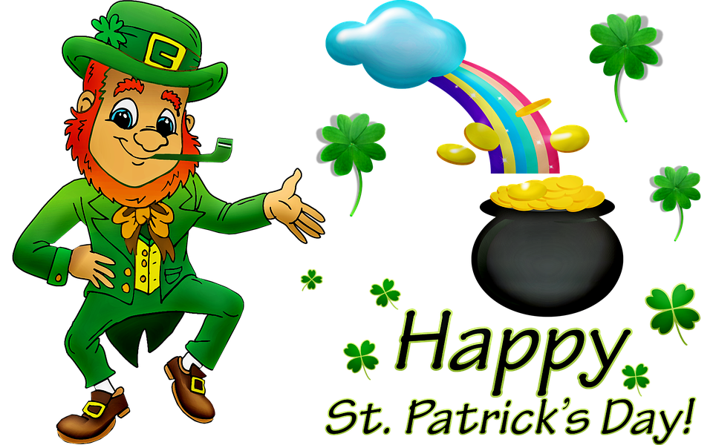
Class News
Mrs. Williams’ Second Grade
March 20, 2023
Reading Skills: summarize/restate, main idea/details, helping verbs

Language: poetry

Spelling: consonant digraphs gh/ph

Math: wrap up/test geometric shapes and symmetry

Science/Social Studies: wrap up/test unit on economics

Upcoming Events:

