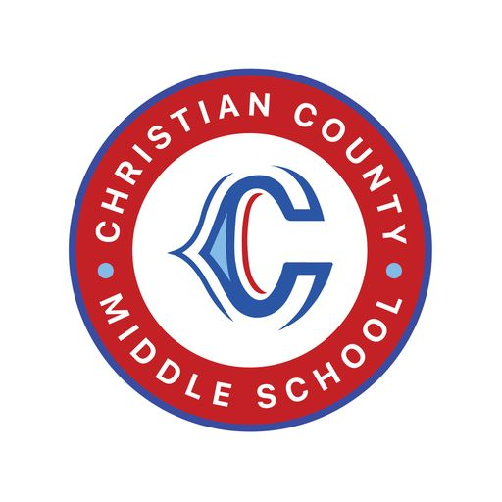

**Christian County Middle School**

**School-Parent Compact 2024-2025**

*Send any suggestions or revisions to* [*mari.owens@christian.kyschools.us*](mailto:mari.owens@christian.kyschools.us)

*Please sign digitally through Parent Square.*

| **Student**  As a student, it is important that I work to the best of my ability; therefore, I will:   * attend school regularly, including not checking out often. * be positive in my attitude and choices in and out of the classroom. * be accountable by being prepared for class with my supplies and work. * be willing to learn by participating in class every day. * ask for help or support when I need it. * show respect for myself, other people, and property at all times.   Student Signature: _________________________________________________ | **Teacher**  As your teachers, it is important that our students achieve success in all content areas; therefore, we will:   * respect you and your child at all times. * encourage and praise your child’s efforts. * communicate with you often through Parent Square, calls, messaging, and/or email. * maintain and update the gradebook weekly. * be flexible with parent conferences to discuss your child’s academic progress. * take the time to know your child and his or her individual needs. * maintain high standards concerning your child’s education and actively do what is needed to ensure that he or she grows academically.   Teacher Signatures: **All CCMS Teachers** |
| --- | --- |
| **Parent/Guardian**  As a parent/guardian, I want my child to succeed; therefore, I will encourage my child by doing the following:   * strive to see that my child attends school each day, is on time, and does not check out often. * talk to my student daily about his or her school day. * support CCMS staff in maintaining proper discipline, making sure my child has necessary materials, monitoring assignments on Canvas, communicating through Parent Square, and checking grades in Infinite Campus. * visit, call, or email my child’s school to conference with his or her teacher. * speak positively regarding school, teaching, and education.   .  Parent Signature: __________________________________________________ | **Principal**  As the CCMS principal, I will support parent involvement; therefore, I will:   * maintain high standards of professionalism for myself and my staff. * maintain an orderly and positive school environment. * foster and maintain high standards of academic achievement and behavior. * actively interact with students. * maintain ositive communication between parents, students, and staff. * develop resources and support for academic programs.   Principal’s Signature: _______________________________________________ |