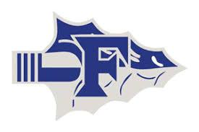

Frankston Powerlifting
2026 Schedule
DATE | MEET
Jan. 5 | @ Sabine (Girls)
Jan. 9 | @ White Oak (Boys)
Jan. 17 | @ Van (Boys)
Jan. 24 | @ White Oak (Girls)
Jan. 28 | @ Winona (Boys)
Feb. 11 | @ Winona (Girls LCQ)
Feb. 26 | @ Winona (Boys LCQ)
Feb. 28 | @ Rains (Girls Regionals)
TBA | @ Navasota (Boys Regionals)
TBA | @ Edinburgh (Girls State)
TBA | @Abilene (Boys State)
Head Coach: Kyle Kern Assistant Coaches: Nathan White, Kyle Dezern
Athletic Director: Paul Gould Principal: Edgar Rodriguez
Superintendent: Nikki Cook

