

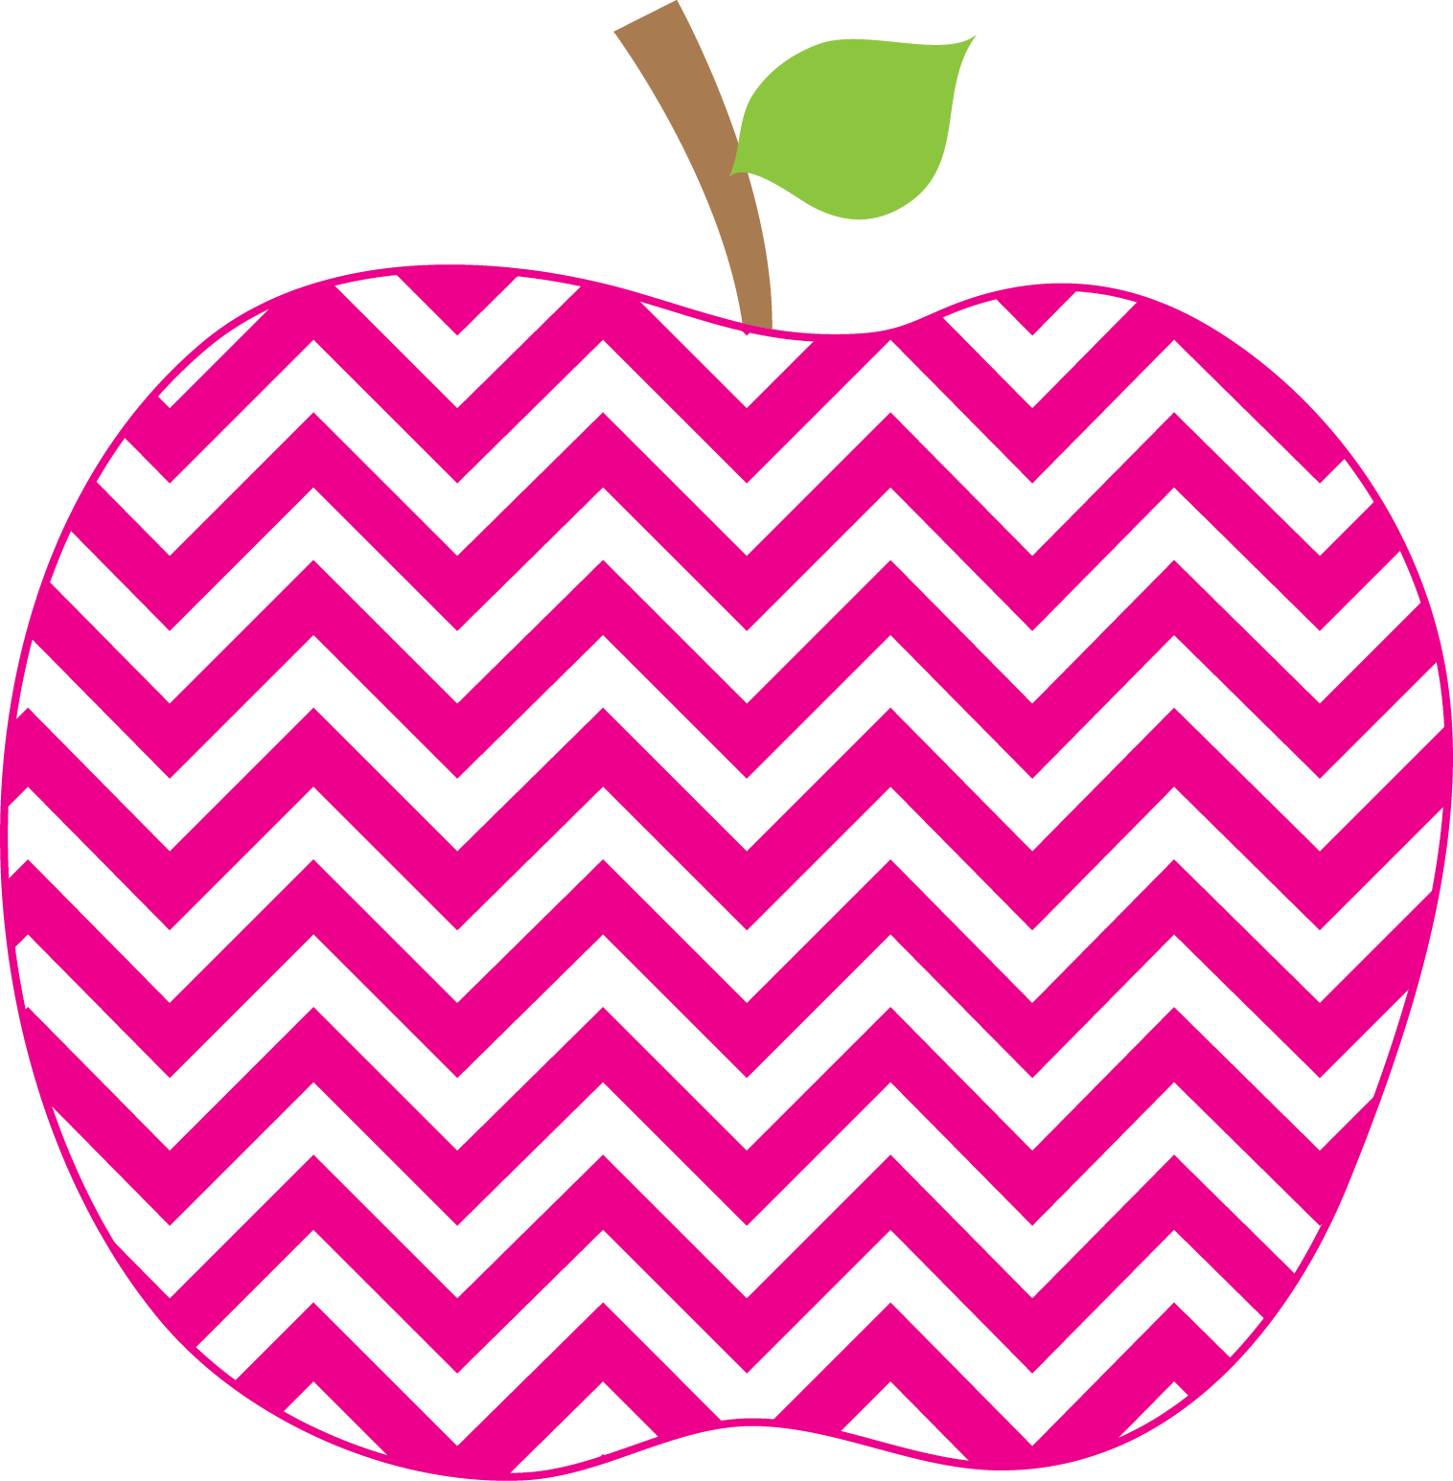



E. Robinson Weekly
Ms. E

August 18, 2025

Reading:
Phonics Skills:
*Consonant /s/ spelled s
* Consonant /m/ spelled m
* Vowel /a/ spelled a
* Consonant /t/ spelled t and tt
*Compare and Contrast
*Making Connections

High-Frequency Words:
can, on, am and
RED Words: see, me
Writing:
*Writing about Me
*Lowercase Letters l and t
*Writing from left to right, top to bottom

Math:
*Addition to 10

Social Studies/Science- All About Me Unit

This Week’s Focus:

Star Apple of the Week:
Each student will get an opportunity to be the Star Apple of the Week. You will find this information in the binder. We will begin this on September 2nd.

* Please check the APPLE Binder each day for homework and sign the daily behavior sheet located in the back.

Friday, August 29th Spirit Day
Special Snack

Friday, September 5th Grandparent’s
Picnic

Monday September 8th Open House

Reminders:
Important Reminders:

