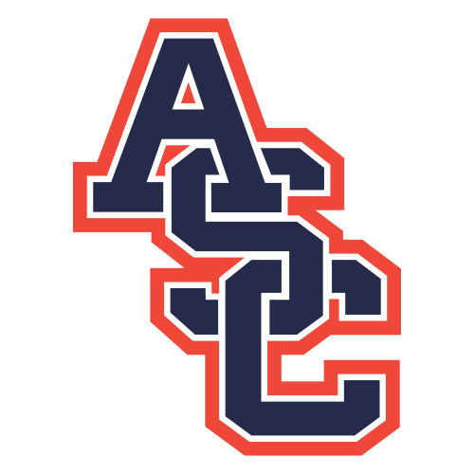
2026 ASC Junior High Football Schedule

Thursday, August 13 @ Copiah Jamboree TBA
Thursday, August 27 @ Columbia Academy 6:00 PM
Thursday. September 3 CHEF 6:00 PM
Thursday, September 10 Centreville Academy 6:00 PM
Thursday, September 17 @ Cathedral 6:00 PM
Thursday, September 24 Bowling Green 6:00 PM
Thursday, October 1 @ Silliman Institute 6:00 PM

Bold = District Contest

