2022-2023
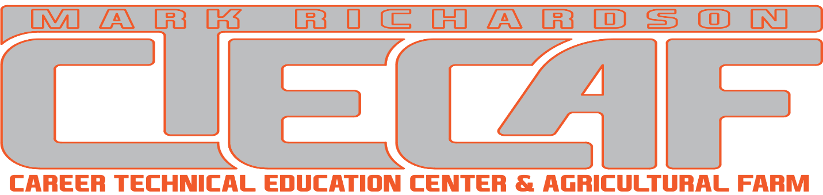

Santa Maria Joint Union High School District

Richardson Center
1280 Founders Avenue
Santa Maria, CA 93455
Office: 805.934.0330
Fax: 805.934.0338
This handbook shall serve as a supplement to the District and School Site handbook. All district rules and regulations apply at the Richardson Center. Academic and behavioral expectations, attendance, and grading policies set at the home schools will be enforced.

Contents

Section  - Hours of Operation  - Phone List  - Bell Schedules  - Bus Schedule  - Calendar  - Attendance  - Discipline  - Dress Code  - Campus Map | Page  3  4  5  6  7  8  8  9  10

Hours of Operation

Visitors/Parents

Gates are locked during school hours. Please call front office: 805-934-0330 ext 8702
to be admitted. Then proceed to office to sign in.

General Hours:

The Richardson Center is open Monday through Friday 8:00 -4:00 every school day.

Ag Barn and Animal Feeding:

Feeding times will be posted on barn entrance.
Holiday feeding times will vary. Please call advisor for verification of hours.

Animal Feeding must be conducted during normal feeding hours. If students need to feed after hours, they must be accompanied by their FFA advisor. Special Fair schedule hours will be published during March to July. These are subject to change.

AG Farm and SAE Projects:

Students on site for SAE projects are expected to follow all school & District rules. They are to conduct themselves professionally and be in communication with their SAE advisor. An SAE contract must be signed and on file.

Phone List

 | Staff | Phone
 | Main Office | 805.934.0330
 | Fax | 805.934.0338
Director | Dr. Paul Robinson | Ext: 8701
Director’s Assistant | Meredith Brough | Ext: 8702
Agricultural Farming | Steve Gambril | Ext: 8713
Construction | Glen Holmes | Ext: 8732
Culinary Classroom | Russell Thomas | Ext: 8712
Diesel /Heavy Engines | Eduardo Gonzales-Ramos | Ext: 8722
Machining | Dan Howard | Ext: 8734
Farm Technician | Erik Fulton | Ext: 8703
Farm Technician | Blake DeBernardi | Ext: 8704
Grounds/Custodial | Greg Gentile | 805.631.0591
Security | David Millard | Ext: 8705
DELTA HS | 805-937-6356
PIONEER VALLEY HS | 805-922-1305
RIGHETTI HS | 805-937-2051
SANTA MARIA HS | 805-925-2567
DISTRICT OFFICE | 805-922-4573

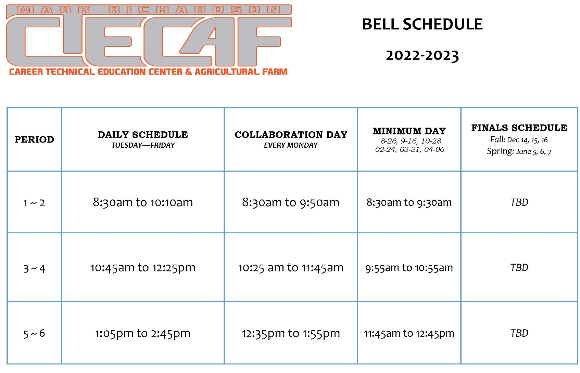

Bus Schedule
ALL STUDENTS ARE REQUIRED TO RIDE THE BUS
Buses will run as close as possible to the published schedule. However, the first several weeks of school are a period of adjustment. Routes will not run early but may occasionally run late until revisions are made.
General Safety Rules
Obey the instructions of the bus driver. At no time will a student act toward or address comments to a bus driver in a disrespectful manner or refuse to cooperate with the driver.

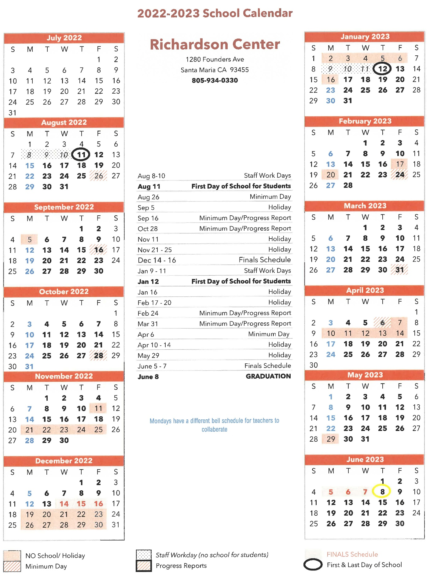
Calendar
Attendance

Absences:
Absences shall be reported to the home school (DELTA, ERHS, PVHS, or SMHS) per the home school’s normal absence reporting procedures.

Late Arrivals:
Students arriving late may be dropped off at the Richardson Center by parents or guardians and checked in at the office. The student’s late arrival will be reported to the home school by Richardson Center staff. If the gate is closed, call the main office at 805-934-0330 x 8702 to be let in.

Early Release:
Parents may choose to pick up their student at the Richardson Center in an emergency. Parents must check in at the Richardson Center office and check out their student after showing proper identification per District Policy. If parents arrive at the students’ home school, they will need to wait for transportation to bring student back at the regularly scheduled drop off time. (See Bus Schedule)

Discipline

All District and School Site Discipline policies will be enforced at the Center.

Any academic or behavior expectations that are not met will be referred to the students site Principal or designee for handling. Repeated violations may result in removal from Center programs.

No Food or Drinks are allowed in the shops or classrooms. All food must be consumed outside.

No food may be delivered to school site.

Each shop will have one restroom pass. One student may use the rest room at a time during class hours.

Dress Code
Shop Attire:
Safety in the shop is vital. Students enrolled in shop classes will wear shop appropriate clothing (e.g., closed toed shoes, gloves, safety glasses, etc.) as directed by the instructor and required by safety regulations. Career Tech programs may provide program specific uniforms and require they be worn on certain days.
General Dress Code:
The dress code complies with District and State policies and applies to all school activities. These policies require that student attire be neat, clean, and non-disruptive. Interpretation of this policy rests with the individual classroom instructor, site administrators, or any staff member while students are on campus.
Requirements apply to all students, as provided in the Education Code and/or District Policy. They are:
1. No attire including clothing, jewelry, hats, or personal items:
*may promote or advertise drugs, alcohol, or tobacco use.
*depict obscenity or lewdness.
*be inflammatory with regard to race, religion, or heritage.
*may promote gang affiliation.
2. Feet must be covered, minimally, providing protection to the bottom of the foot.
3. The upper torso must be covered. Clothes shall be sufficient to conceal undergarments at all times. See-through or fishnet fabrics, halter tops, spaghetti straps (must be two inches wide), off-the-shoulder or low-cut tops, bare midriffs, and skirts or shorts shorter than midthigh are prohibited.
4. Pajamas and slippers are not appropriate school apparel.
Students who are not in compliance with this dress code will:
- Be referred to a site Principal or designee.
- Have their parents contacted by the school.
- Not be permitted to return to class until the dress code infraction is corrected.
- Repeated non-compliance may result in on- or off -campus suspension.

Map

