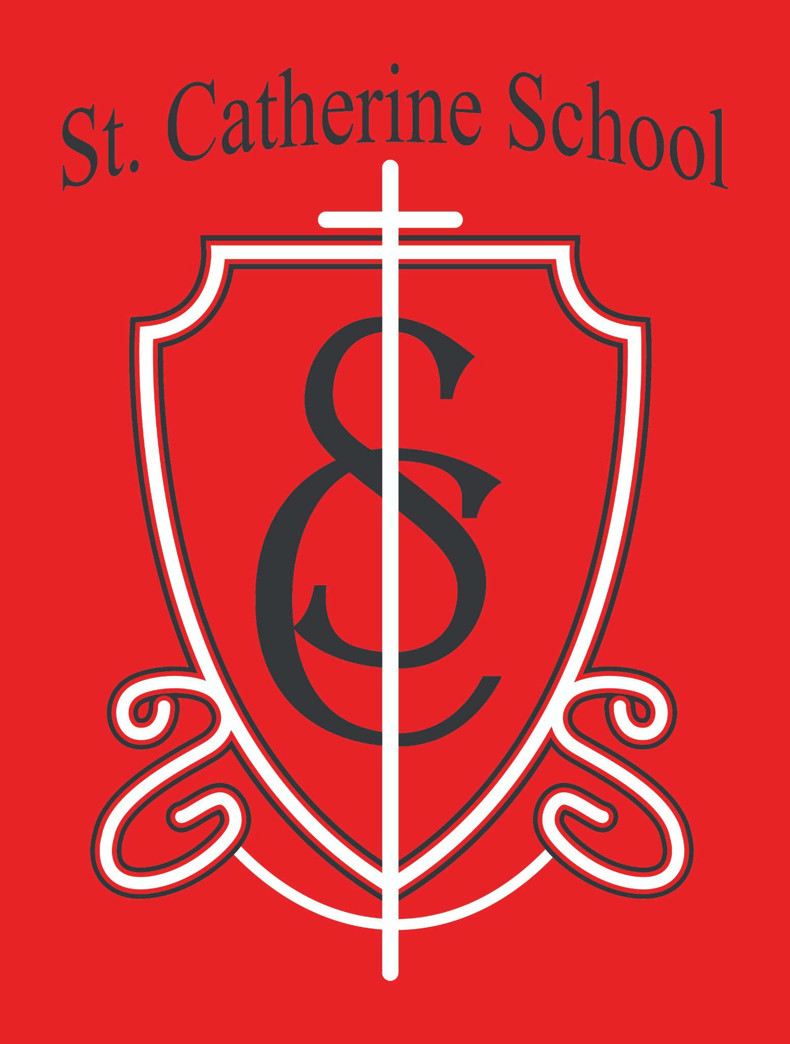

St. Catherine School Weekly Newsletter (Week of August 24-28)
https://www.stcatherine.k12.nd.us/parents

Principal's Message
Dear St. Catherine Families,
It has been wonderful to have our students back and to feel the energy of a new school year throughout the building!
Unfortunately, sickness is already spreading through our school. I left work Friday intending to finish this email at home, but I ended up feeling under the weather myself. Please help us keep everyone healthy by making sure your children get plenty of rest, practice good handwashing, and bring clean water bottles to school each day. At school, we will continue paying special attention to sanitizing high-touch areas throughout the building. My apologies for not getting this out on Friday!
Thank you for partnering with us as we care for one another and begin a healthy, happy school year together!

Reminders
Homecoming T-Shirt Orders: VCPS Homecoming 2026 T-shirt order forms went home with all students. Completed forms are due back to school tomorrow, September 1. In past years, local businesses have sometimes sponsored a special Hi- Liner Pride shirt for all Valley City students, including students at St. Catherine School and Circle of Friends. However, a sponsored shirt is not guaranteed, so please return

an order form if your child would like a Homecoming shirt. Order forms went home in take-home folders last week.
Reading Theme Kickoff: This Friday, we will kick off our reading theme for the year: “Reading is the Golden Ticket to a Great School Year!” As a special treat, students will watch the classic version of Willy Wonka and the Chocolate Factory Friday afternoon. Students may bring a pillow and blanket to school that day.

No School: School will be closed on Monday, September 7, in observance of Labor Day.
Picture Day: School pictures will be taken Tuesday, September 15.

All-School Mass and Guest Lunch: Our next All-School Mass will be Thursday, September 17, followed by Guest Lunch. We will share more information as the date approaches.

Birthday Invitations: As a reminder, you may distribute birthday invitations at school only when the entire classroom is invited. If the whole class is not being invited, please arrange to distribute invitations outside of school. This has always been our school policy and helps protect every child's feelings.


St. Catherine Spotlight
This week, we are shining the spotlight on:
Our fifth- and sixth-grade students as they begin band with Mr. Kjelland!
All the wonderful energy in our building as Little League settles into its new spaces!
Our amazing staff members, who continue to be flexible and willing to take on different tasks throughout the building. Their teamwork and positive attitudes are helping us begin the year strong!
Stay Connected with St. Catherine School
📍 Address: 540 3rd Ave. NE, Valley City, ND 58072
Email: nicholas.lee1@k12.nd.us
📧

Phone: 1-701-845-1453
📞
Website: www.stcatherine.k12.nd.us
🌐
📘 Follow Us on Facebook: St. Catherine School on Facebook

“Inspiring excellence through faith, learning, and service.”

