……

Mrs. Janes Newsletter
January 6th-10th, 2025

New

Reading:

- VCe and Consonant -le Syllabes
- Main Idea, Inferencing, Text Features, Author’s Purpose

Word Study
hope shape baseball mistake inside candle apple little table purple

High Freuency Words
answer brown country start then there wash went who your

Math
- Topic 5-Subtraction

Language:
- Proper Nouns
- Handwriting

Social Science:
- Scholastic News/Lady Liberty

this week’s focus

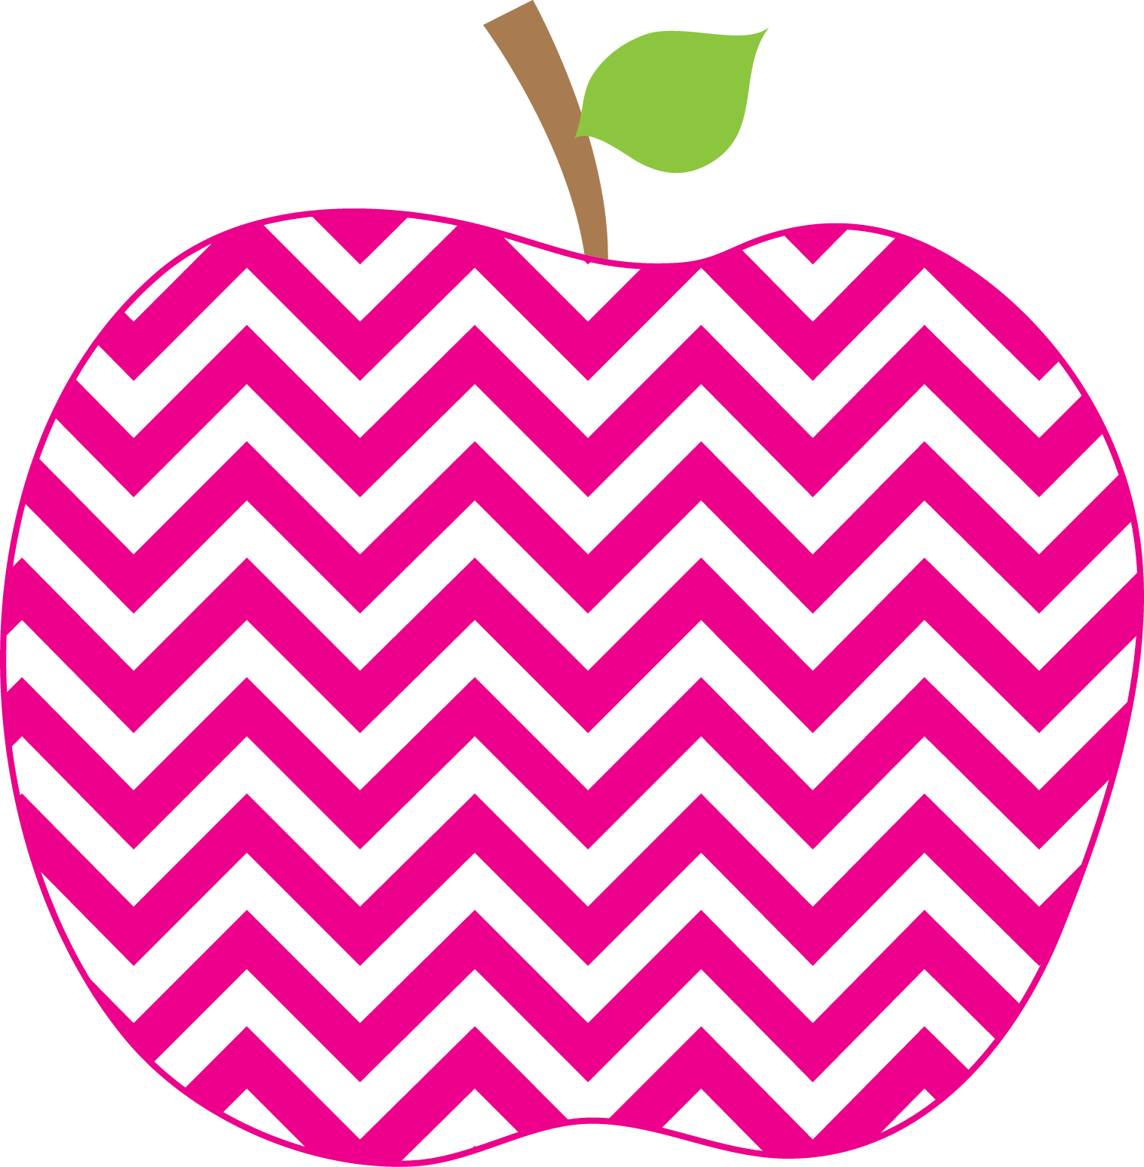


: (

Student of the Week
Josie

N/A
If you would like to send in student of the week treats for your child’s week, please send them in on Friday.
- PLEASE SEND EXACT CHANGE FOR SNACK. ($0.75 or $1.50) I do not have change to give back.
- PE 11:20-1205
- Lunch: 12:29-12:56
- Please label any money sent in (ex. Snack, field trip, etc.)
- Your child must wear tennis shoes or closed toe shoes to PE EVERYDAY!

Upcoming Events and Important Info
- January 9th-Report Cards
- January 20th-No School (MLK Bday)
- Wonderful Wednesday Snack ($2.00)
- Please initial behavior calendar NIGHTLY!!!
- Please clean out your child’s folder nightly!

Reminders

Every Student Empowered, Every Student Succeeds

