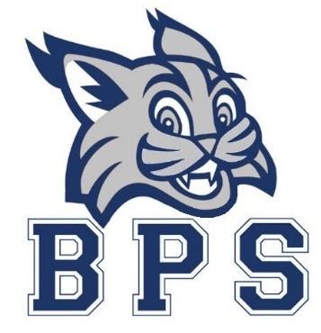
School Council Meeting
November 4, 2021
School Council Officer Positions and first meeting

Lawrence Divine
Christina Holland
Ami Lenderman
Johnathan Yerby
Rachel Youngblood
Samantha Moinipour – Teacher Representative
Kelly Scarbrough – Teacher Representative
Elgin Mayfield - School Principal

Agenda
- Call to order
- School Safety Plan
  - Green, Yellow, Red, Blue, and Covid
- Communications
  - Dojo, Facebook, Twitter, Instagram, LED Sign, Callout
  - One Note (internal)
- Next Meetings
  - January 20th
  - February 24th
- New Business?
- Adjourn

