This week is a review week in reading. We will review all the skills that have been taught so far. We will take a grade during review week that will count as a minor grade.

Apples

Review skills

MATH:

We will test topic 2 this week and then start topic 3 which is adding and subtracting to 20.

Week of Sept. 19

Homework-

You will find a math review sheet in the binder for homework this week. We will take the topic 2 math test this week.

High Freq. Words:

We will review all the words learned so far.

Contact Information

Email: Pamela.luker@acboe.net

Website: prattvilleprimary.com/pamelaluker

LANG. ARTS:

SS/SCIENCE:

READING:

Our Learning





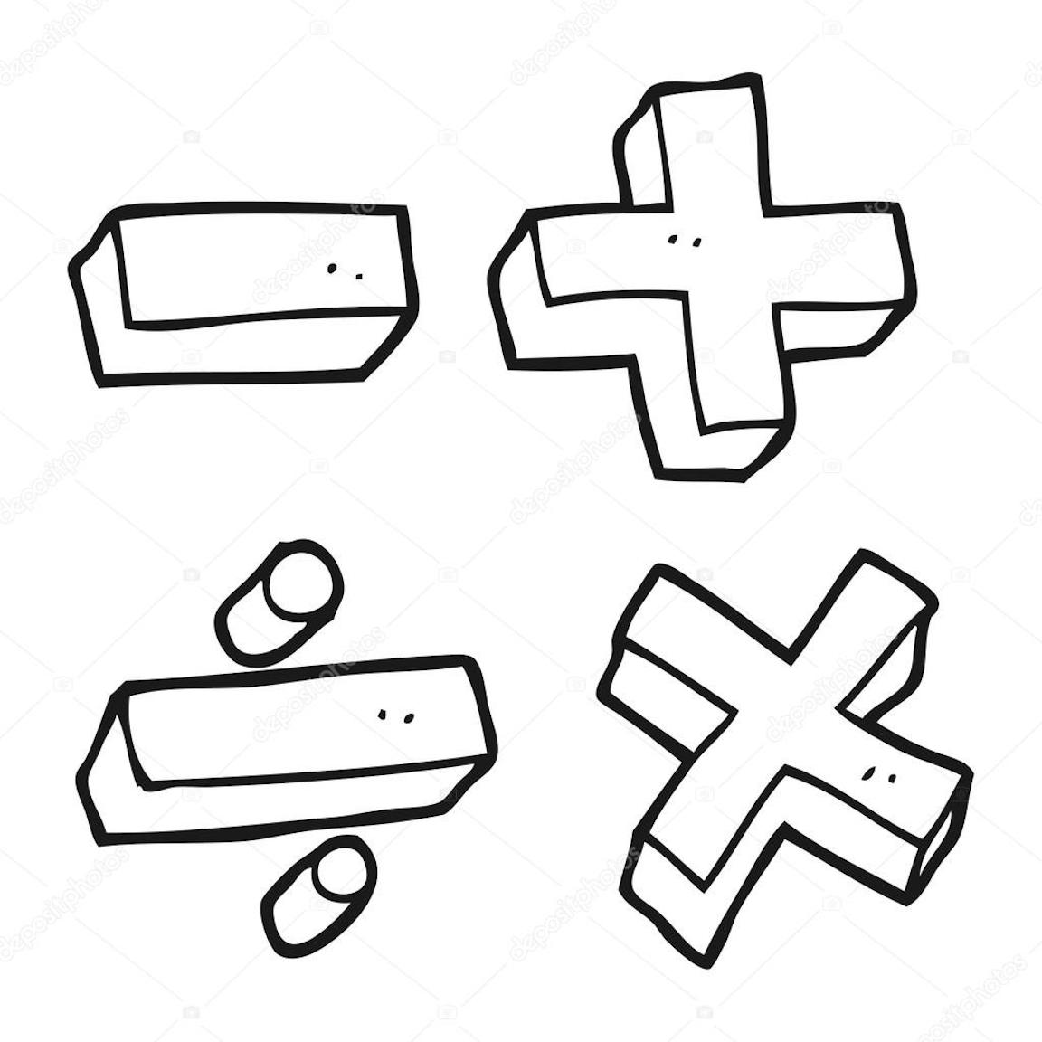



Upcoming Events

Sept. 23- free slushy for perfect attendance during the week (that includes check ins and outs)

Sept. 28- fall pictures

Sept. 30- Spirit Day- bring a stuffed animal

Reminders

\* if you have put money is your child’s binder please tell them to turn it in to me- especially if they need to buy snack; that is sold first thing in the morning

Mrs. Luker’s Class