First Grade Times
September 18, 2023

Classroom Studies:
Phonics: Review digraphs, Review spellings for /k/: c, k, ck, cc, Digraph ee
Tricky Words: he, she, be, me, we, see, for, blue
Spelling Words: set, vet, bet, jet, men, ten, den, hen, web, bed
Reading Stories: “Chew, Swallow, Squeeze, and Churn” “The Body’s Super Highway” “Control Center: The Brain” “Dr. Wellbody’s Heros”
Grammar Skill: Nouns that name things, people, and things, Common and Proper Nouns
Math: Topic 2 Assessment, Count on to Add, Count on to Add Using an Open Number Line, Doubles,
Doubles Plus
Math Vocabulary: Open Number line, Doubles-plus facts

Homework:

Monday:
- Math-Practice Page
- ELA-Fluency Passage, Tricky Words, Spelling Words
Tuesday:
- Math-Practice Page
- ELA-Fluency Passage, Homework Book, Spelling Words
Wednesday:
- Math-Family Letter
- ELA-Comprehension Page, Fluency Passage, Spelling Words

Thursday:
- Math-Practice Page
- ELA-Fluency Passage, Reading Sheet, Spelling Words

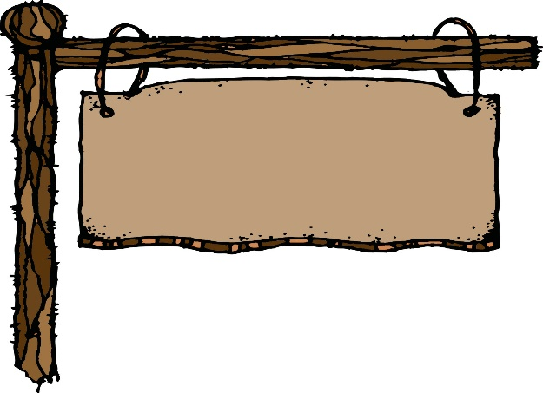
Classroom News:

  - Wear green on Wednesday to show at Broadview we promote empathy and inclusivity. We will understand the feelings of others, reach out and include others, and start with Hello!

  - Almost all first grade students have an AR book. Please be taking time to listen to your child read his/her AR book. Students should read them for two nights before taking a test on their book. We also ask that you stick a note in the book or in your child’s Eagle Folder saying he/she is ready to test.

- Calendar of Events:

September 26………………………………………………..Back to School BBQ
October 9-13…………….…………………………………....Fall Break
October 24…………………………………………………..Parent Teacher Conferences

Have a great week!!
Mrs. Boswell & Miss Basham

