New Brockton Elementary School
Enroll/Withdraw Procedures

Are you new to NBES? | Are you moving?
- Contact NBES with your address to make sure you are in our school zone. This must be where you reside, and proof of residency will be required prior to enrollment. If you are not in our school zone, an Interdistrict Transfer Request must be submitted and approved before completing the enrollment process.  - Withdraw from your previous school and collect any paperwork they provide. You will need to bring this with you.  - Pick up an enrollment packet from NBES. These are available in Spanish and English. The parent/legal guardian will need to return the completed packet along with the following required documents:  *Copy of the ID of the parent/legal guardian  *birth certificate  *current AL immunization records  *2 proofs of residency.  *We can only accept the following as POR: property tax records, mortgage documents/lease documents, utility bills, driver’s license, voter ID, automobile registration.*  - If you have any custody paperwork, please provide a copy of this as well.  Enrollments will be processed throughout the summer. Class lists will be released at Open House for the 22-23 school year. Completed packets AND required documents should be submitted no later than 3:00 on Wednesday, July 27th to guarantee placement in a homeroom prior to Open House. Enrollments submitted after this deadline will be processed on a first come/first served basis. | - Come by NBES and complete a Withdrawal form. This is easy to complete. You will need to provide the name and contact information for your next school. If you are moving to a homeschool program, please be prepared to provide the name of the program as well as proof of enrollment.  - Withdrawals will be processed throughout the summer. After your withdrawal is processed, we will provide a copy of your withdrawal form, your birth certificate, and your immunization records. You will likely need these for your next school.  - Enroll in your next school. Once enrolled, they will request other records from NBES. This verifies that you are enrolled in your next school.  It is very important that you complete these steps as early as possible in order to help us balance class sizes for next year. Withdrawals will be processed beginning the last week of school and continue throughout the summer.  The school counselor, Mrs. Bowers, will be available from 7-4 each Monday in the summer with the exception of June 13th and July 4th.  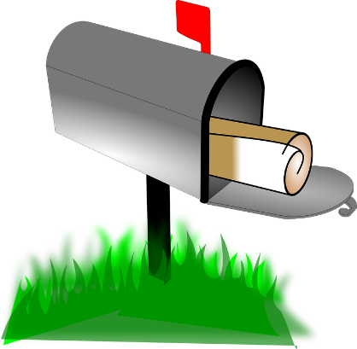
(334) 894-6152 504 North John Street, New Brockton, AL 36351

