INVITATION TO BID

Date Released: January 9, 2026

Bid Number: 26-016

Bid Name: Uniforms for School Nutrition Employees

The Houston County School District is soliciting bids for Uniforms for School Nutrition Employees. Specifications, terms and conditions are contained herein. It shall be the intent and purpose of this Invitation to Bid (ITB) to cover the terms and conditions under which a successful Bidder shall be responsible to supply and deliver all products listed on the Bid Response Form to the Houston County School District.

BID DUE/OPENING DATE/TIME: February 6, 2026/2:00 P.M. EST

LOCATION: Purchasing Department, 200 Jerry Barker Drive, Warner Robins, GA 31088

SAMPLES DUE BY: Samples may be requested by HCSD prior to awarding the bid. (Refer to pg. 4, item 4). All samples should be mailed to: School Nutrition, 1600 Macon Road, Suite C, Perry, GA 31069.

DEADLINE FOR WRITTEN QUESTIONS: January 30, 2026

RETURN SEALED BID VIA: Mail or hand deliver bid. Return Attachments A, B, C, D, E, and F with your Bid Response Form to the Buyer listed below. The Bid Response form is an additional document that is located on the purchasing website with the ITB. All bids must be submitted on a USB flash drive in our excel format only. A hardcopy of the form must accompany your bid. Faxed bids, email bids or copying and pasting of the spreadsheet into another document will not be accepted.

All Bids and supporting documentation must be enclosed in a sealed envelope and marked “ITB # 26-016, Bid Due Date/Time: February 6, 2026/2:00 P.M. EST”

The Houston County School District is not responsible for bids that are not received by the Buyer in the Purchasing Department at the address below by the due date and time. Late bids will not be considered in bid evaluation.

Bids shall be submitted to the attention of the Buyer at the address listed below.
L. Renee Langston, CPPB
200 Jerry Barker Drive
Warner Robins, GA. 31088
Phone: (478) 988-6211
Fax: (478) 988-6212
Email: Renee.Langston@hcbe.net
DEFINITIONS

Addendum - An addition to an ITB or contract document.

Amendment - A change or correction to an ITB or contract document.

Bidder/Vendor - A firm, individual, or corporation submitting a bid in response to this ITB.

Bid Unit - The unit designation, which shall be applicable to all pricing, offered for bid evaluation purposes. Unit cost, freight, fixed fee, estimated usage and the extended cost shall be stated in terms of the designated bid unit. In some instances, the bid unit and the package unit may be the same.

Board – Houston County School District

Contract Documents - Consist of the Agreement between the HCSD and the Vendor, terms and conditions, schedule, specifications, drawings, any and all addenda, errata, ITB, and bulletins issued prior to execution of the contract, other documents listed in the Agreement, and modifications issued after execution of the contract.

Damaged Item- Refers to an item that has sustained damage that would allow spillage from the original container, a loss or disfigurement of a label that would hinder identification, contaminated package that would affect the content of that package or any other happening that would affect the quality and/or quantity of the original item.

Dry Food Product- A dry product that does NOT require freezing or refrigeration.

HCSD – Houston County School District, by its duly elected Houston County Board of Education.

Invitation To Bid (ITB) - A type of solicitation document used in competitive bidding, where the primary consideration is cost and the expectation is that competitive bids will be received and an acceptance (award) will be made to the most responsive and responsible Bidder whose bid is lowest in price. The ITB must be publicly advertised with sufficient time to respond by the date and time set for opening the bids.

Pack size - With some items the bid unit does not represent a package configuration by which the item would normally be purchased. In such instances, the Bidder will be required to bid according to the designated bid unit and state how the product will be packaged and to provide a cost for purchase unit.

Purchase Unit - The package configuration (case, carton, box, bag, etc.) by which the product would normally be sold. This shall also mean packaging being referred to when the term "case price" is applicable.

Solicitation - A document used by the Houston County School District to acquire goods and/or services. Solicitations must incorporate a clear and accurate description of the technical requirements for the material, product, or service to be procured. Solicitations must also identify all the requirements that the Bidders must fulfill and all other factors to be used in evaluating the bids or proposals. An ITB is a type of solicitation.

NSLP - National School Lunch Program

SBP - School Breakfast Program

SNP – School Nutrition Program

- GENERAL INFORMATION FOR BIDDERS
- From the issue date of this Invitation to Bid (ITB) until an award has been announced, Vendors shall not communicate with any HCSD employee, with the exception of the name stated on page one of this document or the Director of Purchasing, concerning this ITB or any information herein. The Houston County School District reserves the right to reject the bid response of any Bidder violating this provision.

- Whenever the terms “shall,” “must,” “will,” or “is required” are used in this ITB, the item being referred to is a mandatory requirement of this ITB and failure to meet any mandatory requirement may be cause for rejection of the bid.

- Contracts are non-exclusive as the HCSD reserves the right to purchase any products from any Vendor at any time.

- BIDS
- The HCSD reserves the right to:
- Waive formalities and technicalities in any bid.
- Reject any and/or all bids when it will be in the best interest of the HCSD.
- Accept the bid that in HCSD’s judgment will be in our best interest.
- Purchase from any source, in part or in whole, any supplies, equipment or services.
- Award on individual items or on a lump sum basis.
- Award this bid to the Vendor who in the HCSD's opinion is most responsive and responsible and will perform in the best interest of HCSD.

- Price alone may not be the determining factor in award of this bid.

- The Bidder may give bids on any one or more items. Bidders must bid on specific brand and item number if listed. However, Bidders may offer alternates on a separate list that meet or exceed the product number listed. Samples of alternates should be submitted with the bid response.

- In the event of one or more Vendors quoting the exact same price and this being the lowest price bid, the tie will be broken by a coin toss conducted by someone other than the buyer responsible for this ITB.

- Where applicable, in the case of discrepancy between the unit price or rate and the extension of that unit price or rate, the unit price or rate shall govern.

- The HCSD will not be responsible for any bid responses not received at the correct time/location prior to bid due date/time. It is the responsibility of the Vendor to ensure bids are received at the proper time/location regardless of delivery method.

- Bids cannot be modified after receipt of bids. Care should be taken to ensure that information provided is accurate, complete, and consistent. Omission of any of the required information may subject the Bidder to disqualification. The HCSD reserves the right to request information or respond to inquiries for clarification purposes only.

- Bidders may withdraw bids at any time up to the scheduled time for receipt of bids. Bidders desiring to withdraw their bid may do so by submitting a request in writing to the Buyer listed on page one of this document. Bidders may resubmit bids provided it is prior to the scheduled time for receipt of bids.

- It is the responsibility of each Bidder to examine the entire solicitation, seek clarification in writing, and check its offer for accuracy before submitting the offer. Lack of care in preparing an offer shall not be grounds for withdrawing the offer after the offer due date and time, and it shall not give rise to any contract claim.

- Any Bidder who has demonstrated consistently poor performance with HCSD or other similar entities or has had a contract canceled by HCSD due to poor performance during a current or previous Agreement with the HCSD may be considered a non-responsible Bidder and their bid may be rejected. The HCSD reserves the right to exercise this option as is deemed to be in the best interest of the HCSD.

- Once a bid is awarded, if the awarded Bidder declines their award, the Bidder will be considered a non-responsible Bidder and future bids may be rejected for up to three years.

- PRICE
Prices quoted shall include all costs and charges to include, but not limited to, purchasing, packing, services described herein, and transporting the item(s) to specified location(s). HCSD is exempt from State Sales Tax and Federal Excise Tax. All fees shall be included in the bid price. Bidders must bid based on the bid unit listed using Bid Response Form(s) included with this ITB. The HCSD reserves the right to reject the bid response of any Bidder violating this provision. Prices bid must remain valid for the duration of the contract.

This will be a firm fixed-price contract with no economic price adjustment during the contract period.

- SAMPLES
Samples may be requested by HCSD prior to awarding the bid. If samples are requested by HCSD, they shall be at no charge to HCSD and will become property of the HCSD, unless return is requested by the Bidder in writing in their bid. Return of samples will be at Bidder’s expense and must be returned or picked up no longer than 30 days after bid closing date. Samples must be received by HCSD within five business days of the written request.

- QUESTIONS
Questions regarding this Invitation to Bid shall be directed in writing only to the Buyer listed on page one of this document. All questions and answers will be posted on the HCSD website as they are received at www.hcbe.net under “Departments,” “Purchasing,” “Bids/Proposals.” It is the responsibility of each Bidder to inquire about any aspect of the ITB that is not fully understood or is believed to be susceptible to more than one interpretation. The HCSD will accept only written inquiries regarding this ITB up to 5 business days prior to bid closing date.

- AMENDMENTS/ADDENDUMS
All amendments/addendums will be posted to the HCSD website at www.hcbe.net under “Departments,” “Purchasing,” “Bids/Proposals,” and it is the Bidders’ responsibility to view any posted items. It is recommended that Vendors refer to the website on a regular basis during the course of this bid. No amendments/addendums will be posted within 5 days prior to bid closing.

- COST OF SUBMITTING RESPONSE
The HCSD is not liable for any costs incurred by Bidders prior to issuance of or entering into a contract. Costs associated with developing the bid, preparing for oral presentations, and any other expenses incurred by the Bidder in responding to this ITB are entirely the responsibility of the Bidder and shall not be reimbursed in any manner by HCSD.

- AWARD
This bid may be awarded to one or more Vendors. Award is contingent upon available funds and necessary approvals. Award will be made within sixty (60) days of the bid opening date. The selected Vendor(s) shall provide products in accordance with the specifications, all terms and conditions, instructions and applicable amendments/addendums in this ITB. Notification will be forwarded by HCSD to the successful Bidder after bid selection. HCSD has the right to cancel the bid and make no award if it is in the best interest of the HCSD.

- BRAND NAME
Bidders are required to indicate the brands and models of merchandise and/or services bid.

- MARKING
Merchandise in full cases shall have an identification marking on the outside of the case. Packing slip/list shall include the Purchase Order Number or contact name supplied by SNP.

- SAFETY
Material Safety Data Sheets shall be provided for all applicable items and must accompany delivery.

- ORDERS
There will be multiple orders for this contract. The first initial order will be a large order that will provide uniforms for majority of our employees. The estimated quantities of each uniform are listed on the Bid Response Form. There will be smaller orders throughout the year as new employees are hired. These orders will not be more often than once per month.

It shall be understood and agreed that quantities listed are estimates only and may be increased or decreased. Therefore, if the amount ordered is less than that shown, that fact shall not constitute the basis for a price adjustment nor will HCSD be responsible for ordering/paying for the resulting difference. SNP reserves the right to add any new products during the duration of this contract. In addition, SNP reserves the right to remove items from this contract if products are no longer needed. A purchase order will be entered for each order. All purchase orders placed under this contract will be made through the School Nutrition Central Office.

Should a condition arise where the product originally contracted can no longer be supplied by the vendor, an application for substitution of another brand under the contract at an equal or lower price must be submitted to the Director of School Nutrition or designee and upon approval, the substitution will be allowed. Substitution of product not approved by the Director of School Nutrition or designee may result in the cancellation of the contract.

- DELIVERY
- Vendor is responsible for all delivery costs.

- Vendor shall be responsible for the removal of all packing material and debris when delivering items that need to be unpacked or installed by the Vendor.

- Deliveries shall be supplied by the Vendor as requested and specified except during an emergency and on holidays. In an emergency situation in which HCSD requires delivery in less than 2 days and if the Vendor cannot provide the goods within the emergency delivery period, HCSD has the option to purchase those goods from another source with no penalty to either party. Delivery schedules that fall on a holiday will be made the following business day. A holiday schedule is included as Attachment I.

- Successful Bidder will supply the Director of School Nutrition with a phone number and representative’s name through which to place orders.

- Delivery schedules will be created and agreed upon by both parties after the awarding of the bid.

- All items will be delivered to Houston County School District, School Nutrition Program, 1600 Macon Road, Suite C, Perry, GA 31069.

- All items must be delivered inside the building and cannot be drop-shipped outside. Delivery personnel must put product in the location as directed by authorized representative of SNP.

- Entire delivery must be made no later than Tuesday, June 30, 2026 to one central location.

- There should be no minimum order requirement to be delivered.

- HCSD reserves the right to require overtime payment to school employees by the Bidder due to late deliveries. The HCSD will notify the Vendor and deduct the amount from the next invoice.

- Direct Delivery, delivery shall be made between 8:00 AM and 4:00 PM Monday-Friday.

- All cases should be sanitary and free from any foreign matter. Any back-ordered item(s) not delivered within the time limit may be canceled by the HCSD at no expense to the same. Unsatisfactory products will be replaced with fresh units at no cost to the HCSD.

- INSPECTION
All merchandise and services shall be subject to inspection after arrival at HCSD or completion of work. In the case any items are found to be defective or otherwise not in conformity with specifications, the HCSD has the right to reject such items and/or services and return them at Bidder’s expense or require that Bidder return to site (if service is performed on HCSD property to correct the issue). Problems found with products due to concealed damage will be addressed as soon as damage is revealed and on a case-by-case basis. Rejected products must be picked up no later than the next delivery date.

- PAYMENT
- SNP shall make payment for goods and services within thirty (30) days upon receipt, inspection and acceptance by SNP personnel, and receipt of invoice. Advance billings are not allowed.

- Where partial delivery is made, invoice for such part shall be made upon delivery, and payment made within thirty (30) days under conditions as above.

- Payment may be made by check or by credit card. If a fee will be added to the invoice for use of a VISA credit card, it must be noted on Attachment B, Certification Letter.

- INVOICES
- All invoices shall be addressed as follows:

Houston County School District
School Nutrition Program
Attn: Meredith Potter
1600 Macon Road, Suite C
Perry, Georgia 31069

- All copies of the invoice must be signed at the time of delivery by the School Nutrition Designee.

- A credit or replacement will be issued for damaged or unacceptable items as determined by the Director of School Nutrition. Replacement of damaged or unacceptable items will be made no later than the next delivery date. In the event of errors, a credit/debit shall be issued against the invoice as it was presented to the School Nutrition Designee. The credit or debit shall be sent to the address listed above.

- All invoices are to clearly indicate the account name, school name, date, product, brand name, quantity, unit price and total prices.

- FACILITIES AND EQUIPMENT
The Bidder shall be responsible for the protection of HCSD premises and property, and will be held liable for any damages caused by the Bidder, Bidder’s employee(s) or Bidder’s agent(s) during the execution of delivery/installation of goods/services resulting from this ITB.

- INDEMNIFICATION
- The Bidder does hereby indemnify and shall hold harmless HCSD, its Board members, employees, agents, and servants (each of the forgoing being hereafter referred to individually as “Indemnified Party”) against all claims, demands, causes of actions, actions, judgments or other liability including attorney’s fees (other than liability solely the fault of the Indemnified Party) arising out of, resulting from or in connection with the Bidder’s performance or failure to perform this agreement, including but not limited to:

- All injuries or death to persons or damage to property, including theft.
- Bidder’s failure to perform all obligations owed to the Bidder’s employees including any claim the Bidder’s employees might have or make for privilege, compensation or benefits under any HCSD benefit plan.
- Any and all sums that are due and owing to the Internal Revenue Service for withholding FICA, and unemployment or other State and Federal taxes.

- The Bidder’s obligation to indemnify the Indemnified Party will survive the expiration or termination of this agreement.

- TERM OF CONTRACT
Code section 20-2-506 of the laws of the State of Georgia as of this date and as may be amended apply to this agreement. In addition to other requirements, the following are specifically enumerated.

- The initial contract term is one (1) year, or less, from the date of the award through June 30, 2027. The contract may be extended at bid pricing up to four years (total contract not to exceed 60 months) with mutual written agreement by both parties.

- TERMINATION OF AGREEMENT, CONTRACT, or AWARD
Any agreement, contract, or award resulting from this ITB may be canceled by either party for just cause in writing 30 days prior to termination.

- FAILURE TO BID
If you do not wish to bid, please return this bid and state reason(s).

- BID SUMMARY
A bid summary shall be sent to all responding Bidders and will be placed on the HCSD website.

- REFERENCES
Each Bidder shall submit on enclosed form a minimum of 3 references. Preferred are references from other school systems in Georgia. Reference Form is attached as Attachment F. HCSD reserves the right to solicit references from businesses that have had a recent working relationship with the Bidder. These references may be used to evaluate the responsibility level of a Vendor and may influence the award of this ITB.

STANDARD TERMS AND CONDITIONS

- DEBARMENT AND SUSPENSION VERIFICATION (required for all Contracts)
By signing the Debarment Form, Attachment C, Vendor certifies that the Vendor and/or any of its sub Vendors have not been debarred, suspended, or declared ineligible by any agency of the State of Georgia or the HCSD or as defined in the Federal Acquisition Regulation (FAR) 48 C.F.R. Ch.1 Subpart 9.4. Vendor will immediately notify the HCSD Purchasing Department and the Director of School Nutrition if Vendor is debarred or placed on the Consolidated List of Debarred, Suspended, and Ineligible Vendors by a federal entity. Please see and complete Attachment C.

- LOBBYING CERTIFICATE (for bids over $100k)
A Lobbying Certification and Disclosure must be completed for all bids $100,000 and over. Byrd Anti-Lobbying Amendment (31 U.S.C. 1352): Vendors that apply or bid for an award exceeding $100,000 must file the required certification. Each tier certifies to the tier above that it will not and has not used Federal appropriated funds to pay any person or organization for influencing or attempting to influence an officer or employee of any agency, a member of Congress, officer or employee of Congress, or an employee of a member of Congress in connection with obtaining any Federal contract, grant or any other award covered by 31 U.S.C. 1352. Each tier must also disclose any lobbying with non-Federal funds that takes place in connection with obtaining any Federal award. Such disclosures are forwarded from tier to tier up to the non-Federal award. Per CFR 7.3018 - A Lobbying Certification and Disclosure must be completed for all bids $100,000 and over. Please see and complete Attachment E.

- DOMESTIC PREFERENCE FOR GOODS AND MATERIALS (Applicable to non-food only)
As appropriate and to the extent consistent with law, the recipient and/or subrecipient should, to the greatest extent practicable under a Federal award, provide a preference for the purchase, acquisition, or use of goods, products, or materials produced in the United States (including but not limited to iron, aluminum, steel, cement, and other manufactured products). The requirements of this section must be included in all subawards including all contracts and purchase orders for work or products under this award.
For purposes of this section:
(1) “Produced in the United States” means, for iron and steel products, that all manufacturing processes, from the initial melting stage through the application of coatings, occurred in the United States.
(2) “Manufactured products” means items and construction materials composed in whole or in part of non-ferrous metals such as aluminum; plastics and polymer-based products such as polyvinyl chloride pipe; aggregates such as concrete; glass, including optical fiber; and lumber.
Federal agencies providing Federal financial assistance for infrastructure projects must implement the Buy American preferences set forth in 2 CFR part 184.

- REMEDY FOR NON-PERFORMANCE/TERMINATION OF AGREEMENT, CONTRACT, OR AWARD
In the event that a vendor does not perform according to the standards and conditions described in this ITB that is made a part of the contract with HCSD, HCSD may take measures to remedy the default. The optional remedies for non-performance are listed below. HCSD and Vendor agree that the damages caused by a breach of the ITB terms incorporated into a subsequent contract are difficult or impossible of estimation due to labor costs and costs to cure when Vendor does not deliver as stated in the ITB and Vendor acceptance. In order to provide for damages and estimate a reasonable probable loss, HCSD and Vendor agree to the following damage calculation as an optional remedy for the Vendor’s breach.

- Damages - Payment for Damages will be accepted in the form of a check, within 30 days of notification.

Non-Delivery: In the event that a delivery does not occur at all on the scheduled delivery day, the Vendor may be assessed damages for up to 20% of the cost of the missing order.

Late Delivery: In the event that the entire delivery is not delivered by the required delivery date, the contractor may be assessed a financial penalty for up to 20% of the cost of the late order. Backorders are considered a late delivery if not delivered prior to the stated date listed in this ITB.

Incorrect Shipment and Delivery: Failure to deliver all items according to the delivery requirements listed in this ITB may result in the Bidder being assessed a financial penalty for up to 20% of the cost of the items that were shipped incorrectly.

The company that is awarded this bid will be responsible for any fees assessed by SNP, regardless of other entities or services that may have been involved in the production or delivery of the product.

- Suspension (Notice of Default) – In the event that either the Vendor or the Board defaults in the performance of any obligation specified in the agreement, contract, or award, the non-defaulting party shall notify the other party in writing and may suspend the agreement, contract, or award in whole or in part, pending remedy of the default. If such default is not remedied within fifteen (15) days from the date of receipt of such notice or if the other party is diligently attempting to cure such default but is unable to cure such default within thirty (30) days from the date of receipt of such notice, then the non-defaulting party shall have the right to terminate the contract immediately by providing written notice of termination to the other party.

- Termination – The Houston County School District reserves the right, at any time and for its convenience, to terminate the agreement, contract, or award in whole or in any separable part by written notice to vendor. Such notice shall be provided at least thirty (30) days prior to the intended termination date. Vendor shall be compensated for Goods accepted and for Services performed in accordance with the provisions of the agreement, award, or contract up to the effective date of termination, less any payments previously made by the Board/SNP for such Goods or Services, but in no event shall the vendor be entitled to recover loss of profits.

Immediate Termination – This contract will terminate immediately and absolutely if the HCSD determines that adequate funds are not appropriated or granted or funds are de-appropriated such that the HCSD cannot fulfill its obligations under the Contract, which determination is at the HCSD’s sole discretion and shall be conclusive. Further, the HCSD may terminate the Contract for any one or more of the following reasons effective immediately without advance notice:

- In the event the Vendor is required to be certified or licensed as a condition precedent to providing goods and services, the revocation or loss of such license or certification may result in immediate termination of the Contract effective as of the date on which the license or certification is no longer in effect;
- The HCSD determines that the actions, or failure to act, of the Vendor, its agents, employees or sub vendors have caused, or reasonably could cause, life, health or safety to be jeopardized;
- The Vendor fails to comply with confidentiality laws or provisions; and/or
- The Vendor furnished any statement, representation, or certification in connection with the Contract or the bidding process, which is materially false, deceptive, incorrect, or incomplete.

Termination for Cause – The occurrence of any one or more of the following events shall constitute cause for the HCSD to declare the Vendor in default of its obligation under the Contract:

  - The Vendor fails to deliver or has delivered nonconforming goods or services or fails to perform, to the HCSD’s satisfaction, any material requirement of the Contract or is in violation of a material provision of Contract, including, but without limitation, the express warranties made;
  - The HCSD determines that satisfactory performance of the Contract is substantially endangered or that a default is likely to occur;
  - The Vendor fails to make substantial and timely progress toward performance of the Contract;
  - The Vendor becomes subject to any bankruptcy or insolvency proceeding under federal or state law to the extent allowed by applicable federal or state law including bankruptcy laws; the Vendor terminates or suspends its business; or the HCSD reasonably believes that the Vendor has become insolvent or unable to pay its obligations as they accrue consistent with applicable federal or state law;
  - The Vendor has failed to comply with applicable federal, state, and local laws, rules, ordinances, regulations and orders when performing within the scope of the Contract;
  - The Vendor has engaged in conduct that has or may expose the HCSD or the State to liability, as determined in the HCSD’s sole discretion; or
  - The Vendor has infringed any patent, trademark, copyright, trade dress or any other intellectual property rights of the HCSD, the state, or a third party.

Termination Due to Change in Law – The HCSD shall have the right to terminate this Contract without penalty by giving thirty (30) days’ written notice to the Vendor as a result of the following:
  - The HCSD’s authorization to operate is withdrawn or there is a material alteration in the programs administered by the HCSD; and/or
  - The HCSD’s duties are substantially modified.

The Vendor’s Termination Duties. Upon receipt of notice of termination or upon request of the HCSD, the Vendor shall:
  - Cease work under the Contract and take all necessary or appropriate steps to limit disbursements and minimize costs, and furnish a report within thirty (30) days of the date of notice of termination, describing the status of all work under the Contract, including, without limitation, results accomplished, conclusions resulting there from, and any other matters the HCSD may require;
  - Immediately cease using and return to the HCSD, any personal property or materials,
whether tangible or intangible, provided by the HCSD to the Vendor;
  - Comply with the HCSD’s instructions for the timely transfer of any active files and work product by the Vendor under the Contract;
  - Cooperate in good faith with the HCSD, its employees, agents, and vendors during the transition period between the notification of termination and the substitution of any replacement vendor; and
  - Immediately return to the HCSD any payments made by the HCSD for goods and
services that were not delivered or rendered by the Vendor.

- HUB STATEMENT (7CFR3016.36(e))
It is the intent of the SFA to provide maximum practicable opportunities in its solicitations to minority firms, women's business enterprises, labor surplus area firms and veteran-owned businesses.
Small businesses, women and minority-owned business sources, labor surplus area firms and veteran-owned businesses will not be given unfair advantage when evaluating competitive purchases i.e., simplified acquisition purchases, sealed bids, proposals, or noncompetitive procurement (2 CFR 200.321).

When possible, the recipient or subrecipient should ensure that small businesses, minority businesses, women's business enterprises, veteran-owned businesses, and labor surplus area firms (See U.S. Department of Labor's list) are considered as set forth below. Such consideration means:
    - These business types are included on solicitation lists;
    - These business types are solicited whenever they are deemed eligible as potential sources;
    - Dividing procurement transactions into separate procurements to permit maximum participation by these business types;
    - Establishing delivery schedules (for example, the percentage of an order to be delivered by a given date of each month) that encourage participation by these business types;
    - Utilizing organizations such as the Small Business Administration and the Minority Business Development Agency of the Department of Commerce; and
    - Requiring a contractor under a Federal award to apply this section to subcontracts.

- EQUAL EMPLOYMENT OPPORTUNITY COMPLIANCE STATEMENT (for bids over $10k)
In accordance with Federal Law and U.S. Department of Agriculture policy, this institution is prohibited from discriminating on the basis of race, color, national origin, age, disability, and where applicable, sex, marital status, familial status, parental status, religion, sexual orientation, genetic information, political beliefs, reprisal, or because all or part of an individual's income is derived from any public assistance. To file a complaint of discrimination, write USDA, Director, Office of Adjudication, 1400 Independence Avenue, SW, Washington, D.C. 20250-9410 or call toll free (866) 632-9992. (Voice) Individuals who are hearing impaired or have speech disabilities may contact USDA through the Federal Relay Service at (800) 877-8339; or (800) 845-6136 (Spanish). USDA is an equal opportunity provider and employer.

- ENERGY POLICY AND CONSERVATION ACT STATEMENT
Compliance with mandatory standards and policies relating to energy efficiency which are contained in the state energy conservation plan issued in compliance with the Energy Policy and Conservation Act (Public Law 94-163, 89 Stat.871).

- CLEAN AIR/ CLEAN WATER STATEMENT (for bids over $150k)
Compliance with all applicable standards, orders, or requirements issued under section 306 of the Clean Air Act (42 U.S.C. 1857(h)) Clean Air and Water Certification. Vendor certifies that none of the facilities it uses to produce goods provided under the Contract are on the Environmental Protection Authority (EPA) List of Violating Facilities. Vendor will immediately notify the School Food Authority of the receipt of any communication indicating that any of Vendor’s facilities are under consideration to be listed on the EPA List of Violating Facilities. Clean Air Act (42 U.S.C. 7401-7671q.) and the Federal Water Pollution Control Act (33 U.S.C. 1251-1387), as amended: Contracts and subgrants of amounts in excess of $150,000 must contain a provision that requires the non-Federal award to agree to comply with all applicable standards, orders or regulations issued pursuant to the Clean Air Act (42 U.S.C. 7401-7671q) and the Federal Water Pollution Control Act as amended (33 U.S.C. 1251-1387). Violations must be reported to the Federal agency and the Regional Office of the Environmental Protection Agency (EPA).

- CIVIL RIGHTS STATEMENT
In accordance with Federal Law and U.S. Department of Agriculture policy, this institution is prohibited from discriminating on the basis of race, color, national origin, sex, age and disability. To file a complaint of discrimination, write USDA, Director, Office of Civil Rights, Room 326-W, Whitten Building, 1400 Independence Avenue, SW, Washington, D.C. 20250-9410 or call (202) 720-5964 (voice and TDD). USDA is an equal opportunity provider and employer.

- CIVIL RIGHTS ASSURANCE
The School District hereby agrees that it will comply with: Title VI of the Civil Rights Act of 1964 (42 U.S.C. 2000d et seq.); Title IX of the Education Amendments of 1972 (20 U.S.C. 1681 et seq.); Section 504 of the Rehabilitation Act of 1973 (29 U.S.C. 794); Age Discrimination Act of 1975 (42 U.S.C. 6101 et seq.); Title II and Title III of the Americans with Disabilities Act (ADA) of 1990 as amended by the ADA Amendment Act of 2008 (42 U.S.C. 12131-12189); Executive Order 13166, "Improving Access to Services for Persons with Limited English Proficiency." (August 11, 2000); All provisions required by the implementing regulations of the Department of Agriculture (USDA) (7 CFR Part 15 et seq.); Department of Justice Enforcement Guidelines (28 CFR Parts 35, 42 and 50.3); Food and Nutrition Service (FNS) directives and guidelines to the effect that, no person shall, on the grounds of race, color, national origin, sex, age, or disability, be excluded from participation in, be denied the benefits of, or otherwise be subject to discrimination under any program or activity for which the Program applicant receives Federal financial assistance from USDA; and hereby gives assurance that it will immediately take measures necessary to effectuate this Agreement. The USDA non-discrimination statement that in accordance with Federal civil rights law and U.S. Department of Agriculture (USDA) civil rights regulations and policies, the USDA, its Agencies, offices, and employees, and institutions participating in or administering USDA programs are prohibited from discriminating based on race, color, national origin, religion, sex, gender identity (including gender expression), sexual orientation, disability, age, marital status, family/parental status, income derived from a public assistance program, political beliefs, or reprisal or retaliation for prior civil rights activity, in any program or activity conducted or funded by USDA (not all bases apply to all programs). This assurance is given in consideration of and for the purpose of obtaining any and all Federal financial assistance, grants, and loans of Federal funds, reimbursable expenditures, grant, or donation of Federal property and interest in property, the detail of Federal personnel, the sale and lease of, and the permission to use Federal property or interest in such property or the furnishing of services without consideration or at a nominal consideration, or at a consideration that is reduced for the purpose of assisting the recipient, or in recognition of the public interest to be served by such sale, lease, or furnishing of services to the recipient, or any improvements made with Federal financial assistance extended to the Program applicant by USDA. This includes any Federal agreement, arrangement, or other contract that has as one of its purposes the provision of cash assistance for the purchase of food, and cash assistance for purchase or rental of food service equipment or any other financial assistance extended in reliance on the representations and agreements made in this assurance. By accepting this assurance, the School District agrees to compile data, maintain records, and submit records and reports as required, to permit effective enforcement of nondiscrimination laws and permit authorized USDA personnel during hours of program operation to review and copy such records, books, and accounts, access such facilities and interview such personnel as needed to ascertain compliance with the nondiscrimination laws. If there are any violations of this assurance, the Department of Agriculture, FNS, shall have the right to seek judicial enforcement of this assurance. This assurance is binding on the School District, its successors, transferees and assignees as long as it receives assistance or retains possession of any assistance from USDA. The person or persons whose signatures appear below are authorized to sign this assurance on behalf of the School District. (Signatures on bid documents and purchase agreements will reflect agreement of this assurance).

- RECORD RETENTION AND ACCESS CLAUSE
The Vendor shall maintain books, records and documents in accordance with generally accepted accounting principles and procedures and which sufficiently and properly document and calculate all charges billed to the HCSD, School Nutrition Program throughout the term of the Contract and for a period of at least seven (7) years following the date of final payment or completion of any required audit, whichever is later. Records to be maintained include both financial records and service records.

The Vendor shall permit the Auditor of the State of Georgia or any authorized representative of the HCSD School Nutrition Program and where federal funds are involved, the Comptroller General of the United States, or any other authorized representative of the United States government, to access and examine, audit, excerpt and transcribe any directly pertinent books, documents, papers, electronic or optically stored and created records or other records of the Vendor relating to orders, invoices or payments or any other documentation or materials pertaining to the Contract, wherever such records may be located during normal business hours. The Vendor shall not impose a charge for audit or examination of the Vendor’s books and records. If an audit discloses incorrect billings or improprieties, the State and/or the HCSD reserve the right to charge the Vendor for the cost of the audit and appropriate reimbursement. Evidence of criminal conduct will be turned over to the proper authorities.

- BID PROTEST PROCEDURES
- Any protests arising from this solicitation and award shall be made in writing and shall be delivered to the Superintendent as the acting protest official of the Houston County School District at 1100 Main Street, Perry, GA 31069. The protest shall be filed no later than ten (10) days from the award notice and shall include:
- The name, address, and telephone number of the protester;
- The signature of the protester or an authorized representative of the protester;
- Identification of the purchasing agency and the solicitation or contract number;
- A detailed statement of the legal and factual grounds of the protest including copies of relevant documents;
- The form of relief requested.
- A written response to the protest will be made within 30 days from receipt of the protest (with above documentation).
- The HCSD shall in all instances disclose information regarding protests to State Agency.

- CODE OF CONDUCT
HCSD maintains a written code of conduct governing the performance of its employees engaged in the award and administration of contracts. The code of conduct outlines the responsibilities of, or proper practices for, HCSD employees. HCSD code of conduct governs the performance of the officers, employees, or agents engaged in any contract awards. All HCSD purchasing policies can be located at www.HCBE.net. Specific purchasing policies include Policy DJE: Purchasing, Policy DJEA: Purchasing Authority, Policy DJED: Bids and Quotations, Policy DJEE: Local Purchasing, Policy DJEI: Vendor Relations, and Policy DJEG: Purchase Orders and Contracts.

- EXCEPTIONS TO TERMS AND CONDITIONS
Any bid that takes exception to a requirement of any part of this solicitation shall be rejected.

- ASSIGNMENT
The agreement with the HCSD resulting from this ITB shall remain with the Vendor awarded. The Vendor shall not assign, transfer, convey, delegate, sublet, or otherwise dispose of the agreement, or its rights, title, or interest herein, or its power to execute such agreement, to any other person, company, or corporation without the previous consent and written approval by the HCSD.

- PROPRIETARY INFORMATION/OPEN RECORDS REQUEST
If a Bidder submits any document with the bid that is considered to be proprietary in nature or is considered to be a trade secret, the Bidder shall note such in the documents included in the bid. The school district will honor the request unless or until a competing Bidder requests access to the information under the Open Records Act. In such case, the school district will notify the affected Bidder that a challenge has been made. If the affected Bidder can produce a court issued restraining order within ten calendar days subsequent to the notification, the information will remain confidential and shall not be released pending subsequent court action. If the restraining order is not received within the ten working day period, the information will be released and the school district shall not be held liable.

- FORCE MAJEURE
Except for payments of sums due, neither party shall be liable to the other nor deemed in default under this contract if and to the extent that such party’s performance of this contract is prevented by reason of Force Majeure. The term “Force Majeure” means an occurrence that is beyond the control of the party affected and occurs without its fault or negligence. Without limiting the forgoing, Force Majeure includes acts of God; fire; flood; or other similar occurrences beyond the control of the Vendor or the school district.

- EVIDENCE OF INSURANCE
- The successful Vendor, at its expense, shall carry and maintain in full force at all times during the term of the contract resulting from this ITB the following insurance:

Coverage Limits of Liability
Workmen’s Compensation | Statutory
General Liability/Property Damage | $1,000,000 each occurrence  $2,000,000 aggregate
Personal Injury | $1,000,000 each occurrence  $2,000,000 aggregate
Automobile Liability/Property Damage | $1,000,000 each occurrence
Bodily Injury | $500,000 each occurrence  $1,000,000 aggregate

- Prior to commencement of performance of this Agreement, Vendor shall furnish to HCSD a certificate of liability insurance evidencing all required coverage in at least the limits required herein, naming the HCSD, its elected officials, agents, and employees as additional insured under the Comprehensive General Liability coverage, and providing that no policies may be canceled without ten (10) days advance written notice to the HCSD. Such certificate shall be issued to: Houston County School District.

- Said policies shall remain in full force and effect until the expiration of the terms of the contract or until completion of all duties to be performed hereunder by the Vendor, whichever shall occur later.

- WARRANTY
A successful Vendor shall fully warrant all products furnished under the terms of this contract, against poor and inferior quality. Time is of the essence of this contract. While under warranty, a successful Vendor shall replace any damaged or inferior product in a timely manner to minimize the disruption of HCSD’s regular and daily operations.

ATTACHMENT A

Contract

This agreement is dated as of ______________________________ by and between the HCSD and ________________ (hereinafter called VENDOR).

HCSD and VENDOR, in consideration of the mutual covenants hereinafter set forth, agree as follows:

ARTICLE 1. CONTRACT DOCUMENTS
The contract documents consist of ITB # _26-016_ in its entirety unless otherwise specified in this “contract signature page” and the Vendor’s response to ITB # _26-016_. No other documents are a part of this contract.

ARTICLE 2. SEVERABILITY
The provisions of this contract are severable. Any term or condition deemed illegal or invalid shall not affect any other term or condition of the contract.
ARTICLE 3. PRODUCTS
VENDOR shall provide all products/services as specified or indicated in the Contract Documents. VENDOR shall supply and deliver all products/services as specified and directed in ITB # _26-016_.

ARTICLE 4. CONTRACT PERIOD
Code section 20-2-506 of the laws of the State of Georgia as of this date and as may be amended apply to this agreement. In addition to other requirements, the following are specifically enumerated.

- The initial contract term is one (1) year, or less, from the date of the award through June 30, 2027. The contract may be extended at bid pricing up to four years (total contract not to exceed 60 months) with mutual written agreement by both parties.

ARTICLE 5. CONTRACT PRICE
HCSD /SNP shall pay VENDOR for purchase and delivery of all items specified in ITB # _26-016_ in accordance with VENDOR’S bid, which is attached hereto. HCSD /SNP shall pay VENDOR net 30 days from date of delivery unless other terms of payment are agreed upon.

ARTICLE 6. INVOICE PROCEDURES
Invoices for payment shall be sent as specified ITB # _26-016_.

ARTICLE 7. VENDOR’S REPRESENTATIONS
In order to induce HCSD /SNP to enter into this Agreement, VENDOR makes the following representations:

7.1 VENDOR has examined and carefully studied the Contract Documents and all other related data identified in the ITB # _26-016_.

7.2 VENDOR is familiar with and is satisfied as to all federal, state and local laws and regulations that may affect cost, progress, performance, furnishing and delivery of the products.

The contract between the HCSD and the Vendor shall not be amended or modified, nor shall any of its terms be waived, except in writing and executed by both parties.

This Agreement will be effective _____________________, 2026

____________________________________ Houston County School District

____________________________________ Signature of Superintendent

____________________________________ Printed Name of Superintendent

____________________________________ Date

____________________________________ Vendor’s Legal Company Name

____________________________________ Signature of Vendor Representative

____________________________________ Printed Name of Vendor Representative

____________________________________ Title of Representative

____________________________________ Date
ATTACHMENT B

Certification Letter
(Form must be completed and returned with bid.)

I certify that I have read and understand the terms and conditions herein. I further state that I am and/or my Vendor is capable, able to, and will provide the requested product(s) and/or service(s) described herein. I am the owner or agent of the Vendor stated below and am authorized and empowered to contract. By my signature on this ITB, I/we guarantee and certify that all items included in my bid meet or exceed specifications.

I certify that this bid is made without prior understanding, agreement, or connection with any corporation, firm or person submitting a bid for the same materials, supplies, equipment, or services and is in all respects fair and without collusion or fraud. I understand collusive bidding is a violation of State and Federal Law and can result in fines, prison sentences, and civil damage awards. I agree to abide by all conditions of this ITB and certify that I am authorized to sign this bid for the Vendor.

By signing below, I warrant that the bid price(s), terms and conditions stated in my response to ITB # _26-016_ shall be firm through the bid process and until the time the award is made at which time prices shall remain firm and fixed for the entire contract period.

SUBMITTED BY__________________________________________ DATE ________________________

TITLE___________________________________EMAIL: _______________________________________

VENDOR NAME_______________________________________________________________________

ADDRESS______________________________________CITY_________________ST_____ZIP________

TELEPHONE NUMBER__________________________FAX NUMBER___________________________

VENDOR WEBSITE ___________________________________________________________________

SIGNATURE ___________________________________________________________________________

DO YOU ACCEPT VISA? ______________

ADDITIONAL FEE IF PAYMENT MADE WITH VISA: _______________

TURNAROUND TIME FOR INITIAL ORDER:___________________________

ATTACHMENT C
Certificate Regarding Debarment, Suspension, Ineligibility
(Form must be completed and returned with bid.)
AD-1047 OMB No. 0505-0027
Expiration Date: 09/30/2025

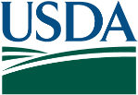
Certification Regarding Debarment, Suspension, and Other Responsibility Matters Primary Covered Transactions

The following statement is made in accordance with the Privacy Act of 1974 (5 U.S.C. § 552a, as amended). This certification is required by the regulations implementing Executive Order 12549, Debarment and Suspension, and 2 CFR § 180.335, Participants' responsibilities. The regulations were amended and published on August 31, 2005, in 70 Fed. Reg. 51865-51880. Copies of the regulations may be obtained by contacting the Department of Agriculture agency offering the proposed covered transaction.
According to the Paperwork Reduction Act of 1995, an agency may not conduct or sponsor, and a person is not required to respond to a collection of information unless it displays a valid OMB control number. The valid OMB control number for this information collection is 0505-0027. The time required to complete this information collection is estimated to average 15 minutes per response, including the time for reviewing instructions, searching existing data sources, gathering and maintaining the data needed, and completing and reviewing the collection of information. The provisions of appropriate criminal or civil fraud, privacy, and other statutes may be applicable to the information provided.
(Read instructions on page two before completing certification.)
- The prospective primary participant certifies to the best of its knowledge and belief, that it and its principals:
  - Are not presently debarred, suspended, or proposed for debarment, declared ineligible, or voluntarily excluded from covered transactions by any Federal department or agency;
  - Have not within a 3-year period preceding this proposal been convicted of or had a civil judgment rendered against them for commission of fraud or a criminal offense in connection with obtaining, attempting to obtain, or performing a public (Federal, State or local) transaction or contract under a public transaction; violation of Federal or State antitrust statutes or commission of embezzlement, theft, forgery, bribery, falsification or destruction of records, making false statements, or receiving stolen property;
  - Are not presently indicted for or otherwise criminally or civilly charged by a governmental entity (Federal, State or local) with commission of any of the offenses enumerated in paragraph (A.2.) of this certification; and
  - Have not within a 3-year period preceding this application/proposal had one or more public transactions (Federal, State or local) terminated for cause or default.
- Where the prospective primary participant is unable to certify to any of the statements in this certification, such prospective participant shall attach an explanation to this proposal.
ORGANIZATION NAME | PR/AWARD NUMBER OR PROJECT NAME
NAME(S) AND TITLE(S) OF AUTHORIZED REPRESENTATIVE(S)
SIGNATURE |  | DATE
In accordance with Federal civil rights law and U.S. Department of Agriculture (USDA) civil rights regulations and policies, the USDA, its Agencies, offices, and employees, and institutions participating in or administering USDA programs are prohibited from discriminating based on race, color, national origin, religion, sex, gender identity (including gender expression), sexual orientation, disability, age, marital status, family/parental status, income derived from a public assistance program, political beliefs, or reprisal or retaliation for prior civil rights activity, in any program or activity conducted or funded by USDA (not all bases apply to all programs). Remedies and complaint filing deadlines vary by program or incident.
Persons with disabilities who require alternative means of communication for program information (e.g., Braille, large print, audiotape, American Sign Language, etc.) should contact the responsible Agency or USDA's TARGET Center at (202) 720-2600 (voice and TTY) or contact USDA through the Federal Relay Service at (800) 877-8339. Additionally, program information may be made available in languages other than English.
To file a program discrimination complaint, complete the USDA Program Discrimination Complaint Form, AD-3027, found online at How to File a Program Discrimination Complaint and at any USDA office or write a letter addressed to USDA and provide in the letter all of the information requested in the form. To request a copy of the complaint form, call (866) 632-9992. Submit your completed form or letter to USDA by: (1) mail: U.S. Department of Agriculture, Office of the Assistant Secretary for Civil Rights, 1400 Independence Avenue, SW, Washington, D.C. 20250-9410; (2) fax: (202) 690-7442; or (3) email: program.intake@usda.gov. USDA is an equal opportunity provider, employer, and lender.

Instructions for Certification

- By signing and submitting this form, the prospective primary participant is providing the certification set out on page 1 in accordance with these instructions.
- The inability of a person to provide the certification required below will not necessarily result in denial of participation in this covered transaction. The prospective participant must submit an explanation of why it cannot provide the certification set out on this form. The certification or explanation will be considered in connection with the Department or agency's determination whether to enter into this transaction. However, failure of the prospective primary participant to furnish a certification or an explanation will disqualify such person from participation in this transaction.
- The certification in this clause is a material representation of fact upon which reliance was placed when the Department or agency determined to enter into this transaction. If it is later determined that the prospective primary participant knowingly rendered an erroneous certification, in addition to other remedies available to the Federal Government, the Department or agency may terminate this transaction for cause or default.
- The prospective primary participant must provide immediate written notice to the Department or agency to which this proposal is submitted if at any time the prospective primary participant learns that its certification was erroneous when submitted or has become erroneous by reason of changed circumstances.
- The terms "covered transaction," "debarred," "suspended," "ineligible," "lower tier covered transaction," "participant," "person," "primary covered transaction," "principal," "proposal," and "voluntarily excluded," as used in this clause, have the meanings set out in the Definitions and Coverage sections of the rules implementing Executive Order 12549, at 2 CFR Parts 180 and 417. You may contact the Department or agency to which this proposal is being submitted for assistance in obtaining a copy of those regulations.
- The prospective primary participant agrees by submitting this form that, should the proposed covered transaction be entered into, it may not knowingly enter into any lower tier covered transaction with a person who is debarred, suspended, declared ineligible, or voluntarily excluded from participation in this covered transaction, unless authorized by the Department or agency entering into this transaction.
- The prospective primary participant further agrees by submitting this form that it will include the clause titled "Certification Regarding Debarment, Suspension, Ineligibility and Voluntary Exclusion - Lower Tier Covered Transactions," provided by the Department or agency entering into this covered transaction, without modification, in all lower tier covered transactions and in all solicitations for lower tier covered transactions.
- A participant in a covered transaction may rely upon a certification of a prospective participant in a lower tier covered transaction that is not debarred, suspended, ineligible, or voluntarily excluded from the covered transaction, unless it knows that the certification is erroneous. A participant may decide the method and frequency by which it determines the eligibility of its principals. Each participant may, but is not required to, check the General Services Administration’s System for Award Management Exclusions database.
- Nothing contained in the foregoing shall be construed to require establishment of a system of records in order to render in good faith the certification required by this clause. The knowledge and information of a participant is not required to exceed that which is normally possessed by a prudent person in the ordinary course of business dealings.
- Except for transactions authorized under paragraph (6) of these instructions, if a participant in a covered transaction knowingly enters into a lower tier covered transaction with a person who is suspended, debarred, ineligible, or voluntarily excluded from participation in this transaction, in addition to other remedies available to the Federal Government, the Department or agency may terminate this transaction for cause or default.

Form AD-1047 (REV 12/22)
Page 2 of 2

ATTACHMENT D

Non-Collusion Affidavit
(Form must be completed and returned with bid.)

Houston County School District C/O HCSD, Perry, GA 31069

I state that I am ____________________________ of ____________________________________
Title Name of Vendor
And that I am authorized to make this affidavit on behalf of my firm, and its owners, directors, and officers. I am the person responsible in my firm for the price(s) and the amount of this bid and I state that this bid is made in good faith.

I state that:

- The price(s) and amounts of this bid have been arrived at independently and without consultation, communication or agreement with any other Vendor, Bidder, or potential Bidder; neither the approximate price(s) have been disclosed nor will they be disclosed before bid opening to any other Vendor, Bidder or potential Bidder.

- No attempt has been made or will be made to induce any firm or person to refrain from bidding on this contract, or to submit a bid higher than this bid, or to submit any intentionally high or noncompetitive bid or other form of complimentary bid.

__________________________________________________, its affiliates, subsidiaries, officers,
Name of Vendor
Directors and employees are not currently under investigation by any government agency and have not in the last three years been convicted or found liable for any act prohibited by State or Federal law in any jurisdiction, involving conspiracy or collusion with respect to bidding on any public contract.

I understand and my firm understands that any misstatement in this affidavit is and shall be treated as fraudulent concealment from the HCSD of the true facts relating to submission of bids for this contract.

________________________________ ________________________________
Name/Date Title or Position
________________________________
Signature
ATTACHMENT E

Lobbying Form & Disclosure
Complete this form to disclose lobbying activities pursuant to 31 U.S.C. 1352

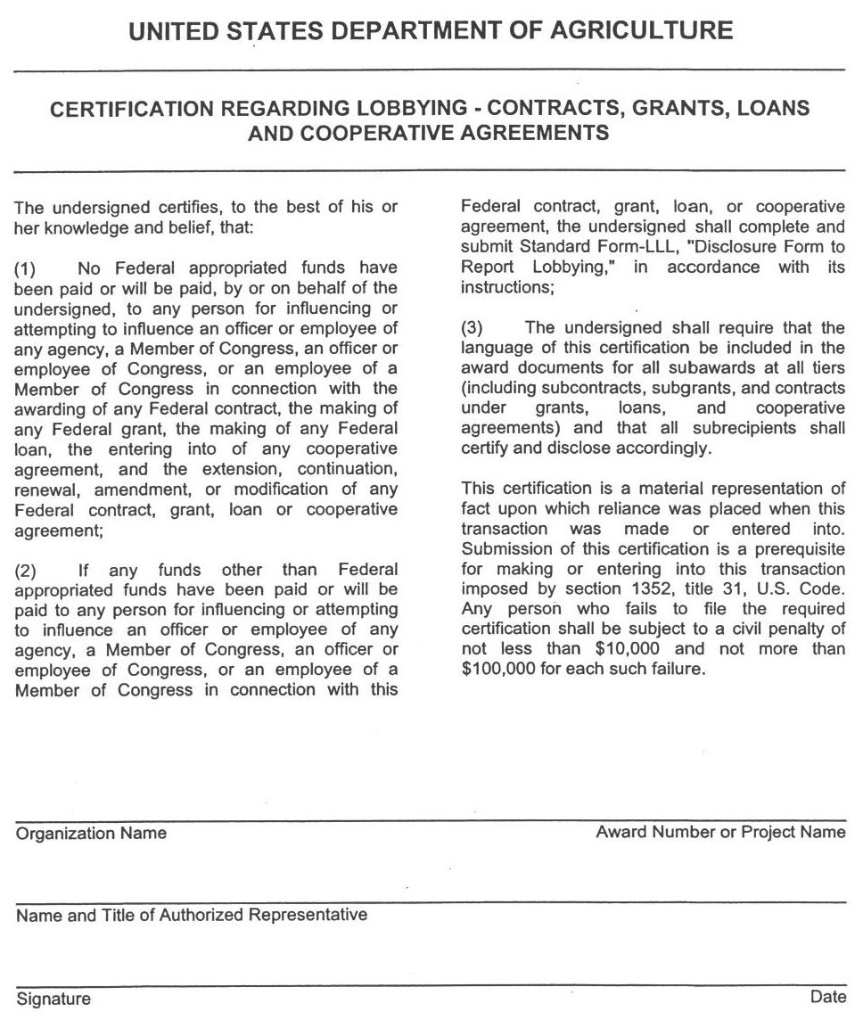

ATTACHMENT F
References

School/Business Name
Address

Contact Name
Contact Phone/email

School/Business Name
Address

Contact Name
Contact Phone/email

School/Business Name
Address

Contact Name
Contact Phone/email

ATTACHMENT I
School Calendar
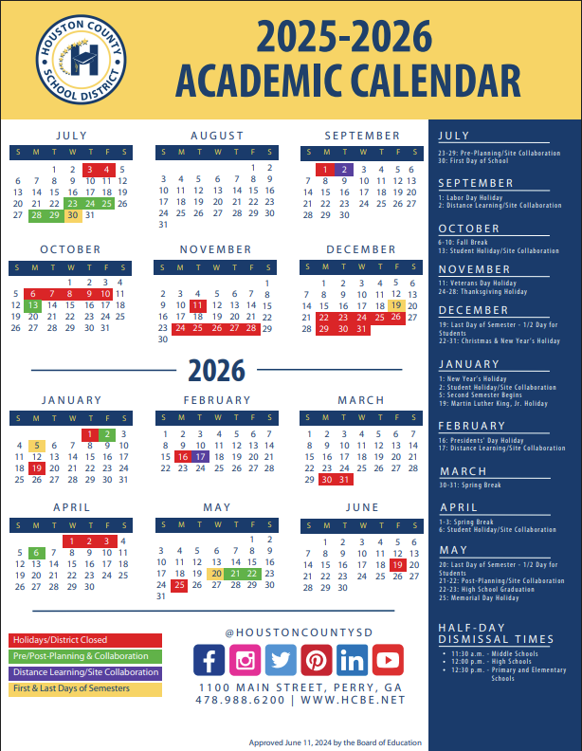

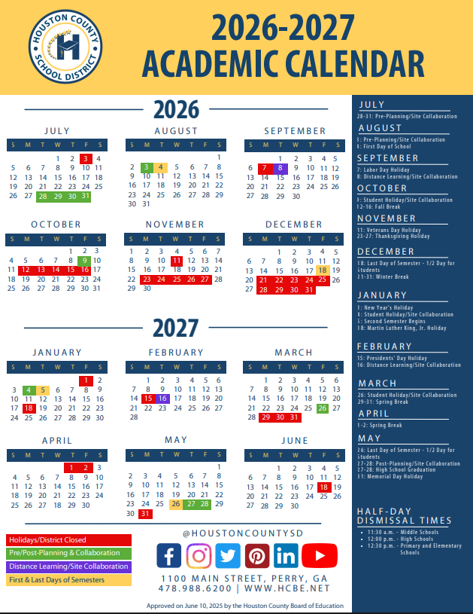

Information Regarding Logo

Printed logo for T-shirts
All t-shirts will require the Houston County School Nutrition Program logo to be screen printed over the left chest.

The dimensions of the logo on the shirts are approximately 3 inches wide by 3 ¼ inches tall (3” x 3 1/4”).

An image of the logo is provided below. Note that the gray areas of the logo pictured represent the fabric of the garment itself, not the screen print.



Embroidered logo for polos and jackets
All other shirts will require the Houston County School Nutrition Program logo to be embroidered over the left chest.

The dimensions of the logo on the shirts are approximately 3 inches wide by 3 ¼ inches tall (3” x 3 1/4”).

An image of the logo is provided below. Note that the gray areas of the logo pictured represent the fabric of the garment itself, not the embroidery.

Logo for aprons
All aprons will require the “H” logo to be embroidered at the top center.

The dimensions of the logo on the aprons are approximately 4 ¼ inches wide by 4 inches tall (4 ¼” x 4”).

An image of the logo is provided below. Note that the black areas of the logo pictured represent the black fabric of the garment itself, not the embroidery.

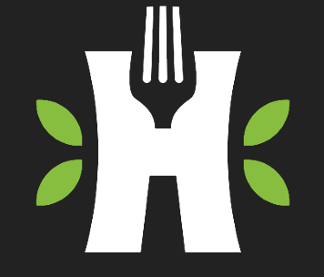

NOTE: Upon awarding the bid, an appropriate file version of the logo will be sent to the awarded vendor. The vendor should submit a sample of the embroidered logo and screen-printed logo for approval before putting the logo on all shirts and aprons. The vendor is responsible for ensuring the number of stitches that are included in the bid pricing is adequate to produce an excellent quality embroidered logo. The garment fabric should not show through the embroidery.

