
2026-2027
The following items are required in the Personnel Office:
∙ Opening Day Agendas- must list Compliance training, Title IX training, and Certified Evaluation training on the Agenda ∙ Opening Day Sign In for Staff
∙ Poster Check Off Sheet
**These three (3) items will be collected during Admin Academy in September. Please wait until then to turn them in to the Personnel Director.**

It is recommended to have a checkoff system in your building for all compliance documents.

ANNUAL EMPLOYEE COMPLIANCE TRAINING (2026-2027)
FOR PRINCIPAL USE
TABLE OF CONTENTS
DATE  COMPLETED | ACTIVITY/TRAINING
Frontline  (30 min) | Section 1. PROFESSIONAL CODE OF ETHICS: (Please give staff hard/paper copies)  Ethics for Educators  https://www.education.ky.gov/epsb/educatorethics  Document to Print for each Employee  Review in person during opening days & it is recommended to revisit during faculty meetings throughout the year.
Section 2. REVIEW OF DISTRICT POLICIES, TITLE IX POWERPOINT, AND EMPLOYEE HANDBOOK
Please complete this section during the opening day meeting
Title IX Sexual Harassment Compliance Training

Title IX Sexual Harassment Signature Sheet

Frontline  (20 min) | Section 3. CONFIDENTIALITY OF STUDENT INFORMATION TRAINING FERPA AND HIPPA
Frontline  (20 min) | Section 4. BLOODBORNE PATHOGEN TRAINING  Bloodborne Pathogens for School Employees
Follow  Instructions  provided by Dr. Kim Stevenson | Section 5. BULLYING PREVENTION TRAINING  Individual School Level Training Plan  - Bullying - PBIS in Practice  https://shop.ket.org/product/pbis-in-practice/  - Hit home so it will go to the homepage  - Click on K-12, then click on PBIS in Practice  - Click on Full Product Details" and add to cart, then view cart  - If you don't have a username and password, then create an account  - The program will show up in your course overview, or it will be emailed to you.  - Take two quizzes, print certificate; sign-off in office  - Principals or designee- upon completion of all employees from the school, send the form to Marie Hughes for PD credit.
Frontline  (20 min)  Grades PreK-5 Follow  Instructions  provided by Dr. Kim Stevenson Grades 6-12 | Section 6. SUICIDE PREVENTION TRAINING  Suicide Prevention  - Suicide Training https://jasonfoundation.my.site.com/lms/s/learning-plan-detail-standard?ltui__urlRecordId=a2EUu0000008YkTMAU&ltui__urlRedirect=learning-plan-detail-standard  - login in or create a username and password (I had to use my personal email because I couldn’t reset my password on my work email.)  - On left, select 1 hour course  - Then select and complete the 1 hour course titled: 2026 Bullying and Suicide  - Launch the 1 hour video; then take the quiz  - When you pass the quiz, find the certificate in under the Achievements tab  - Print certificate, Sign-off in office
Follow  Instructions  provided by Dr. Melanie Barrett | Section 7. RECOGNIZING & REPORTING CHILD ABUSE & NEGLECT Recognizing & Reporting Child Abuse & Neglect . Follow the path for your designated level.  2026- 2027 Child Abuse & Neglect Training
Frontline  (20 min) | Section 8. SEIZURE AWARENESS TRAINING  Epileptic Seizure Awareness
Frontline  (30 min) | Section 9. ACCEPTABLE USE OF TECHNOLOGY TRAINING: (Electronic Signature)  Internet Safety for School Employees
 | Section 10. COMPLIANCE POSTER INFORMATION
Section 11. ADDITIONAL BEGINNING OF THE YEAR PERSONNEL INFORMATION
Please review this section with staff during the opening day meetings.
Section 12:
Traceable Communication SB181
Please review this section with staff during the opening day meetings. Keep signed acknowledgement of training and understanding in your building.
SB 181 Training - Sign this acknowledgement and turn in to front office

Section 13: It is recommended that schools complete this together
Response to Active Shooter—
School district employees who wish to complete the training individually may:
- Visit KyLearningHub.org.
- Locate the Active Shooter Response Training for 2026–2027.
- Select Enroll.
- Sign in using their district credentials.
- Complete the course and all required components.
Employees who complete the course individually will receive an email from the KY Learning Hub with a link to their certificate.

Section 14: McKinney Vento Homeless Awareness Training
- WatchMcKinney Vento Homeless Awareness Training kJjcjPpAak B https://nche.ed.gov/basic-requirements-of-the-mckinney-vento-act-webinar/
- video
- Take quiz (click after the video then print certificate (have to get 100% - here is help if needed)
- Sign-off in office

**Sections assigned in Frontline DO NOT need to be reviewed on Opening Day, just mentioned where the training videos are located for staff completion. PLEASE HAVE A SYSTEM FOR TRACKING STAFF COMPLETION.** Please ensure new hires throughout the school year complete compliance training!
CHRISTIAN COUNTY PUBLIC SCHOOLS
COMPLIANCE & CERTIFIED TRAINING SIGN-IN SHEET
DATE ______________
Printed Name: | Signature: | Location (School):

Compliance Checklist
Frontline – Videos and quizzes:
- Epileptic Seizure Awareness
- Bloodborne Pathogens
- Ferpa/Hippa
- Internet Safety
- Ethics for Educators
- To access videos in Frontline:
  - Go to Professional Growth in Frontline
  - Under navigation (left hand side) click Insights
  - On right, scroll until you see Secondary Compliance under My Requests heading
  - Click Manage, then click open next to the compliance title, then launch to start
  - After each video, you must complete the quiz. Frontline will keep record of the quizzes when you complete them.

Non-Frontline Videos & Quizzes:
- WatchMcKinney Vento Homeless Awareness Training kJjcjPpAak B https://nche.ed.gov/basic-requirements-of-the-mckinney-vento-act-webinar/
- video
- Take quiz (click after the video then print certificate (have to get 100% - here is help if needed)
- Sign-off in office

- Recognize Child Abuse and Neglect – Recognizing & Reporting Child Abuse & Neglect
2026- 2027 Child Abuse & Neglect Training

- Suicide Training https://jasonfoundation.my.site.com/lms/s/learning-plan-detail-standard?ltui__urlRecordId=a2EUu0000008YkTMAU&ltui__urlRedirect=learning-plan-detail-standard

- login in or create a username and password (I had to use my personal email because I couldn’t reset my password on my work email.)
- On left, select 1 hour course
- Then select and complete the 1 hour course titled: 2026 Bullying and Suicide
- Launch the 1 hour video; then take the quiz
- When you pass the quiz, find the certificate in under the Achievements tab
- Print certificate, Sign-off in office

- Bullying - PBIS in Practice
https://shop.ket.org/product/pbis-in-practice/
  - Hit home so it will go to the homepage
  - Click on K-12, then click on PBIS in Practice
  - Click on Full Product Details and add to cart, then view cart
  - If you don't have a username and password, then create an account
  - The program will show up in your course overview or it will be emailed to you.
  - Take two quizzes, print certificate; sign-off in office
  - Principals or designee- upon completion of all employees from the school, send the form to Marie Hughes for PD credit.
- Traceable Communication SB181- Employees sign this acknowledgement form. Turn in to the front office.
- Response to Active Shooter-
School district employees who wish to complete the training individually may:
- Visit KyLearningHub.org.
- Locate the Active Shooter Response Training for 2026–2027.
- Select Enroll.
- Sign in using their district credentials.
- Complete the course and all required components.
Employees who complete the course individually will receive an email from the KY Learning Hub with a link to their certificate.

Title IX - Title IX Sexual Harassment Compliance Training
- Technology Acceptable Use Policy
- SB 181 Training - Sign this acknowledgement and turn in to front office

Turn in and sign-off completion to your school designee once all compliance trainings are complete.

Section 1. PROFESSIONAL CODE OF ETHICS TRAINING (Assigned in Frontline) Please give hard copy to all staff.
∙ Train all instructional staff in your building
∙ No later than the end of the first month of reporting for employment
∙ A copy of the Code of Ethics should be provided to all instructional staff, read by the staff member, and discussed by administration
Educator Ethics

Educator Ethics
Published: 2/24/2026 8:57 PM
​​​

​​​​​​​​​Code of Ethics​​​
KRS 161.028 requires that the Education Professional Standards Board develop a professional code of ethics. The Professional Code of Ethics for Kentucky Certified Personnel, codified in 16 KAR 1:020, establishes the ethical standards for Kentucky certified school personnel and establishes that violation of the code may be grounds for revocation or suspension of Kentucky teacher or administrator certification.

Certified Personnel in the Commonwealth
- Shall strive toward excellence, recognize the importance of the pursuit of truth, nurture democratic citizenship, and safeguard the freedom to learn and to teach;
- Shall believe in the worth and dignity of each human being and in educational opportunities for all;
- Shall strive to uphold the responsibilities of the education profession, including the following obligations to students, to parents, and to the education profession.
To students:
- Shall provide students with professional education services in a nondiscriminatory manner and in consonance with accepted best practice known to the educator;
- Shall respect the constitutional rights of all students;
- Shall take reasonable measures to protect the health, safety, and emotional well-being of students;
- Shall not use professional relationships or authority with students for personal advantage;
- Shall keep in confidence information about students which has been obtained in the course of professional service, unless disclosure serves professional purposes or is required by law;
- Shall not knowingly make false or malicious statements about students or colleagues;
- Shall refrain from subjecting students to embarrassment or disparagement; and
- Shall not engage in any sexually related behavior with a student with or without consent, but shall maintain a professional approach with students. Sexually related behavior shall include such behaviors as sexual jokes; sexual remarks; sexual kidding or teasing; sexual innuendo; pressure for dates or sexual favors; inappropriate physical touching, kissing, or grabbing; rape; threats of physical harm; and sexual assault.​
To parents:
- Shall make reasonable effort to communicate to parents information which should be revealed in the interest of the student;
- Shall endeavor to understand community cultures and diverse home environments of students;
- Shall not knowingly distort or misrepresent facts concerning educational issues;
- Shall distinguish between personal views and the views of the employing educational agency;
- Shall not interfere in the exercise of political and citizenship rights and responsibilities of others;
- Shall not use institutional privileges for private gain, for the promotion of political candidates, or for partisan political activities; and
- Shall not accept gratuities, gifts, or favors that might impair or appear to impair professional judgment, and shall not offer any of these to obtain special advantage.
To the education profession:
- Shall exemplify behaviors which maintain the dignity and integrity of the profession;
- Shall accord just and equitable treatment to all members of the profession in the exercise of their professional rights and responsibilities;
- Shall keep in confidence information acquired about colleagues in the course of employment, unless disclosure serves professional purposes or is required by law;
- Shall not use coercive means or give special treatment in order to influence professional decisions;
- Shall apply for, accept, offer, or assign a position or responsibility only on the basis of professional preparation and legal qualifications; and
- Shall not knowingly falsify or misrepresent records of facts relating to the educator's own qualifications or those of other professionals.

CODE OF ETHICS FOR CERTIFIED SCHOOL PERSONNEL
SOURCE: 16 KAR 1:020
Section 1. Certified personnel in the Commonwealth:
(1) Shall strive toward excellence, recognize the importance of the pursuit of truth, nurture democratic citizenship, and safeguard the freedom to learn and to teach; (2) Shall believe in the worth and dignity of each human being and in educational opportunities for all;
(3) Shall strive to uphold the responsibilities of the education profession, including the following obligations to students, to parents, and to the education profession: (a) To students:
1. Shall provide students with professional education services in a nondiscriminatory manner and in consonance with accepted best practice known to the educator; 2. Shall respect the constitutional rights of all students;
3. Shall take reasonable measures to protect the health, safety, and emotional well-being of students;
4. Shall not use professional relationships or authority with students for personal advantage;
5. Shall keep in confidence information about students which has been obtained in the course of professional service, unless disclosure serves professional purposes or is required by law;
6. Shall not knowingly make false or malicious statements about students or colleagues; 7. Shall refrain from subjecting students to embarrassment or disparagement; and 8. Shall not engage in any sexually related behavior with a student with or without
consent, but shall maintain a professional approach with students. Sexually related behavior shall include such behaviors as sexual jokes; sexual remarks; sexual kidding or teasing; sexual innuendo; pressure for dates or sexual favors; inappropriate physical touching, kissing, or grabbing; rape; threats of physical harm; and sexual assault.
(b) To parents:
1. Shall make reasonable effort to communicate to parents information which should be revealed in the interest of the student;
2. Shall endeavor to understand community cultures and diverse home environments of students;
3. Shall not knowingly distort or misrepresent facts concerning educational issues; 4. Shall distinguish between personal views and the views of the employing educational agency;
5. Shall not interfere in the exercise of political and citizenship rights and responsibilities of others;
6. Shall not use institutional privileges for private gain, for the promotion of political candidates, or for partisan political activities; and
7. Shall not accept gratuities, gifts, or favors that might impair or appear to impair professional judgment, and shall not offer any of these to obtain special advantage. (c) To the education profession:
1. Shall exemplify behaviors which maintain the dignity and integrity of the profession; 2. Shall accord just and equitable treatment to all members of the profession in the exercise of their professional rights and responsibilities;
3. Shall keep in confidence information acquired about colleagues in the course of employment, unless disclosure serves professional purposes or is required by law; 4. Shall not use coercive means or give special treatment in order to influence professional decisions;
5. Shall apply for, accept, offer, or assign a position or responsibility only on the basis of professional preparation and legal qualifications; and
6. Shall not knowingly falsify or misrepresent records of facts relating to the educator's own qualifications or those of other professionals.
Section 2. Violation of this administrative regulation may result in cause to initiate proceedings for revocation or suspension of Kentucky certification as provided in KRS 161.120 and 704 KAR 20:585.

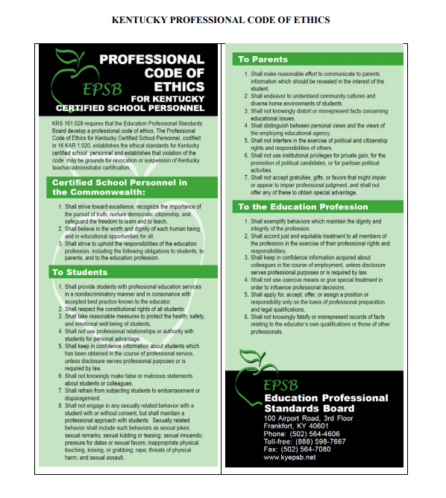

Section 2. REVIEW OF DISTRICT POLICIES AND EMPLOYEE HANDBOOK – Please review this section with all staff.
∙ Train all staff in your building
∙ No later than the end of the first month of reporting for employment
∙ Demonstrate how to access the Policy and Procedure Manual from the District website: www.christian.kyschools.us ; then “Our District” tab; then “Board of Education”; then “Board Agenda & Policies”. The link is highlighted in yellow:
http://policy.ksba.org/Chapter.aspx?distid=6

∙ Demonstrate how to access the Employee Handbooks from the District website: www.christian.kyschools.us ; then “Our District”, then “CCPS Employee Handbook “2025- 2026 Employee
Handbook”.
∙ Specifically review the indicted policies/sections of the Handbook:
Topic | Policy #s
Harassment/Discrimination/Title IX | 03.162/03.262
Confidentiality | 03.111/03.211
Supervision Responsibilities and Bullying | 03.162/03.262/09.422/ 09.42811
Required Reporting-READ ALL | Numerous

REQUIRED REPORTS
Although you may be directed to make additional reports, the following reports are required by law and/or Board policy:
∙ Within seventy-two (72) hours of the discovery or notification of a security breach, the District shall notify the Commissioner of the Kentucky State Police, the Auditor of Public Accounts, the Attorney General, and the Education Commissioner. 01.61

∙ An employee shall report to the Superintendent if the employee has been found by the Cabinet for Health and Family Services to have abused or neglected a child, and if the employee has waived the right to appeal such a substantiated finding or the finding has been upheld upon appeal. 03.11/03.21
∙ Report to the immediate supervisor damaged, lost, stolen, or vandalized school property or if District property has been used for unauthorized purposes. 03.1321/03.2321
∙ If you know or believe that the District’s alcohol-free/drug-free policies have been violated, promptly make a report to the local police department, sheriff, or Kentucky State Police. This is required if you know or have reasonable cause to believe that conduct has occurred which constitutes the use, possession, or sale of controlled substances on the school premises or within one thousand (1,000) feet of school premises, on a school bus, or at a school sponsored or sanctioned event. 03.13251/03.23251/09.423
∙ Upon the request of a victim, school personnel shall report an act of domestic violence and abuse or dating violence and abuse to a law enforcement officer. School personnel shall discuss the report with the victim prior to contacting a law enforcement officer.
School personnel shall report to a law enforcement officer when s/he has a belief that the death of a victim with whom s/he has had a professional interaction is related to domestic violence and abuse or dating violence and abuse. 03.13253/03.23253/09.425
∙ Report potential safety or security hazards to the Principal and notify your supervisor immediately after sustaining a work-related injury or accident. 03.14/03.24/05.4
∙ Report to the Principal/immediate supervisor or the District’s Title IX Coordinator if you, another employee, a student, or a visitor to the school or District is being or has been subjected to harassment or discrimination. 03.162/03.262/09.42811
∙ Employees who believe or have been made aware that they or any other employee, student, or visitor has been subject to Title IX Sexual Harassment shall report it to the TIXC. Failure to make such a report shall be grounds for discipline up to and including termination. If the knowledge of the reporting party gives rise to reasonable cause to believe that the reported conduct constitutes child abuse Policy 09.227 or a reportable criminal offense Policy 09.221, notification of state officials shall be made as required by law. 03.1621/03.2621/09.428111
∙ If you suspect that financial fraud, impropriety or irregularity has occurred, immediately report those suspicions to the Principal or the Superintendent. If the
Superintendent is the alleged party, employees should address the complaint to the Board chairperson. 04.41
∙ Report to the Principal any student who is missing during or after a fire/tornado/bomb threat drill or evacuation. 05.41 AP.1/05.42 AP.1/05.43 AP.1
∙ When notified of a bomb threat, scan the area noting any items that appear to be out of place, and report the same to the Principal/designee. 05.43 AP.1
∙ If you know or believe that the District’s weapon policy has been violated, promptly make a report to the local police department, sheriff, or Kentucky State Police. This is required when you know or have reasonable cause to believe that conduct has occurred which constitutes the carrying, possession, or use of a deadly weapon on the school premises or within one thousand (1,000) feet of school premises, on a school bus, or at a school sponsored or sanctioned event. 05.48
∙ District bus drivers taking medication either by prescription or without prescription shall report to their immediate supervisor and shall not drive if that medication may affect the driver's ability to safely drive a school bus or perform other driver responsibilities. 06.221
∙ District employees who know or have reasonable cause to believe that a student has been the victim of a violation of any felony offense specified in KRS Chapter 508 (assault and related offenses) committed by another student while on school premises, on school-sponsored transportation, or at a school sponsored event shall immediately cause an oral or written report to be made to the Principal of the school attended by the victim.
The Principal shall notify the parents, legal guardians, or other persons exercising custodial control or supervision of the student when the student is involved in such an incident.
Within forty-eight (48) hours of the original report of the incident, the Principal also shall file with the Board and the local law enforcement agency or the Department of Kentucky State Police or the County Attorney a written report containing the statutorily required information. 09.2211
∙ Notify the Principal as soon as possible when you use seclusion or physical restraint with a student, but no later than the end of the school day on which it occurs, and document in writing the incident by the end of the next school day. 09.2212
∙ If you know or have reasonable cause to believe that a child under eighteen (18) is dependent, abused or neglected, or a victim of human trafficking, or is a victim of female genital mutilation, you shall immediately make an oral report to a local law enforcement agency or Kentucky State Police, the Cabinet for Health and Family Services or its designated representative, the Commonwealth’s or County Attorney, and then make a report to the Principal. (See Child Abuse section.) 09.227
∙ District employees shall report to the Principal or to their immediate supervisor those situations that threaten, harass, or endanger the safety of students, other staff members, or visitors to the school or District. Such instances shall include, but are not limited to, bullying or hazing of students and harassment/discrimination of staff, students or
visitors by any party. In serious instances of peer-to-peer bullying/hazing/harassment, employees must report to the alleged victim’s Principal, as directed by Board Policy 09.42811.
In certain cases, employees must do the following:
1. Report bullying and hazing to appropriate law enforcement authorities as required by policy 09.2211; and
2. Investigate and complete documentation as required by policy 09.42811 covering federally protected areas. 09.422
∙ Report to the Principal any threats you receive (oral, written or electronic). 09.425

Section 3. CONFIDENTIALITY OF STUDENT INFORMATION TRAINING (Assigned in Frontline)
∙ Train all staff in your building
∙ No later than the end of the first month of reporting for employment
FAMILY EDUCATIONAL RIGHTS AND PRIVACY ACT
If during the course of this agreement, Christian County Public Schools discloses to the contractor any data protected by the Family Educational Rights and Privacy Act of 1974 (FERPA), as amended, and its regulations, and data protected by the Richard B. Russell National School Lunch Act (42 U.S.C. 1751 et seq)(NSLA) and Child Nutrition Act of 1966 (42 U.S.C. 1771 et seq.)(CNA) the contractor is bound by the confidentiality, security and disclosure requirements and restrictions stated in FERPA, NSLA and CNA and will enter into a confidentiality agreement and ensure its employees and contractors execute affidavits of nondisclosure as required by Christian County Public Schools. The confidentiality agreement and affidavits will then become part of this original agreement.

Christian County Public Schools
EMPLOYEE OR CONTRACTOR GENERAL AFFIDAVIT OF NONDISCLOSURE Employee or Contractor Name______________________________________
Title________________________________________
Office________________________________________
Supervisor________________________________________
Address _______________________________________
Phone________________________________________
If, in the performance of my official job duties, I am provided access to confidential information (information designated as confidential by FERPA, NSLA, CNA, KRS 61.931(6), or other federal or state law), by signing this document I agree to the following:
• I will not permit access to confidential information to persons not authorized by the Christian County Public Schools.
• I will maintain the confidentiality of the data or information.
• I will not access data of persons related or known to me for personal reasons.
• I will not reveal any individually identifiable information furnished, acquired, retrieved, or assembled by me or others for any purpose other than statistical purposes specified in a Christian County Public Schools survey, project, or proposed research.
• I will report, immediately and within twenty-four (24) hours, any known reasonably believed instances of missing data, data that has been inappropriately shared, or data taken off site
∙ to my immediate supervisor, Associate Commissioner, and
∙ to the Division of Human Resources if I am a Christian County Public Schools employee or
o to the Christian County Public Schools Office for whom I perform work under the contract if I am a Christian County Public Schools contractor or an employee of a Christian County Public Schools contractor.
I understand that procedures must be in place for monitoring and protecting confidential information.
• I understand and acknowledge that FERPA-protected information obtained under provisions of Family Educational Rights and Privacy Act of 1974 (FERPA) as an employee or contractor of Christian County Public Schools is confidential information. Christian County Public Schools protects information in students’ education records that are maintained by an educational agency or institution or by a party acting for the agency or institution, and includes, but is not limited to the student's name, the name of the student's parent or other family members, the address of the student or student's family, a personal identifier, such as the student's social security number, student number, or biometric record, other indirect identifiers, such as the student's date of birth, place of birth, and mother's maiden name, and other information that, alone or in combination, is linked or linkable to a specific student that would allow a reasonable person in the school community, who does not have personal knowledge of the relevant circumstances, to identify the student with reasonable certainty.
• I understand that any unauthorized disclosure of confidential information is illegal as provided in FERPA and in the implementing of federal regulations found in 34 CFR, Part 99. The penalty for unlawful disclosure is a fine of not more than $250,000 (under 18 U.S.C. 3571) or imprisonment for not more than five years (under 18 U.S.C. 3559), or both. • I understand and acknowledge that children’s free and reduced price meal and free milk eligibility information or information from the family’s application for eligibility, obtained under provisions of the Richard B. Russell National School Lunch Act (42 U.S.C. 1751 et seq)(NSLA) or Child Nutrition Act of 1966 (42 U.S.C. 1771 et seq.)(CNA) and the regulations implementing these Acts, is confidential information.
• I understand that any unauthorized disclosure of confidential free and reduced price lunch information or information from an application for this benefit is illegal as provided in the Richard B. Russell National School Lunch Act (42 U.S.C. 1751 et seq)(NSLA) or Child Nutrition Act of 1966 (42 U.S.C. 1771 et seq.)(CNA) and the regulations implementing these Acts, specifically 7 C.F.R 245.6. The penalty for unlawful disclosure is a fine of not more than $1,000.00 (under 7 C.F.R. 245.6) or imprisonment for up to one year (under 7 C.F.R. 245.6), or both.
• I understand that KRS 61.931 also defines “personal information” to include: ∙ an individual's first name or first initial and last name; personal mark; or unique biometric or genetic print or image, in combination with one (1) or more of the following data elements:
∙ An account number, credit card number, or debit card number that, in combination with any required security code, access code, or password, would permit access to an account;(b) A Social Security number;
∙ A taxpayer identification number that incorporates a Social Security number; ∙ A driver's license number, state identification card number, or other individual identification number issued by any agency;
∙ A passport number or other identification number issued by the United States government; or
∙ Individually identifiable health information as defined in 45 C.F.R. sec. 160.103, except for education records covered by the Family Educational Rights and Privacy Act, as amended, 20 U.S.C. sec. 1232g.
• I understand that other federal and state privacy laws protect confidential data not otherwise detailed above and I acknowledge my duty to maintain confidentiality of that data as well.
• I understand that any personal characteristics that could make the person’s identity traceable, including membership in a group such as ethnicity or program area, are protected.
• In addition, I understand that any data sets or output reports that I may generate using confidential data are to be protected. I will not distribute to any unauthorized person any data sets or reports that I have access to or may generate using confidential data. I understand that I am responsible for any computer transactions performed as a result of access authorized by use of sign on/password(s).
Employee Signature________________________________________
Date________________________________________
Division of HR Representative Signature___ Leslie Lancaster____
Date_______________________________________
**Please keep this document on file at your school or building level.**
Section 4. BLOODBORNE PATHOGEN TRAINING (Assigned in Frontline)
∙ Train all staff in your building
∙ No later than the end of the first month of reporting for employment
CHRISTIAN COUNTY
BOARD OF EDUCATION
BLOODBORNE PATHOGEN EXPOSURE CONTROL PLAN

POLICY
The Christian County Board of Education is committed to providing a safe and healthy work environment for all staff. In pursuit of this endeavor, the following Exposure Control Plan (ECP) is provided to eliminate or minimize occupational exposure to bloodborne pathogens in accordance with OSHA standard 29 CFR 1910.1030, “Occupational Exposure to Bloodborne Pathogens.”
The ECP is a key document to assist in implementing and ensuring compliance with the standard, thereby protecting our employees. The ECP includes:
*Determination of employee exposure
*Implementation of various methods of exposure control, including: Universal precautions
Engineering and work practice controls
Personal Protective Equipment
Housekeeping
*Hepatitis B vaccination
*Post-exposure evaluation and follow-up
*Communication of hazards to employees and training
*Recordkeeping
*Procedures for evaluation of circumstances surrounding an exposure incident
The methods of implementation of these elements of the standard are discussed in the subsequent pages of this ECP.
PROGRAM ADMINISTRATION
● The District Health Director and the Director of Personnel are responsible for the implementation of the ECP. They will maintain, review, and update the ECP at least annually, and whenever necessary to include new or modified tasks and procedures. o Contact person/phone number:
Megan Kidd, RN, District Health Director 270-887-7000 Leslie Lancaster , Director of Personnel 270-887-7002
● Those employees who are determined to have occupational exposure to blood or other potentially infectious materials (OPIM) must comply with the procedures and work practices outlined in this ECP.
● District Health Director and/or Facilities Director will maintain and provide all necessary personal protective equipment (PPE), engineering controls (e.g., sharps containers), labels, and red bags as required by the standard. The above named individuals will ensure that adequate supplies of the aforementioned equipment are available in the appropriate sizes.
● District Health Director and Director of Personnel will be responsible for ensuring that all medical actions required are performed and that appropriate employee health and OSHA records are maintained.
● District Health Director and Director of Personnel will be responsible for training, documentation of training, and making the written ECP available to employees, OSHA, and NIOSH representatives.
EMPLOYEE EXPOSURE DETERMINATION
The following is a list of all job classifications at our establishment in which all employees have occupational exposure:
JOB TITLE DEPARTMENT LOCATION
See Personnel for List - 270- 887-7002
The following is a list of job classifications in which some employees at our establishment have occupational exposure:
JOB TITLE DEPARTMENT/LOCATION TASK/PROCEDURE See Personnel for List - 270-887-7002
METHODS OF IMPLEMENTATION AND CONTROL
Universal Precautions
All employees will utilize universal precautions.
Exposure Control Plan
Employees covered by the bloodborne pathogens standard receive an explanation of this ECP during their initial training session. It will also be reviewed in their annual refresher training. All employees have an opportunity to review this plan at any time during their work shifts by contacting their principal/building supervisor. If requested,
we will provide an employee with a copy of the ECP free of charge and within 15 days of the request.
District Health Director and Director of Personnel are responsible for reviewing and updating the ECP annually or more frequently as necessary to reflect any new or modified tasks and procedures which affect occupational exposure and to reflect new or revised employee positions with occupational exposure.
Engineering Controls and Work Practices
Engineering controls and work practice controls will be used to prevent or minimize exposure to bloodborne pathogens.
Sharps disposal containers are inspected and maintained or replaced by the school nurse whenever necessary to prevent overfilling.
Personal Protective Equipment (PPE)
PPE is provided to our employees at no cost to them. Training is provided by the school nurse in the use of the appropriate PPE for the tasks or procedures employees will perform.
The types of PPE available to employees are disposable gloves approved for medical use, repellent gowns, face and eye protection, and resuscitation devices.
PPE is located in your building and may be obtained through your school nurse, principal, and/or custodians. These individuals are responsible for maintaining an adequate supply of PPE at your school.
All employees using PPE must observe the following precautions:
● Wash hands immediately or as soon as feasible after removal of gloves or other PPE.
● Remove PPE after it becomes contaminated, and before leaving the work area. Used PPE may be disposed of in designated areas in your building.
● Wear appropriate gloves when it can be reasonably anticipated that there may be hand contact with blood or OPIM, and when handling or touching contaminated items or surfaces; replace gloves if torn, punctured, contaminated, or if their ability to function as a barrier is compromised.
● Utility gloves may be decontaminated for reuse if their integrity is not compromised; discard utility gloves if they show signs of cracking, peeling, tearing, puncturing, or deterioration.
● Never wash or decontaminate disposable gloves for reuse.
● Wear appropriate face and eye protection when splashes, sprays, spatters, or droplets of blood or OPIM pose a hazard to the eye, nose, or mouth. ● Remove immediately or as soon as feasible any garment contaminated by blood or OPIM, in such a way as to avoid contact with the outer surface. ● Each school will have a biohazard kit on site for potential biohazard material clean up, and or blood borne pathogen spills.
Housekeeping
Regulated waste is placed in containers which are closable, constructed to contain all contents and prevent leakage, appropriately labeled or color-coded, and closed prior to removal to prevent spillage or protrusion of contents during handling.
Contaminated sharps are discarded immediately or as soon as possible in containers that are closable, puncture resistant, leak-proof on sides and bottoms, and labeled or color-coded appropriately. Sharps disposal containers are available in the first aid room.
Bins and pails (e.g. wash or emesis basins) are cleaned and decontaminated as soon as feasible after visible contamination.
Broken glassware which may be contaminated is picked up using mechanical means, such as a brush and dust pan.
Laundry
The following laundering requirements must be met:
● Handle contaminated laundry as little as possible, with minimal agitation. ● Place wet contaminated laundry in leak-proof, labeled or color-coded containers before transport. Use red bags or bags marked with biohazard symbol for this purpose. ● Wear appropriate PPE when handling and/or sorting contaminated laundry.
Labels
School nurse will ensure warning or biohazard labels are affixed or red bags are used as required if regulated waste or contaminated equipment is brought into the facility. Employees are to notify the District Health Director if they discover regulated waste containers, refrigerators containing blood or OPIM, contaminated equipment, etc. without proper labels.
HEPATITIS B VACCINATION & POST-EXPOSURE FOLLOW-UP
The Hepatitis B vaccine and vaccination series is available to all employees who have had an occupational exposure, incident, as well as post-exposure evaluation and follow up.
Employers ensure that all medical evaluations and procedures including the Hepatitis B vaccine and vaccination series and post-exposure evaluation and follow-up, including prophylaxis are:
● Made available at no cost to the employee.
● Made available to the employee at a reasonable time and place. ● The health facility with whom the board contracts ensure that all medical evaluations and procedures are:
o Performed by or under the supervision of a licensed physician or other licensed health care professional.
o Provided according to recommendations of the U.S. Public Health Service current at the time these evaluations and procedures take place.
o Ensures that all laboratory tests are conducted by an accredited laboratory at no cost to the employee.
Employers do not make participation in a pre-screening program a prerequisite for receiving Hepatitis B vaccination.
If the employee initially declines Hepatitis B vaccination but at a later date while still covered under the standard decides to accept the vaccination, the employer makes available the Hepatitis B vaccination at that time.
Employers assure that employees who decline the Hepatitis B vaccination offered by the employer sign a vaccination declination form.
If routine booster dose(s) of Hepatitis B are recommended by the U.S. Public Health Service at a future date, such booster dose(s) are made available in accordance with OSHA regulations.
Following a report of an exposure incident, the contract health facility makes immediately available to the exposed employee a confidential medical evaluation and follow-up, including at least the following elements:
1. Documentation of route(s) of exposure, and the circumstances under which the exposure incident occurred as reported by the exposed employee.
2. Identification and documentation of the source individual, unless the employer can establish that identification is not feasible or prohibited by state or local law.
● After consent is obtained, the source individual’s blood will be tested as soon as feasible in order to determine HBV and HIV status. If consent is not obtained, the employer will establish that legally required consent cannot be obtained. When the source individual’s consent is not required by law, the source individual’s blood, if available, will be tested and the results documented.
● When the source individual is known to be infected with HBV or HIV, testing for the source individual’s known HBV or HIV status need not be repeated. ● Results of the source individual’s testing will be made available to the exposed employee by the contracted health facility, and the employee will be informed of applicable laws and regulations concerning disclosure of the identity and infectious status of the source individual.
3. Collection and testing of blood for HBV and HIV serological status.
● The exposed employee’s blood will be collected as soon as feasible and tested after consent is obtained.
● If the employee consents to baseline blood collection, but does not give consent at that time for HIV serologic testing, the sample will be preserved for at least 90 days. If within 90 days of the exposure incident, the employee elects to have the baseline sample tested, such testing will be done.
4. Post-Exposure prophylaxis, when medically indicated, as recommended by the U.S. Public Health Service.
5. Counseling
6. Evaluation of reported illness
ADMINISTRATION OF POST-EXPOSURE EVALUATION AND FOLLOW-UP
Director of Personnel ensures that the health care professional responsible for employee’s Hepatitis B vaccination and post-exposure evaluation and follow-up are given a copy of OSHA’s bloodborne pathogens standard.
Director of Personnel ensures that the health care professional evaluating an employee after an exposure incident receives the following:
● a description of the employee’s job duties relevant to the exposure incident ● route(s) of exposure
● circumstances of exposure
● if possible, results of the source individual’s blood test
● relevant employee medical records, including vaccination status
Director of Personnel provides the employee with a copy of the evaluating health care professional’s written opinion within 15 days after completion of the evaluation. ● The written opinion for Hepatitis B vaccination shall be limited to whether Hepatitis B vaccination is indicated for an employee, and if the employee has received such vaccination.
● The written opinion for post-exposure evaluation and follow-up shall be limited to only include that the employee has been informed of evaluation results and any medical conditions resulting from exposure which require further evaluation and treatment. All other findings or diagnoses shall remain confident and shall not be included in the written report.
PROCEDURES FOR EVALUATION THE CIRCUMSTANCES SURROUNDING AN EXPOSURE INCIDENT
District Health Director and Director of Personnel will review the circumstances of all exposure incidents to determine:
● engineering controls in use at the time
● work practices followed
● a description of the device being used
● protective equipment or clothing that was used at the time of the exposure incident (gloves, eye shields, etc.)
● procedure being performed when the incident occurred
● employee’s training
EMPLOYEE TRAINING
All employees who have occupational exposure to bloodborne pathogens receive training conducted by the school nurse or on the specified online video (Personnel via
Frontline Program). The individual nurse will be a licensed registered nurse or practical nurse.
All employees who have occupational exposure to bloodborne pathogens receive training in the epidemiology, symptoms, and transmission of bloodborne pathogen diseases. In addition, the training program covers, at a minimum, the following elements:
● a copy and explanation of the standard
● an explanation of our ECP and how to obtain a copy
● an explanation of methods to recognize tasks and other activities that may involve exposure to blood and OPIM, including what constitutes an exposure incident ● an explanation of the use and limitations of engineering controls, work practices, and PPE
● an explanation of the types, uses, location, removal, handling, decontamination, and disposal of PPE
● an explanation of the basis for PPE selection
● information on the Hepatitis B vaccine, including information on its efficacy, safety, method of administration, the benefits of being vaccinated, and that the vaccine will be offered free of charge (if exposure occurs)
● information on the appropriate actions to take and persons to contact in an emergency involving blood or OPIM
● an explanation of the procedure to follow if an exposure incident occurs, including the method of reporting the incident and the medical follow-up that will be made available
● information on the post-exposure evaluation and follow-up that the employer is required to provide for the employee following an exposure incident ● an explanation of the signs and labels and/or color coding required by the standard and used at this facility
● an opportunity for interactive questions and answers with the person conducting the training session
Training materials for this facility are available in the Frontline Program via Personnel. Employees may also ask for information in the front office and/or nurse office.
RECORDKEEPING
Training Records
Training records are completed for each employee upon completion of training. These documents will be kept for at least three years at each school. Each employee will be logged as completing this training in the Frontline Program via Personnel.
The training records include:
● the dates of the training sessions
● the contents or a summary of the training sessions
● the names and qualifications of persons conducting the training ● the names and job titles of all persons attending the training sessions
Employee training records are provided upon request to the employee or the employee’s authorized representative within 15 working days. Such requests should be addressed to the Director of Personnel.
Medical Records
Medical records are maintained for each employee with occupational exposure in accordance with 29 CFR 1910.20, “Access to Employee Exposure and Medical Records.” Director of Personnel is responsible for maintenance of the required medical records. These confidential records are kept at the CCBOE personnel office for at least the duration of employment plus 30 years.
Employee medical records are provided upon request of the employee or to anyone having written consent of the employee within 15 working days. Such requests should be sent to Christian County Board of Education, 200 Glass Avenue, Hopkinsville, KY 42240, ATTN: Director of Personnel.
OSHA Recordkeeping
An exposure incident is evaluated to determine if the case meets OSHA’s Recordkeeping Requirements (29 CFR 1904). This determination and the recording activities are completed by the District Health Director and Director of Personnel.
Hepatitis B Vaccine Declination Form
The following statement of declination of the hepatitis B vaccine must be signed by an employee who:
∙ Chooses not to accept the vaccine.
∙ Has had appropriate training regarding hepatitis B, hepatitis B
vaccination, the efficacy, safety, method of administration and
benefits of vaccination, given free of charge to the employee.
I understand that due to my occupational exposure to blood or other potentially infectious materials I may be at risk of acquiring hepatitis B virus (HBV) infection. I have been given the opportunity to be vaccinated with hepatitis B vaccine, at no charge to myself. However, I decline hepatitis B vaccination at this time. I understand that by declining this vaccine I continue to be at risk of acquiring hepatitis B, a serious disease. If in the future I continue to have occupational exposure to blood or other potentially infectious materials and I want to be vaccinated with hepatitis B vaccine, I can receive the vaccination series at no charge to me.
Employee Signature:
Date:
This statement is not a waiver; employees can request and receive the hepatitis B vaccination at a later date if they remain occupationally at risk for hepatitis B.
An employer cannot require:
∙ Employees to waive liability in order to receive the vaccine
∙ Participation in pre-screening as a prerequisite for receiving the vaccine.

Section 5. BULLYING PREVENTION TRAINING Follow instructions provided by Dr. Kim Stevenson
Individual school level training
∙ Train all staff in your building
∙ No later than the end of the first month of reporting for employment
This one-hour course meets the Kentucky training requirement for teachers and other school personnel pursuant to 704 KAR 7:160, "Use of Physical Restraint and Seclusion in Public Schools". It showcases authentic models of effective positive behavior systems with school wide, classroom, and individual behavioral plans and demonstrates strategies for improving student achievement and behavior. Each module features authentic classroom video highlighting best practices and methods. At the end of this course, learners earn a Certificate of Completion for two hours of PD and EILA credit.

https://jasonfoundation.my.site.com/lms/s/learning-plan-detail-standard?ltui__urlRecordId=a2EUu0000008YkTMAU&ltui__urlRedirect=learning-plan-detail-standard

This training module delves into the problem of bullying in schools and its relation to suicide. Facts, myths, and research regarding bullying and suicide are discussed. Suggested protective factors and recommendations are provided for educators. The training module and research are presented by Dr. Scott Poland and Richard Lieberman, noted experts in the suicide prevention field.

∙ Follow instructions provided by Dr. Kim Stevenson
Section 6. SUICIDE PREVENTION TRAINING
Below are the links for the Bully and Suicide Training that meets the compliance requirements of 704 KAR 7:160 and KRS 156.095

Once staff have completed the modules, it will produce a certificate of completion. Please make sure someone is assigned in your building to collect the certificates. Once everyone has submitted them, please send the staff roster (make sure to identify completion) to Sarah West. She will work with Marie Hughes on teachers' PD hours. You will keep the certificates in the event they are needed in your school.

Please note the Suicide Training is only required for 6th - 12th grade teachers and staff

- Suicide Training https://jasonfoundation.my.site.com/lms/s/learning-plan-detail-standard?ltui__urlRecordId=a2EUu0000008YkTMAU&ltui__urlRedirect=learning-plan-detail-standard

- login in or create a username and password (I had to use my personal email because I couldn’t reset my password on my work email.)
- On left, select 1 hour course
- Then select and complete the 1 hour course titled: 2026 Bullying and Suicide
- Launch the 1 hour video; then take the quiz
- When you pass the quiz, find the certificate in under the Achievements tab
- Print certificate, Sign-off in office

Section 7. RECOGNIZING & REPORTING CHILD ABUSE & NEGLECT ∙ Follow instructions provided by Dr. Melanie Barrett ∙ Train all staff
∙ By September 30th

- Recognize Child Abuse and Neglect – Recognizing & Reporting Child Abuse & Neglect
2026- 2027 Child Abuse & Neglect Training

Section 8. SEIZURE AWARENESS TRAINING
(Assigned in Frontline)
∙ Train all staff
∙ By September 30th
Summary of HB 147 (Seizure Bill)
∙ Amends KRS 158.832, KRS 158.838
∙ Each school must at least 1 employee on duty during the school day with training on glucagon, insulin, and seizure rescue medication of medication prescribed to treat seizure disorder symptoms (that is USFDA approved for that reason).
∙ Any training program or guidelines adopted by any state agency for training of school personnel in the health care needs of students diagnosed with seizure disorder shall be fully consistent with best practice guidelines from medical professionals with expertise in seizure treatment.
∙ The parent or guardian of each student diagnosed with a seizure disorder shall collaborate with school personnel to implement the seizure action plan. (The Kentucky Board of Education shall promulgate administrative regulations establishing procedures for the implementation of seizure action plans.) The seizure action plan shall be kept in the office of the school nurse or school administrator.
∙ Any school personnel or volunteers responsible for the student shall be given notice of the seizure action plan, the identity of the school employee, or employees trained and the method by which the trained school employee or employee may be contacted in the event of an emergency.
∙ At least 1 hour of self-study review of seizure disorder materials shall be required for all principals, guidance counselors and teachers hired after July 1. 2019. Currently employed principals, guidance counselors and teacher must also complete the 1-hour self-study, if they have not already done so. This self-study review
shall be in addition to the four days required under KRS 158.070 (3)(a) and is a one-time requirement - NOT an annual requirement.

Epilepsy Training Resources
Use this link ONLY if staff is not assigned to Frontline Professional Learning.
https://www.youtube.com/watch?v=PAl9LDq9yas&list=PLpIN29lx9vI54NTBCZPwqz37IzX4AbakN&index=2
For large groups, The Epilepsy Foundation of Kentuckians will provide free trainings for school staff. Phone: (866) 275-1078.

Section 9. ACCEPTABLE USE OF TECHNOLOGY TRAINING
(Assigned in Frontline with Electronic Signing managed through school level STA)

- Technology Acceptable Use Policy

Section 10. COMPLIANCE POSTER INFORMATION
∙ Copies of Required posters to be posted in your building can be found on the next pages of this section
∙ The Check-off list (next page) must be signed and returned to the Personnel office

POSTER CHECK-OFF SHEET
By Law the following information should be posted in each building. Please check that all information is posted in your building and send this Poster Check-Off Sheet back to Personnel along with Opening Day Agenda and Staff Sign In Sheet.
School/Building _______________________________________________________
______ OSHA – Job Safety and Health
______ Employee Rights
______ Equal Employment Opportunity
______ Kentucky Child Labor Laws
______ Kentucky Wage and Hour Laws
______ Wage Discrimination Because of Sex
______ Safety and Health on the Job
______ Family and Medical Leave Act --- Employee Rights and Responsibility
______ Worker’s Compensation
Signature _________________________________________ Date________________________
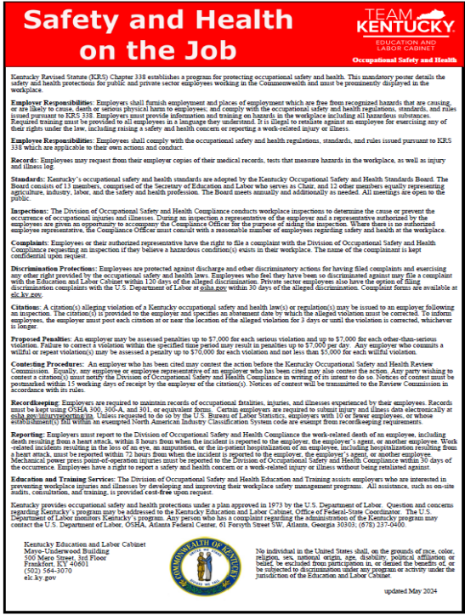
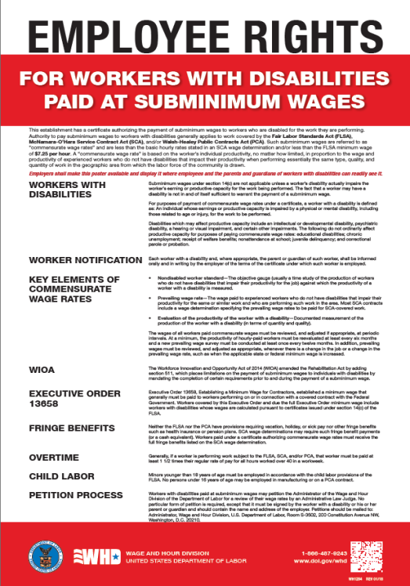

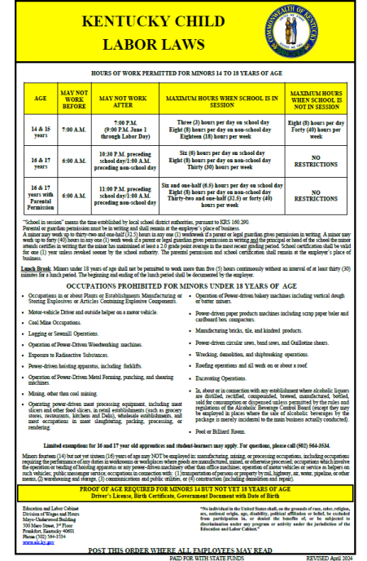

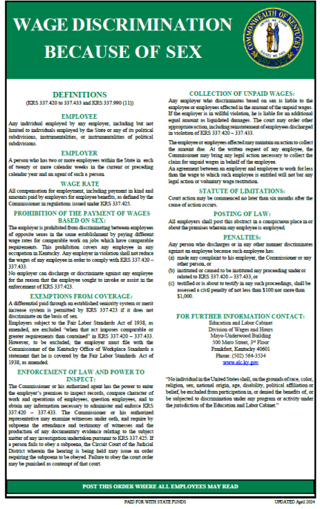
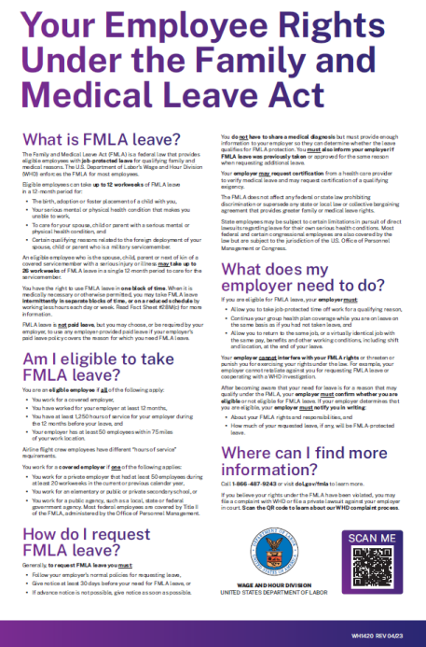

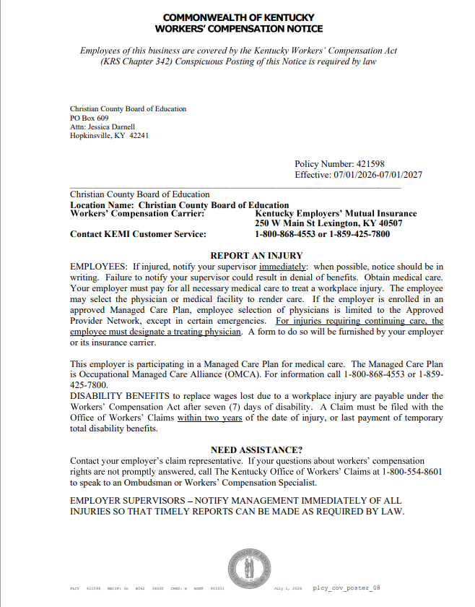

11. ADDITIONAL BEGINNING OF THE YEAR PERSONNEL INFORMATION- Please
Please review this section with staff
∙ Established Daily Work Schedule (complete for all classified staff and return a copy to Personnel office)
∙ Contract Days for classified and certified staff
∙ School Calendar
∙ Holidays, sick and personnel days
∙ Payroll Reporting Schedule

PERSONNEL 03.2332 AP.2 -Classified
Established Daily Work Schedule
□ ORIGINAL Effective date ________________________ □ AMENDED Effective Date ________________________
Employee ________________________________________ Employee Number _______________ Job Classification __________________________________ Level ___________ Step ________ Job Location ______________________________________ Length of Workday ___________ (hrs.) Hourly Rate $__________ Overtime Rate $ __________ Length of Workweek __________ (hrs.)
□ Monday-Friday □ Sun. □ Mon. □ Tues. □ Wed. □ Thurs. □ Fri. □ Sat.
Beginning Time _______:_______ _______:_______
Rest Period _______:_______ __ _______:_______ (10 minutes)
Lunch Period _______:_______ __ _______:_______ □ on duty □ duty-free
Rest Period _______:_______ __ _______:_______ (10 minutes)
Ending Time _______:_______ _______:_______
If the above format cannot adequately reflect the established daily work schedule, the standard Christian County Public Schools Time Record should be completed and attached.
This schedule has been established for the fiscal year indicated above. The immediate supervisor can adjust the established daily work schedule to accommodate special activities such as conferences, open houses, fall festivals, etc., in order to maintain the hourly contract work week. A change in the permanent schedule must be reflected on an amended Established Daily Work Schedule.
□ Check if an attachment is incorporated into this agreement.
Employee Signature _____________________________________________ Date ____________ Supervisor Signature _____________________________________________ Date ____________

**Please keep a copy on file at the school level that is accessible upon request.**

Classified staff:
1- Opening Day
170 -Instructional days with students
4 -Holidays
2-Professional Development Days
5- Staff Work Days
1- Closing day
183 Total Contract Days
Certified staff:
1- Opening Day
170- Instructional days with students
4 -Holidays
4-Professional Development Days
5 -Staff Work Days
1 -Closing day
185 Total Contract Days

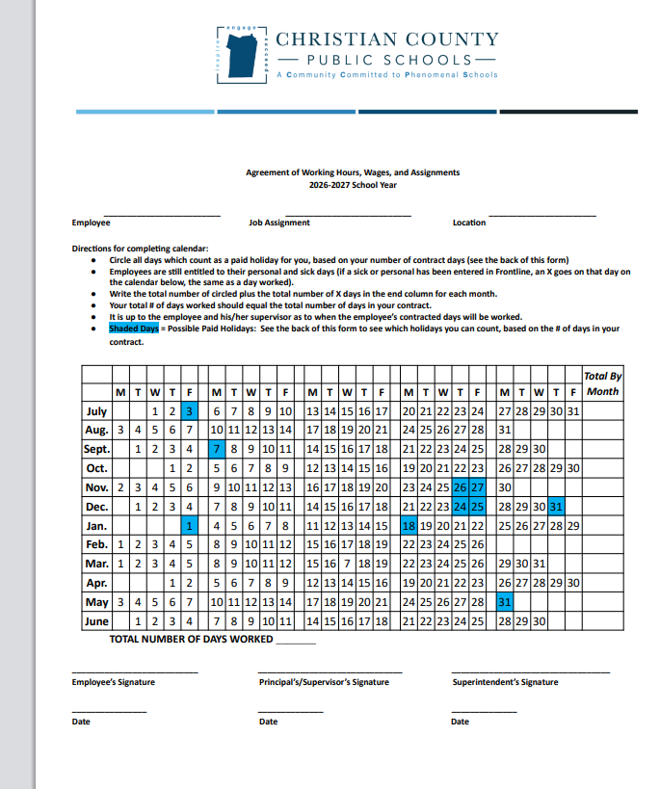

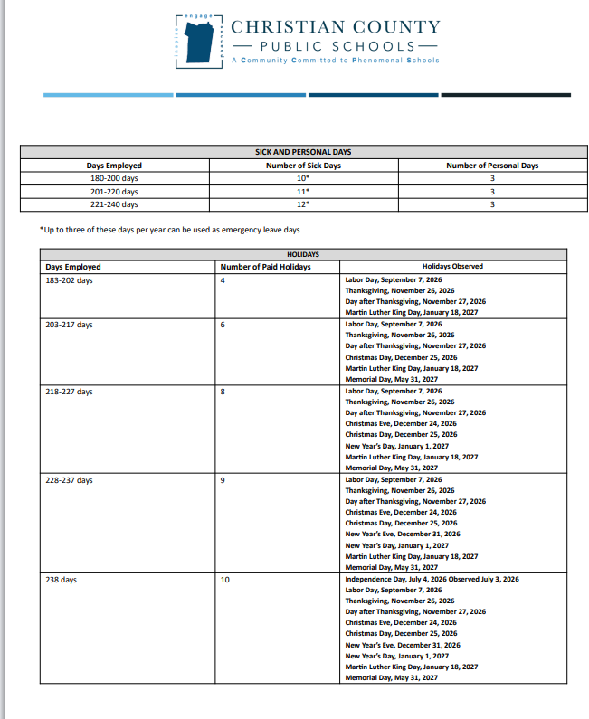

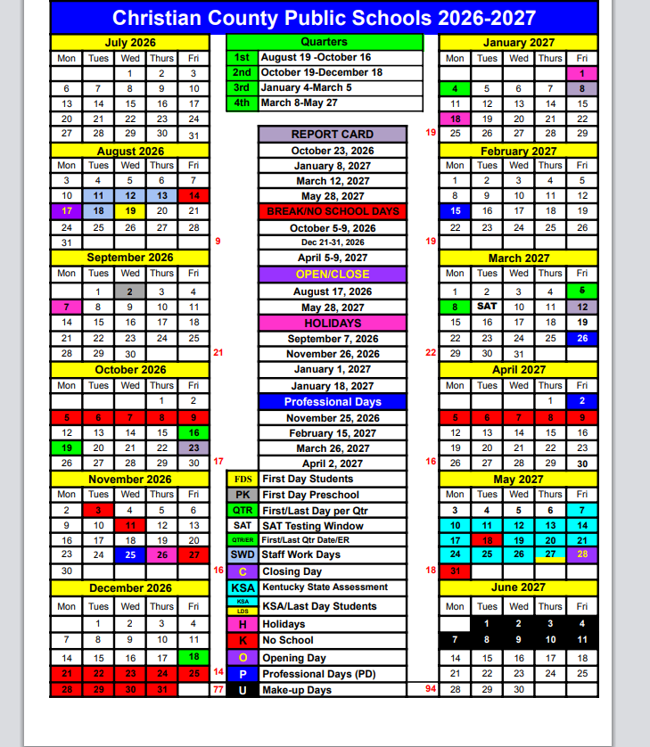

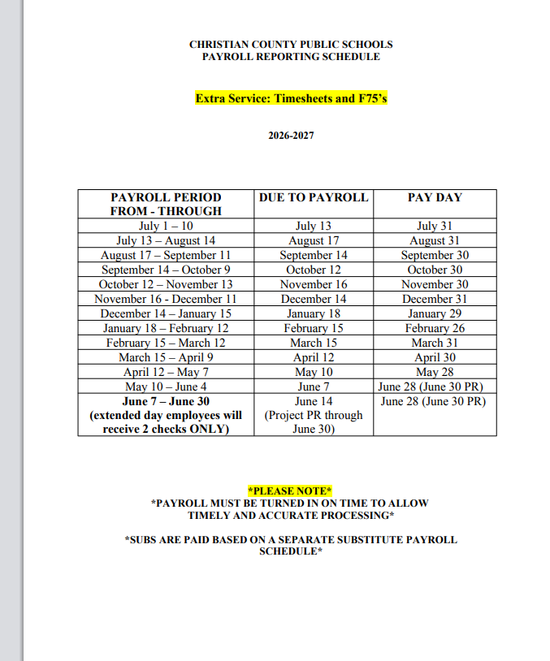

Section 12:
Traceable Communication SB181
Please review this section with staff during the opening day meetings. Keep signed acknowledgement of training and understanding in your building.

https://drive.google.com/drive/folders/1fqv1H2RGWq_4ukXU-jfCk2cdvNXzcNPa?usp=drive_link

SB 181

SB 181: Ensuring Safe, Traceable Communication with Students

Effective Date: July 1, 2025

What is SB 181?

Kentucky law requiring all communication between school staff/volunteers and students to be traceable and professional

Designed to protect students and staff by ensuring transparency in all interactions

Approved Communication Tools:

ParentSquare

Google Classroom

District-provided Email (Gmail)

Google Workspace tools (Docs, Calendar, etc.) – only if traceable and approved

Prohibited Communication Methods:

Personal email accounts

Text messaging via personal cell phones

Social media messaging (e.g., Facebook, Instagram, Snapchat)

Encrypted/untraceable apps (e.g., WhatsApp, Signal)

Family Exception:

Communication with your own child, siblings, nieces/nephews, or grandchildren enrolled in school is allowed

Social Media Expectations:

Do not friend/follow students on personal social media

Parent Communication:

SB 181 doesn’t govern parent communication—but CCPS encourages ParentSquare or district email for professional, documented interactions

Violation Reporting:

Report any suspected violations to your school administrator or the Personnel Office

Certified: KRS 161.790 / EPSB referral

Classified: KRS 161.011(7)

Consequences for Noncompliance:

Certified Employees
- Reported to EPSB under KRS 161.790
- Investigated and subject to disciplinary action per KRS 160.145
Classified Employees
- Investigated and disciplined under KRS 161.011(7)
Volunteers
- Investigated by the school or district
- If substantiated, barred from future volunteer opportunities

Contacts for Questions:

Personnel Director – Leslie Lancaster
- Pupil Personnel- Dr. Melanie Barrett

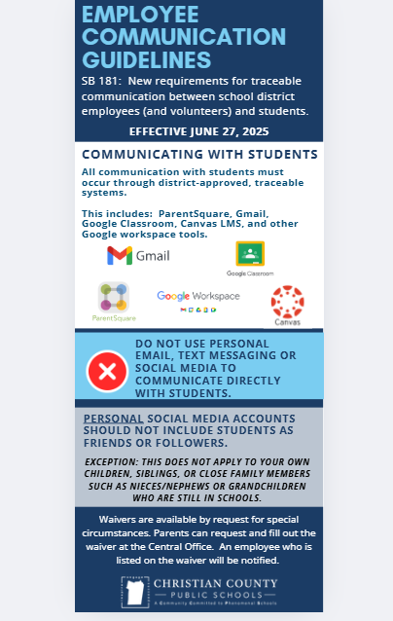
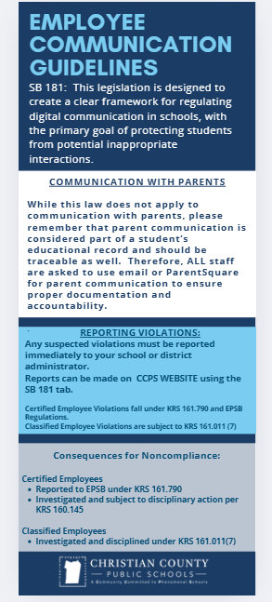

Section 13: Active Shooter Training
It is recommended for schools to complete as a group.

- Response to Active Shooter-
School district employees who wish to complete the training individually may:
- Visit KyLearningHub.org.
- Locate the Active Shooter Response Training for 2026–2027.
- Select Enroll.
- Sign in using their district credentials.
- Complete the course and all required components.
Employees who complete the course individually will receive an email from the KY Learning Hub with a link to their certificate.

Section 14: McKinney Vento

- WatchMcKinney Vento Homeless Awareness Training kJjcjPpAak B https://nche.ed.gov/basic-requirements-of-the-mckinney-vento-act-webinar/
- video
- Take quiz (click after the video then print certificate (have to get 100% - here is help if needed)
- Have employees Sign-off

