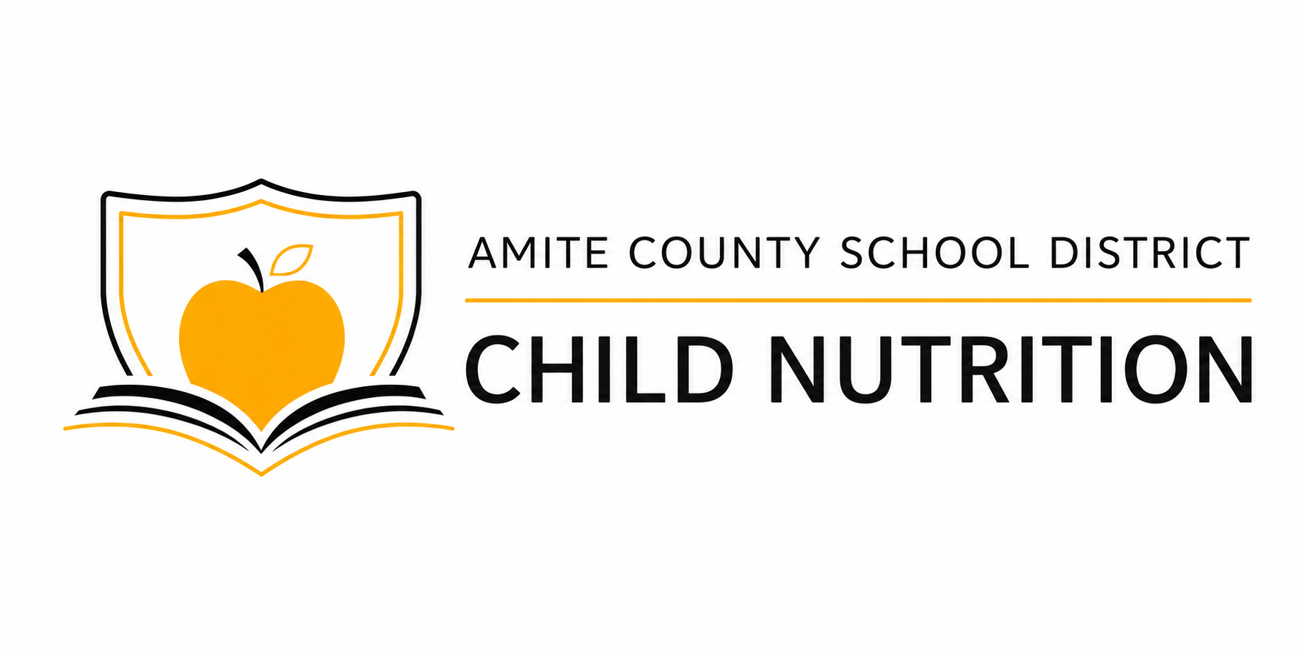 | Medical Statement  for Meal Accommodations  2026-2027 School Year
Important: This form must be completed and signed by a licensed medical authority. This statement remains in effect until the parent/guardian or licensed medical authority requests a change. Changes to medically prescribed accommodations must be authorized by a licensed medical authority.
STUDENT INFORMATION | Parent or guardian completes
Student Name | Date of Birth
School | Parent/Guardian Phone Number
MEDICAL INFORMATION | Licensed medical authority completes
Describe the student's medical condition, disability, or food allergy and how it affects the student's diet or ability to eat or drink

Describe the required meal accommodation, including any texture changes, portion requirements, feeding assistance, or other instructions

FOOD SUBSTITUTIONS AND SAFETY INSTRUCTIONS
FOOD ALLERGENS OR FOODS TO OMIT | REQUIRED FOOD SUBSTITUTIONS
Risk of anaphylaxis? ☐ Yes ☐ No  Epinephrine prescribed? ☐ Yes ☐ No | Special Preparation, Equipment, or Feeding Instructions
LICENSED MEDICAL AUTHORITY CERTIFICATION
I certify that the information provided is accurate and that the requested meal accommodation is medically necessary.
Printed Name and Credentials | Phone Number
Clinic or Practice Name | Date
Signature of Medical Authority

RETURN COMPLETED FORM TO THE SCHOOL NURSE

