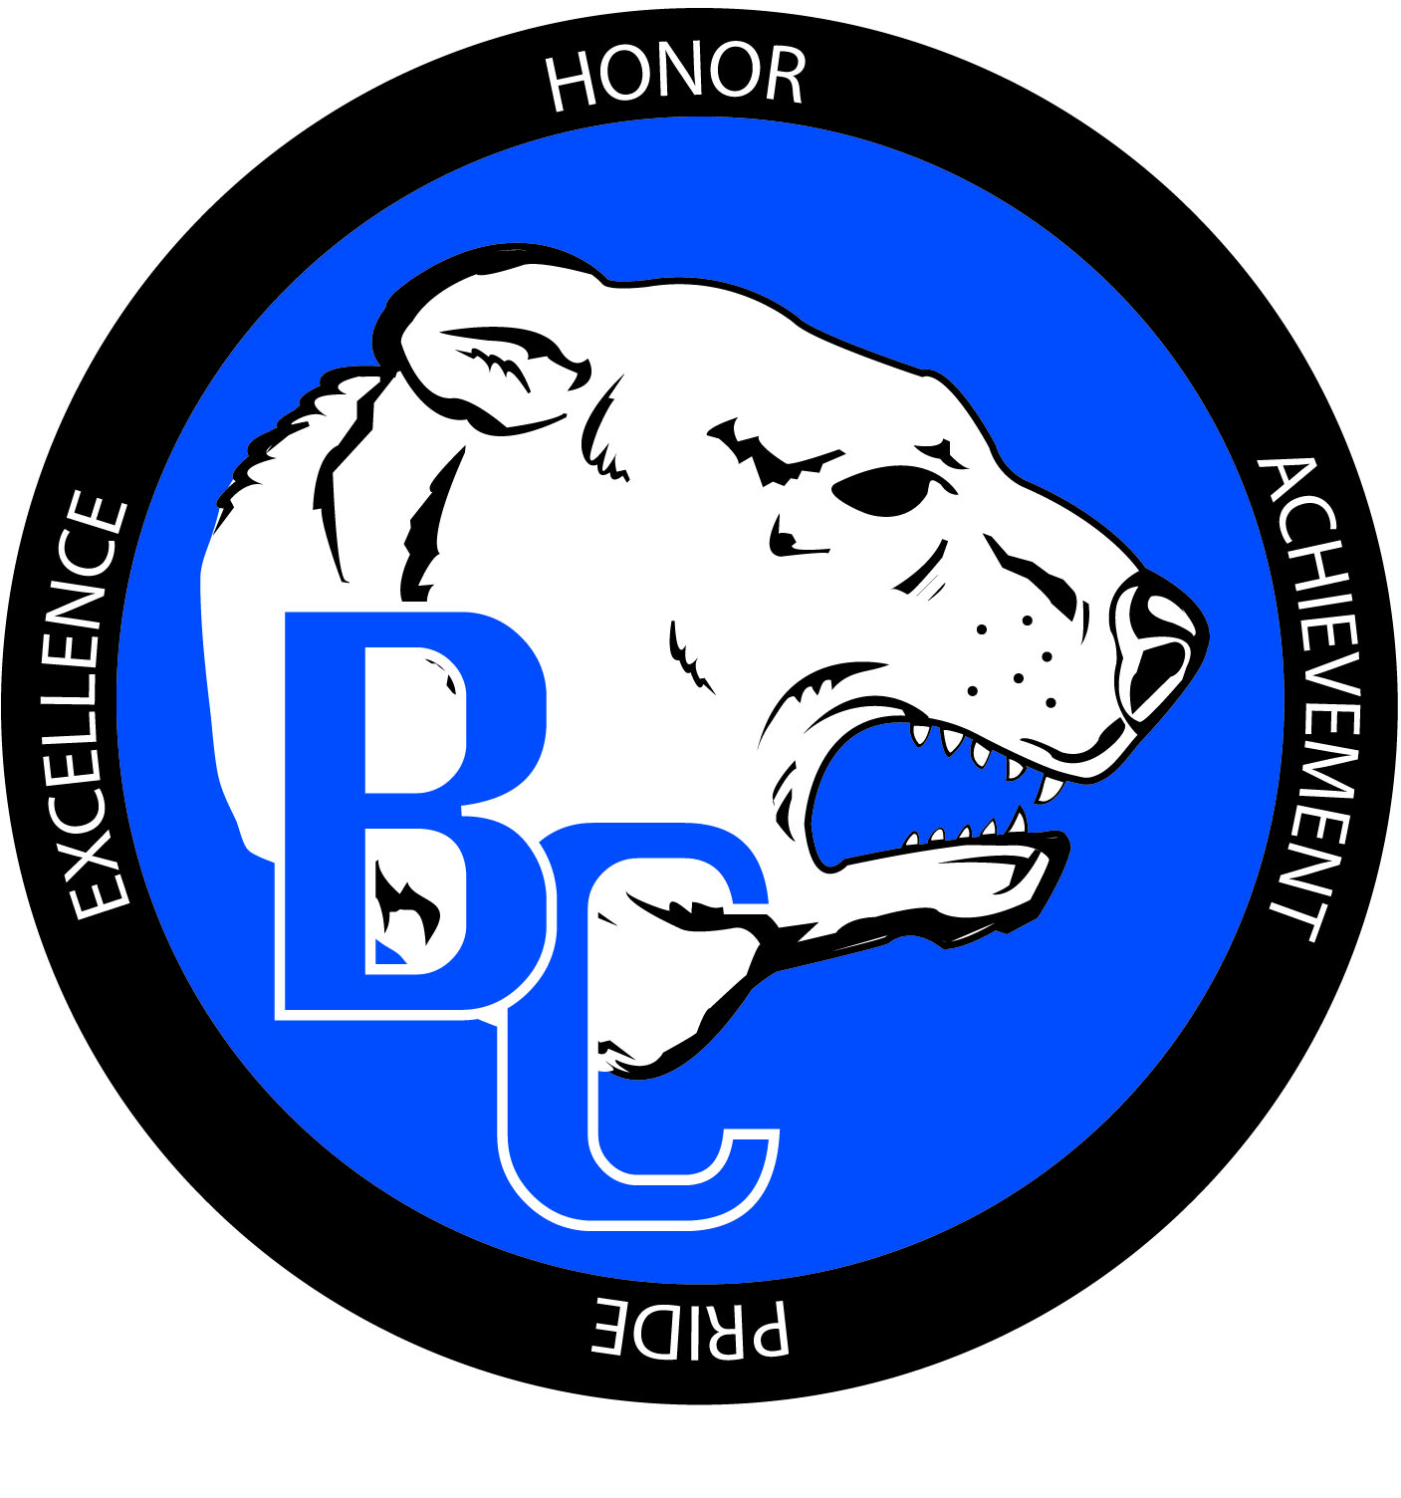
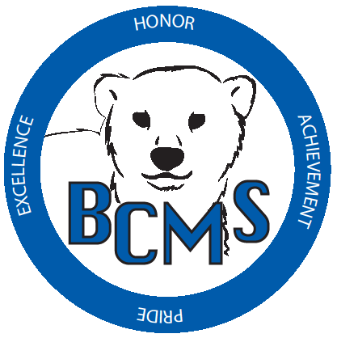
Bracken County Schools
348 West Miami Street

Brooksville, KY 41004
606-735-2523- phone 606-735-3640- fax
“Changing the world, one student at a time.”

Bracken County Schools Gifted and Talented Parent Checklist

Student Name: ______________________________ Teacher Name: _____________________
School: __________________________________ Grade: ___________ Date: _____________
Name of parent/guardian completing checklist: _______________________________________
Signature: ______________________________________

VISUAL AND PERFORMING ARTS: DANCE
A. Indications (check all that apply):
- Observed strengths in the area of dance
Explain: _________________________________________________________________
- Has won an award in dance (in or out of school)
Award: _________________________________________________________________
B. Anecdotal. (Please Attach)
C. Additional information that you believe is relevant. (Please Attach)
D. Dance Checklist (Please complete below)

(MUST BE COMPLETED FOR RECOMMENDED STUDENTS)
Please check the characteristics which accurately describe the TYPICAL behavior of this student.

☐ Uses body as an instrument of expression
☐ Enjoys forms of dancing and movement to music
☐ Uses movement to recreate an emotion or environment
☐ Able to think of many ways of solving movement problems
☐ Displays grace and fluidity of movement
☐ Likes to dance for other people
☐ Is good at imitating movement of others
☐ Can change direction, level, and focus of movement
☐ Masters basic dance skills quickly and easily
☐ Improvises to music
☐ Has awareness of line and the design of body in space
☐ Appears to feel the rhythm of music
☐ Likes to spend time watching others dance
☐ Communicates to others through dance
☐ Deals effectively with own center for gravity
☐ Experiences great joy in movements

Additional Comments: (Use back)

