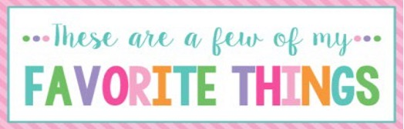

Name: | Loni Cook | T-Shirt Size: | XL
Birthday: | July 9th | Monogram: | LCC
Favorite Color: | Pink | Favorite Flower: | Tulips/Hydrangeas
Favorite Scent: | Volcano | Favorite Candy: | Jolly Ranchers/Cookies ’N’ Cream Hershey
Favorite Drink: | Loaded Tea/Dr. Pepper | Favorite Food: | Cheese Dip and Sushi
Favorite Snack: | Garden Salsa Sun Chips | Favorite Fruit: | Any
Favorite Restaurant: | Mexican | Favorite Fast Food: | Chick-fil-a & Chipotle
Favorite Places to Shop: |  | Amazon, Target, Ultimate Gifts
Favorite Bath & Body Works Scent: |  | Into the Stars
Things I Collect: |  | Coffee Table Books
Wish List for Classroom: |  | https://www.amazon.com/hz/wishlist/ls/2KHYU1R09N62U?ref_=wl_share

