WC Jr/Sr HS Breakfast and Lunch Menu

Choice of Milk Served Daily
FF Chocolate
1% Low Fat White
FF Skim

Offered Daily
BREAKFAST: Poptarts, Cereal, Fruit and Juice
LUNCH: Main Entrée, or Uncrustable Served Daily.
Salad will also include Tomatoes & Cucumbers

CONDIMENTS SERVED: Ketchup, Mustard, Mayo, Butter, BBQ Sauce, Swt n Sour Sauce, Honey Mustard and Ranch Dressing – A 1 Sauce
SNACK: Juice

This institution is an equal opportunity provider.

No School
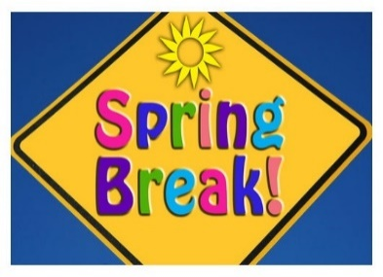
BREAKFAST: Apple Frudel LUNCH: Country Fried Steak w/Gravy - SS Roll - Mashed Potatoes - English Peas - Fruit SNACK: Cereal Bar
BREAKFAST: Combo Bar LUNCH: Calzone - Marinara Sauce - Green Beans - Mixed Veggies - Fruit SNACK: Rice Krispies
BREAKFAST: Cinnamon Roll LUNCH: Quesadilla - Salsa - Pinto Beans - Corn - Fruit SNACK: Granola Bar
BREAKFAST: Pizza Bagel LUNCH: Breaded Chicken - SS Roll - Broccoli w/Cheese - Salad - Fresh Fruit SNACK: Educational Cookies
BREAKFAST: Sausage w/Biscuit LUNCH: Cheeseburger w/Bun - Baked Beans - Fries - Sliced Onions & Tomato - Cheese Slice - Fruit SNACK: Munchies
BREAKFAST: Cinnamon or Cheese Toast LUNCH: Popcorn Chicken - SS Roll - Mashed Potatoes - English Peas - Fruit SNACK: Gripz
BREAKFAST: Breakfast Burrito LUNCH: Pork Patty - Cornbread - Trunip Greens - White Beans - Fruit SNACK: Chips
BREAKFAST: French Toast Sticks w/Syrup LUNCH: Beef Dippers - SS Roll - Candied Carrots - Baby Potatoes - Fruit SNACK: Blueberry Bites
BREAKFAST: Honeybun LUNCH: Big Daddy Pizza - Marinara Sauce - Green Beans - Corn - Salad - Fresh Fruit SNACK: Cheez-its
No School
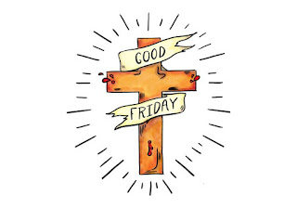
BREAKFAST: Banana Bread LUNCH: Durmstick - SS Roll - Mashed Potatoes - English Peas - Fruit SNACK: Munchies
BREAKFAST: Tornado's LUNCH: Pizza Crunchers - Marinara Sauce - Green Beans - Corn - Fruit SNACK: Cereal Bar
BREAKFAST: Cinnamon Roll LUNCH: BBQ Bologna w/Bun - Baked Beans - Hashbrowns - Fruit SNACK: Rice Krispies
BREAKFAST: Breakfast Pizza LUNCH: Chicken Wrap - Fresh Broccoli - Baby Carrots - Salad - Fresh Fruit SNACK: Granola Bar
BREAKFAST: Biscuit & Gravy w/Jelly LUNCH: Corn Dog - Potato Salad - Fries - Fruit SNACK: Educational Cookies
MENU SUBJECT TO CHANGE due to availability
BREAKFAST: Mini Pancakes w/Syrup LUNCH: Chicken Tenders - SS Roll - Mashed Potatoes - English Peas - Fruit SNACK: Mini Chocolate Chip Cookies
BREAKFAST: Funnel Cake LUNCH: Big Daddy Pizza – Marinara Sauce – Green Beans – Cream Corn – Fruit SNACK: Gripz
BREAKFAST: Glazed Donut LUNCH: Crispito's w/Cheese - Tortilla Chips - Salsa - Pinto Beans - Corn - Fruit SNACK: Chips
BREAKFAST: Pizza Bagel LUNCH: BBQ Potato - Soft Pretzel - Steamed Broccoli - Salad - Cheese Sauce - Fresh Fruit SNACK: Blueberry Bites
BREAKFAST: Sausage w/Biscuit LUNCH: Hot Dog w/Bun – Kraut – Slaw – Curly Fries – Fruit SNACK: Cheez-its

