Boating: Chapter 4 Review

(Unit 4: Your Boat’s Identification-Unit 4: Review)

1. The __________________________ is a number assigned and imprinted by the vessel manufacturer and is unique to your vessel.
2. Allowing passengers to ride on the _________________ and _________________ while underway is reckless operation.
3. If your Blood Alcohol Concentration (BAC) is above the legal limit, it is illegal to ________________ a vessel.
4. In order for a PFD to be legal, it must be __________________ approved, in ____________ condition, and __________________ accessible.
5. All vessels must have at least one U.S. Coast Guard approved __________________ life jacket for each person on board.
6. Most states require at least one ________________________ PFD (Like the one pictured) 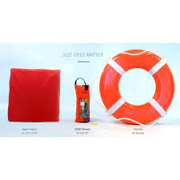

to be on board vessels 16 feet in length and longer

1. PWC operators, no matter what age, must wear an approved _______________ whenever underway.
2. Fire extinguishers should be placed in an area that is _____________________________ and not near the _________________
3. It is recommended that you wait at least ______________ minutes after turning on your vessel’s blower (if so equipped) before starting your engine.
4. For an 18-foot powerboat, required navigation lights include a red light on the ________________, a green light on the ____________________, and _____________________.
5. A 16-foot canoe away from the dock after dark must have on hand at least a _______________ or __________________.
6. Name two visual distress signals (VDSs) for use at night.
   1. ______________________________
   2. ______________________________
7. Describe the appearance of a diver’s flag. _________________________________________________
8. If an observer is on board when pulling a skier behind a vessel, the vessel should be rated to carry at least _________ people.
9. Water skier(s) may be towed at night with proper lighting.
   1. True
   2. False
10. It is illegal to discharge _________________, ________________, or ________________ into federally controlled or state waters.
11. You must report any accident you are involved in if it results in _______________, ________________, or __________________.