**Alongside – A New Mental Health Resource for Our Students**

Hello Panther Families,

We are excited to share a new support resource available for our students! As a school division, we are always looking for ways to strengthen the academic, social, and emotional well-being of our youth. To support this mission, we are introducing [*Alongside*](https://www.alongside.care/)—a tool designed to help students navigate everyday challenges while also providing additional support for those who may need it most.

Alongside works “alongside” teachers, counselors, and the Division Student Support Team to:

* Offer private, accessible support for students who may be hesitant to ask for help.
* Help staff identify students who may be at higher risk and connect them to additional resources.

This program has been recognized by **Evidence for ESSA** as meeting Tier 3 and 4 criteria, meaning it has demonstrated promising impact on student mental health and well-being. Alongside will be available to Rappahannock County students in grades 6–12. You can see a quick 3-minute tour of the platform from their teen advisor, [Ava](https://app.alongside.care/VideoPlayer?videoInfoId=1638&hasViewedAlready=true).

Alongside is an app that provides personalized executive function skill-building, social-emotional learning, and self-help wellness tools, often administered through a school’s counseling team. The tools include modules such as journaling, activities to support improved wellness (such as breathing exercises), and an AI-powered chatbot that uses chats to go through basic exercises that promote resilience, positive social and emotional development, self-monitoring, or goal setting. Alongside uses generative AI to provide personalized and clinically aligned responses to student concerns. AI-generated text is **not used** to respond to severe issues such as self-harm, abuse, and suicidal ideation. Instead, students are guided through a safety protocol and a designated emergency response contact is immediately notified. All emergency responses are immediately forwarded to Erica Jennejahn, School Social Worker, for immediate follow up.

Please read this [article](https://www.alongside.care/learn/keeping-students-safe-in-the-age-of-ai-why-schools-need-alongside) that explains the safety protocols Alongside has developed to ensure your student uses this resource responsibly and safely. Additionally, Rappahannock County Public Schools has evaluated this AI resource to ensure it complies with the Division’s Technology Acceptable Use Policy: AI Integration. You can read more about that [here](https://docs.google.com/document/d/1wEA6s7_3x9cI-WXINIVJ1f8JStU8_AZV3hm-5tvO4is/edit?usp=sharing).

**Getting Started**Students will activate their Alongside accounts during class, with the setup process taking only 15–20 minutes. They can then access the platform anytime using their school email at [app.alongside.care](https://app.alongside.care) or through the mobile app (iOS or Android). All onboarding will be scheduled to minimize disruption to instruction.

**Opt-Out Information**For your review, here are Alongside’s [Terms of Service](https://policies.google.com/terms?hl=en-US) and [Privacy Policy](https://stripe.com/privacy). If you prefer that your student not use this resource, please complete and return the attached Opt-Out form.

If you have any questions or would like additional information, please don’t hesitate to reach out to me at **ejennejahn@rappahannockschools.us**.

Thank you for partnering with us to support the success and well-being of our students!

Warmly,

 Erica Jennejahn, MSW  
 School Social Worker

**Why was Alongside created?**

Every student struggles with everyday challenges and  issues that affect their mental health and the CDC reports 42% of teens feel persistently sad and hopeless, up 50% in the last 10 years. With so much need and limited mental health staff, Alongside can support schools and counselors  to make brief and early interventions accessible to all students. Students talk to the llama, a chatbot, and get personalized support developed by doctoral clinicians. Severe issues are escalated to counselors and staff during school hours and 24/7 resources after hours. Students love talking to the llama to feel better and take care of themselves.

**Anabel Ibarra: A Principal’s Perspective**

*"Alongside is a game changer. It's the first level of support for our students.” (*[*video here*](http://www.alongside.care/learn/anabel-ibarra-school-principal)*)*

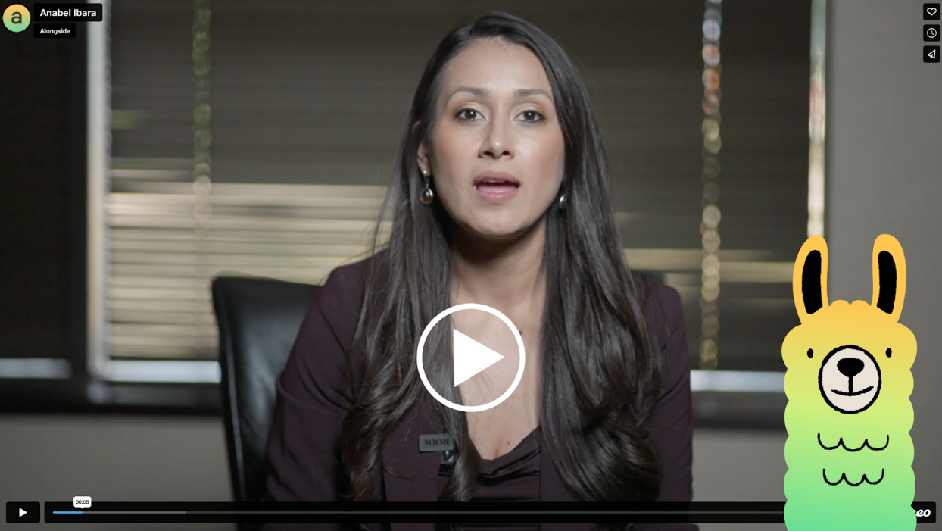

**Ava: Student Overview and Sign In Video** *(*[*video here*](https://youtu.be/JJc8sQe-2oI)***)***

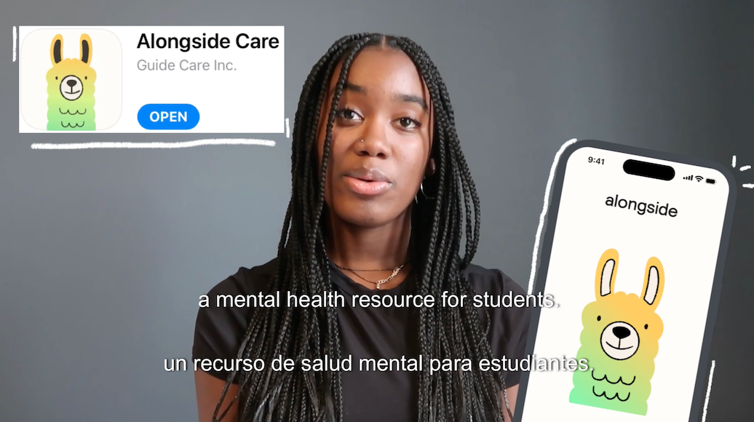

**Rappahannock County Public Schools** **Alongside Mental Health Resource – Parent Opt-Out Form**

Dear Parent/Guardian,

Rappahannock County Public Schools is excited to offer [**Alongside**](https://www.alongside.care/), a new mental health support resource for students in grades 6–12. This platform helps students access private support for everyday challenges and connects staff with students who may benefit from additional resources.

Participation in Alongside is encouraged, but not required. If you prefer that your student **not** participate, please complete the form below and return it to your child’s school **as soon as possible**.

**Parent/Guardian Opt-Out Form**

☐ I DO NOT want my child to participate in Alongside.

**Student’s Name:** ___________________________________________

**Grade:** ___________________

**Parent/Guardian Name (print):** ___________________________________________

**Parent/Guardian Signature:** ___________________________________________

**Date:** ___________________

If you have any questions, please contact:

**Erica Jennejahn, MSW** School Social Worker  
 Email: ejennejahn@rappahannockschools.us