**Course Syllabus for Northside Middle School 8th Grade ELA**

**Teacher:  Malik Horton, Rm 406**

**Planning Period:** 1:20-2:30 PM

**Email:** [**malik.horton@hcbe.net**](mailto:malik.horton@hcbe.net)

***\*\*Sign and Return back page to Mr. Horton ASAP***

**I. Texts/ Supplies**

**Students will need the following supplies for ELA:**

* 4-Subject Composition Notebook
* Into Literature textbooks
* Writing utensils: Pens (Black or Blue), Highlighters, and Pencils.
* Composition Book
* Chromebook Computer

**II. Course Description**

English Language Arts is an 8th grade level English class that uses a variety of texts and works of literature to promote mastery of numerous skills such as reading, writing, semantics, grammar, and comprehension. As a class, we will read, analyze, and discuss many different texts. Students will demonstrate their knowledge and comprehension of texts and writing skills through a number of mini-assessments, tests, performance tasks, and papers. All students are expected to read, write, and analyze at the level of proficiency for or beyond the English grade common core standards.

**III. Course Content and Standards/Objectives**

A complete list of standards and objectives may be found at the GADOE website under 8th grade Common Core Standards. We will be using many different forms of texts, instructions, strategies, and assessments to reach our goals and objectives. We will cover short stories, novels, poetry, and plays. Students will participate in interactive lectures, small-group work, large-group work, Socratic seminars, role-playing, individual work exercises, etc. Formative Assessments will include Interactive Notebook checks, homework, tests, mini-assessments, projects, journals, oral presentations, essays, and debates.

**IV. Instructional Procedures**

**Bell Ringer –** Students will be expected to find their seats in the classroom at the set time and begin on the bell ringer posted on the classroom board with easy-to-follow directions. These bellringers will be written in their composition notebook. There should be no talking as students quietly work at the assignment that energizes their mind and prepares them for the day’s lesson.

**Classroom Activities –** Students will be actively engaged in the instruction process in this class. Lesson plans will include a wide variety of activities including interactive lectures, small and large group discussions, role playing, and instructional games. While students will be frequently provided with opportunities to talk and move about the classroom, it is still their responsibility to remain on task and get quiet when needed.

**Independent Reading**

**Reading Logs**: Silent reading time is scheduled during school time, however, students are expected to read nightly at home for at least 80 minutes a week. Students will bring home a reading log every two weeks which requires the students to record their independent reading, give a reflection, and obtain a parent/guardian signature.

**Missed Work** – Students are responsible for obtaining missed work. ALL WORK MUST BE MADE UP. Absent students have the same number of days to make up missing work as the number of days they missed. (Example: If you miss two days, you have two days to make up the work. If you miss four days, you have four days to make up the work.) If the student does not understand the assignment, it is his or her responsibility to ask the teacher for help.

**Late Work:** Teacher will accept late work within the grading period if possible. Anything received after the due date can still receive a maximum score of 75%. Parents interested in staying abreast of student work completion, please utilize **Parent Portal** to check grades weekly. Questions about using Parent Portal or setting up an account can be directed to the front office.

**V. Classroom Rules and Consequences:**

Every student should be present, respectful, attentive, engaged and prepared with homework and supplies.

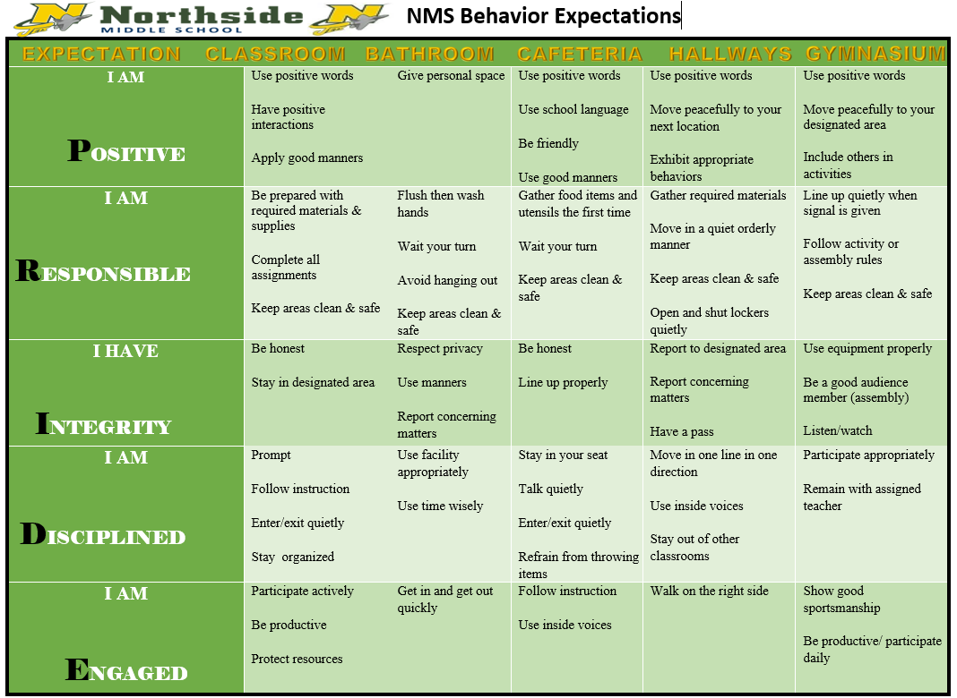

Failure to follow procedures will initially result in a **verbal warning**and if the issue goes uncorrected it will be followed by **new seat assignment**, **call to parent/guardian**, **silent lunch**, **detention** and, ultimately**, referrals.**

**VI.  Parent & Student Information:**

**8th Grade ELA Syllabus**

**Please sign below to indicate that you and your parents have read and discussed the 8th Grade ELA Syllabus. Feel free to give me any additional information that you feel I need to be aware of.**

**___________________________________ /_________**

Student Signature Date

**__________________________________ / _________**

Parent Signature Date

(Please return this signature sheet by **Friday, August 5, 2022**.)

Please complete the following information. PLEASE PRINT.

Student Name_____________________________________ Class Period __________

Mother’s Name_____________________________ Work Number__________________ Cell Number _________________

Father’s Name_____________________________ Work Number__________________ Cell Number __________________

Home Number ___________________________

Email address: ___________________________________________________________

___________________________________________________________