|  |
| --- |
| GED/HSE 23 |
| GED Practice Set 2 |
| 13-24 |

|  |
| --- |
| Kevin Adams |

1. Which expression and graph of the solution represents this inequality?

*The product of six and a number is greater than or equal to the sum of the same number and fifteen.*

(a)



(b)



(c)



(d)



2. Without a calculator, multiply.

(a)

(b)

(c)

(d)

3.

4. *Without a calculator,* perform the following operations.

5. *Without a calculator,* evaluate the following expression.

$$\frac{2^{7}}{2^{4}}$$

(a) 2 (b) 4 (c) 6 (d) 8

6. Maria bought a house 5 years ago for $140,000.

Now, it is worth $200,000.

Rounded to the nearest tenth, what is the percent increase in the value of Maria’s house?

(a) 2.3%

(b) 42.9%

(c) 60%

(d) 233%

7. In a set of marbles, there is a 7:11 ratio of red to blue marbles. If there are 162 total marbles in the set, how many of the marbles are red?

(a) (b)

(c) (d)

1. If , evaluate

(a)

(b)

(c)

(d)

2. Which of the following expressions is the equivalent of

(a)

(b)

(c)

(d)

3. In the little town of St. Pietro, there are three church bells. The first bell rings every two hours. The second bell rings every three hours. The third bell rings every four hours.

If all three bells ring at 12 o’clock midnight, what time will it be the next time all three bells ring at the same time?

4. At a local coffee shop, Grace is hanging paintings for an art exhibit. On one wall, there is space to hang exactly two paintings.

She has five paintings to choose from for this wall. How many different combinations of the five paintings does Grace have to choose from?

(a) 10

(b) 20

(c) 25

(d) 30

5. *Without a calculator*, match the following expressions with their evaluations.

6. *Without a calculator*, evaluate the following expression.

$$7.25÷0.05$$

(a) $0.0145$

(b) $0.689655$

(c) $68.9655$

(d) $145$

Mr. Patterson is an avid bird-watcher. Over the course of six days, he kept a tally of how many Golden-Cheeked Warblers he saw, and recorded the results in the table below.

|  |  |
| --- | --- |
|  |  |
|  |  |
|  |  |
|  |  |
|  |  |
|  |  |
|  |  |

1. What was the median number of warblers Mr. Patterson saw over the six-day period? (Round to the nearest *tenth*.)

(a) 4.1 (b) 4.2

(c) 4.5 (d) 7.0

2. What was the mean number of warblers Mr. Patterson saw over the six-day period? (Round to the nearest *tenth*.)

(a) 4.1 (b) 4.2

(c) 4.5 (d) 7.0

3. Any bird-watcher who records a seven-day average of 4 warblers is eligible for a prize from the local birders’ club.

What is the minimum number of warblers that Mr. Patterson would need to spot on the seventh day to be eligible for the prize?

(a) 2 (b) 3

(c) 4 (d) 5

4. Subtract the following polynomial.

(a)

(b)

(c)

(d)

5. What is the surface area of the figure illustrated below?

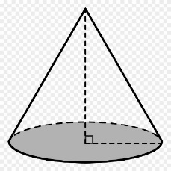

4 5

6

(a) $21π$

(b) $24π$

(c) $60π$

(d) $66π$

(Questions 1-3 refer to the chart.)

Widgets And More, Inc. has recorded its monthly sales data for four categories in the chart below.

*Sales, in Thousands of Dollars*

1. Rounded to the nearest hundredth of a percent, what percentage of total sales do Toys represent?

(a) (b)

(c) (d)

2. What was the amount of total sales for the month reported?

(a) (b)

(c) (d)

3. What was the median amount of sales for the four categories?

(a) (b)

(c) (d)

4. Evaluate .

(a) (b)

(c) (d) 20

5. Simplify

(a)

(b)

(c)

(d)

6. Which set of values for $x$ will make this expression undefined in the set of real numbers?

(a)

(b)

(c)

(d)

1. Evaluate the following expression if $a=1$, $b=-8$, and .

(a)

(b)

(c)

(d) 6

2. Tyler is choosing an outfit for an upcoming job interview. He has 3 jackets to choose from and 5 different ties to choose from.

How many different ways can Tyler choose a jacket and tie?

(a) 8

(b) 10

(c) 15

(d) 35

3. Expand the following expression using the distributive property of multiplication. Enter your answer in the box provided.

4. On the number line below, graph the solution to the inequality described.

*Two less than the product of a number and four is less than eighteen.*



5. What is the volume of a sphere with a radius of 6?

(a)

(b)

(c)

(d)

1. Without using a calculator, evaluate the following expression.

(a)

(b)

(c)

(d)

2. Arrange from least to greatest:

3. A school has a ratio of 8 male students to 11 female students.

If the school has 132 female students, how many male students does it have?

(a) 88

(b) 96

(c) 106

(d) 129

4. What is the length, in units, of the missing side of this triangle?

15

20

(a) 5

(b) 15

(c) 25

(d) 35

5. Jackie has lunch at her favorite restaurant. She orders the Soup and Salad Combo for $7.99 and an Iced Tea for $1.99.

After a sales tax of 8.25% has been added, Jackie adds a tip of 20% to the total.

Rounded to the nearest cent, how much does Jackie spend on lunch at the restaurant?

(a) $9.98

(b) $10.40

(c) $12.96

(d) $22.96

1. Place the following in order from least to greatest.

2. What value or values of $x$ will make this expression undefined in the set of real numbers?

(a)

(b)

(c)

(d)

3. Samuel has taken out a loan of $12,000.00 for 36 months at a simple interest rate of $4\frac{1}{4}\%$.

How much will he have paid in interest by the end of the loan?

(a) $183.60

(b) $1,530.00

(c) $18,360.00

(d) $153,000

4. Without a calculator, evaluate the following expression.

(a)

(b)

(c)

(d)

5. A carton in the form of a rectangular prism holds 480 cubic inches of material. It is 6 inches wide and 8 inches long.

What is the height of the carton, in inches?

(a) 7

(b) 10

(c) 12

(d) 366

6. Evaluate the following expression.

7. Simplify the following expression.

(a)

(b)

(c)

(d)

1. Solve for if , , , and .

(a)

(b)

(c) 1

(d) 2

2. Place a point on the coordinate grid at .

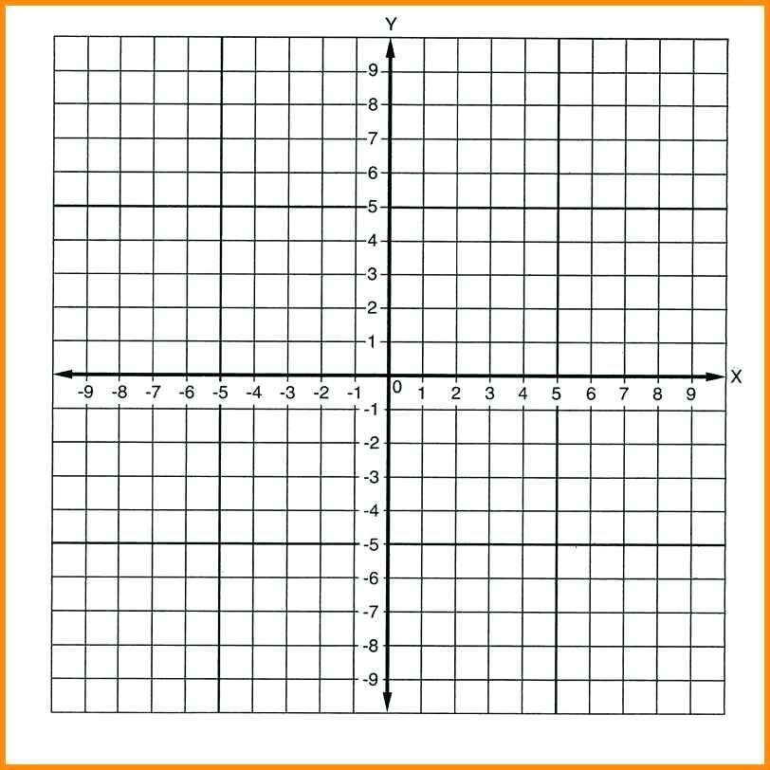

3. Subtract.

(a)

(b)

(c)

(d)

4. Multiply.

(a)

(b)

(c)

(d)

5. Joan wants to cover a box in the shape of a rectangular prism with tin foil.

How many square inches of foil will she need?

11

10

5

(a) 26 (b) 210 (c) 430 (d) 550

1. Three bookstores are advertising weekend sales to celebrate National Poetry Month.

Place the bookstores in order from least to greatest price per book.

EUROPA BOOKS

2 $5.00

4 $10.00

6 $15.00

OLYMPIA BOOKS $2.25 EA

APPOLINAIRE’S BOOKS

3 FOR $7.99

______________ ______________ ______________

2. What is the slope of the line which passes through the points $(3, 2)$ and ?

(a)

(b)

(c)

(d)

3. Without a calculator, divide.

$$0.728÷0.08$$

(a) 0.0091

(b) 0.091

(c) 0.91

(d) 9.1

4. Which of the following is the same as the expression shown?

(a)

(b)

(c)

(d)

5. Without a calculator, add.

(a)

(b)

(c)

(d)

6. Distribute the following expression.

$$-\frac{1}{2}\left(x-4\right)$$

(a)

(b)

(c)

(d)

40

1. James is building a stone wall around a circular area that is 40 feet across from one side to the other.

What will the length of the wall be, rounded to the nearest foot?

(a) 125

(b) 126

(c) 1257

(d) 5027

2. After the wall is built, James will order sod to put down in the enclosed area. He must order the sod by the full pallet.

Each pallet holds 12 square feet of sod.

How many pallets of sod will James need to order?

(a) 11

(b) 105

(c) 126

(d) 1257

3. Without a calculator, evaluate the following expression.

4. Name the ordered pair at which the following line intersects the -axis.

5. The Mendez family owns a trapezoidal

lot that is 40 feet wide. One of its sides

 50 40 70 is 50 feet long, and the other is 70 feet

long. What is the size of the lot, in

square feet?

(a) 1200

(b) 1600

(c) 2400

(d) 4800

1. Simplify the following rational expression.

(a)

(b)

(c)

(d)

2. Five years ago, Kirsten bought a car for $18,000. She sold it for $10,000. What was the percent decrease in the value of the car? Round your answer to the nearest whole percent.

(a)

(b)

(c)

(d)

3. For what value or values of $x$ is the following expression undefined in the set of real numbers?

(a)

(b)

(c)

(d)

4. What is the slope of the line illustrated above?

(a)

(b)

(c)

(d) 2

5. Place a point on the number line to represent .

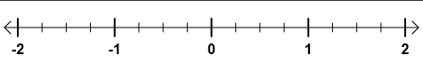

1. Solve and graph the following inequality.



2. Armando is having lunch at a small cafe with his wife. He orders a Fish Taco Plate for $7.99 and a side salad for $3.99.

His wife orders a bowl of Clam Chowder for $5.99 and a side salad for $3.99. They both order Iced Tea for $1.75 each.

After tax of 8.25%, Armando adds a 20% tip to the total.

How much, in all, will the meal cost? (Round to the nearest cent.)

(a) $8.02

(b) $25.46

(c) $30.49

(d) $33.07

3. Which of the following expressions is undefined in the set of real numbers?

(a) (b) (c) (d)

4. If the surface area of a sphere is 1018 square inches, what is its radius? (Round your answer to the nearest whole number.)

(a) 7

(b) 9

(c) 41

(d) 81

5. Subtract.

(a)

(b)

(c)

(d)

6. What is the slope of the line represented by the following table?

|  |  |  |  |  |  |
| --- | --- | --- | --- | --- | --- |
| $$x$$ | $$-4$$ | $$0$$ | $$4$$ | $$8$$ | $$12$$ |
| $$y$$ | $$-7$$ | $$-9$$ | $$-11$$ | $$-13$$ | $$-15$$ |

(a) $-2$

(b) $-\frac{1}{2}$

(c)

(d)

13 1. b

2. c

3.

4.

5. d

6. b

7. a

14 1. c

2. d

3. 12:00 PM (Noon)

4. a

5.

6. d

15 1. c

2. b

3. b

4. c

5. b

16 1. d

2. d

3. c

4. c

5. c

6. d

17 1. d

2. c

3.

 4.

5. d

18 1. b

2.

3. b

4. c

5. c

19. 1.

2. b

3. b

4. c

5. b

6. 1

7. a

20. 1. b

 2.

3. b

4. d

5. c

21. 1. Olympia, Europa, Appliinaire’s

2. d

3. d

4. c

5. d

6. a

22. 1. b

2. b

3. 3

4.

5. c

23. 1. a

2. c

3. d

 4. b

5.

24. 1.



2. d

3. d

4. b

5. b

6. b