Weekly Story  The Best Pet Ever  Easy Read Book: Go Along  Level 3: Describe/categorize characteristics of living things; Identify what living things needs to survive.  Level 2: Match characteristics of a living thing; Identify basic needs for living things(e.g., food, water, air).  Level 1: Select a characteristics of a living thing; Select a basic need.  Skill Sounds: (Cc, Dd, Nn, Short o)  Oral Language Phonological Awareness Alphabet Knowledge  Week of 10/10 Letter Dd Short o  Week of 10/16 Letter Nn Short o  Week of 10/24 Review Short o  Instructional Target:  Language and Literacy Development: Early Writing Students will: use a combination of drawing, dictating, picture selection and emergent writing to express an option, share information about a topic, or tell a story.  Language and Literacy Development: Listening and Speaking  Students will: follow rules for listening and speaking in a discussion (listening to others, turn-taking, etc.)  Ask and answer questions about text or experience.  Use conventions of grammar when speaking: correctly use nouns and verbs, plurals, adjectives, question words. | Mathematics  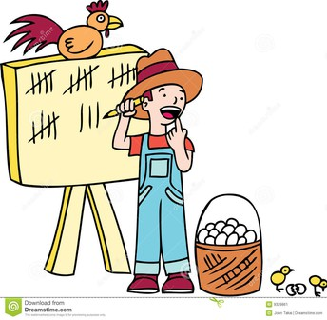  Number Sense/Number Matching  Tracing, Counting, and Writing  One-to-One Correlation  Grade 2 /Counting to 30/Tens and Ones  Science/Social Studies  Leader in Me: Habit #7 Synergize (together is better)  *Fire Safety Month  October Colors of the Month  Blue/Brown  Reminders & Announcements  If you have a pet please text or email a picture or two. I will display the pictures on smart board as we learn: How to Take Care of Pets. 334-954-8409 peggy.flennory@acboe.net  10/20: The Fire House will visit PPS  10/27: Parade of Pumpkins  10/31: Monster Mash

·

