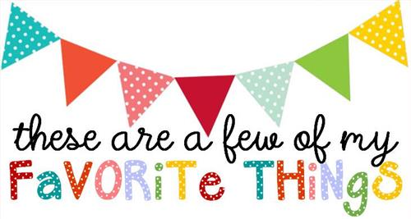

Name: Dawn Stanford
T-shirt Size: Medium
Birthday: 01/09
Monogram: DSM
Favorite Color: Teal
Favorite Flower: Tulips
Favorite Scent: Vanilla
Favorite Candy: Milky Way, Snickers, Twix
Favorite Drink: Dr. Pepper
Favorite Food: Italian
Favorite Snack: Almonds – Lightly Salted or Smokehouse
Favorite Fruit: Green grapes / raisins
Favorite Restaurant: Olive Garden or Longhorn Steakhouse
Favorite Places to Shop: Kohls or Target
Things I collect:
Favorite Author/Book Series for my own personal reading: Nora Roberts
Wish List for Classroom: Individual Wrapped Candy for Rewards

