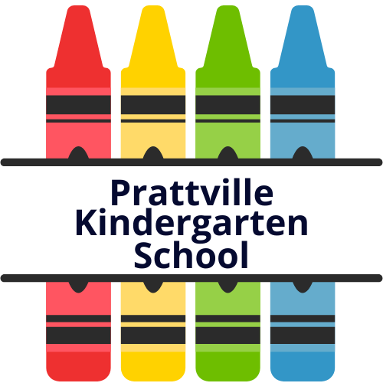
Prattville Kindergarten School
338 First Street
Prattville, AL 36067
Phone: (334)361-3890 Fax: (334)361-3891

Jodi Womble, Principal Lori Harris, Assistant Principal

August 9, 2022
Dear Parent/Guardian
We are pleased to notify you that in accordance with the Every Student Succeeds Act of 2015, you have the right to request information regarding the professional qualifications of your child’s teacher. Specifically, you may request the following:
● Whether the teacher has met State qualification and licensing criteria for the grade levels and subject areas in which the teacher provides instruction.
● Whether the teacher is teaching under emergency or other provisional status through which State qualification or licensing criteria has been waived.
● The baccalaureate degree major of the teacher and any other graduate certification or degree held by the teacher, and the field of discipline of the certification or degree.
● Whether the child is provided services by paraprofessionals and, if so, their qualifications.
If you would like to receive this information, feel free to contact the school, and we will be happy to assist you.

Sincerely,
Jodi Womble
Principal
Prattville Kindergarten School

