Harney County School District #3
Fall 2026 School Bond

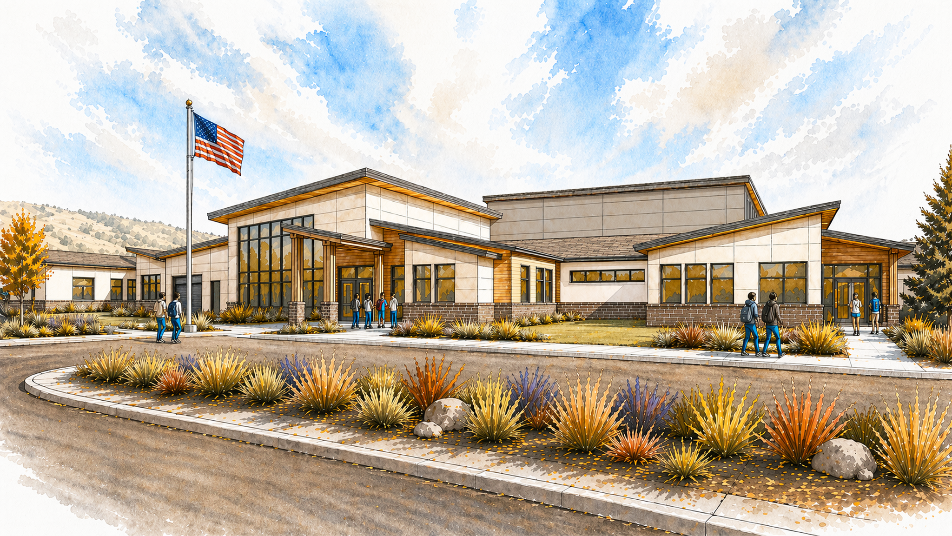
^{Conceptual Front Entrance}
We have been working with family, staff, and community feedback about the functionality of the new school that will be built with the Fall 2026 Bond. The architects, STEELE, have been diligent to take our feedback into the floorplan process. See the floorplan below.

It is important to note what will be included in the Bond. We know that many community members utilize our track at BHS for regular, safe walking. It is now to the point where the track will be condemned and the track not available for anyone to use. This Bond includes proper reconstruction of the BHS track. Also, included in the Bond will be a multi-purpose building. It will be a shared space that can be used in our long winters for safe walking and exercise open to the public, space for our robust wrestling clubs and teams, space for many sports to utilize off-season, maybe even some pickleball! This multi-purpose building has already been included in the cost of the Bond.

The new building will keep our students safer than they are now, with the bus unloading zone to the rear of the new school. Parent drop off will now be on level ground, one way traffic, and smooth for a K-8 student drop off. The fire access will be available to the gyms in case of emergency. The new school will also have better plumbing to suit the needs of proper handwashing, bathroom use, and sanitation.

The new design will have a dedicated band room for the growing Middle School Band. The new Gym on the Elementary side will have the Stage that can be used for community Plays, Concerts, and Performances. The new design will have a properly designed middle school science room, both for safety and educational opportunities for our students.

The Bond is including many updates to Burns High School. This will ensure that repairs are done right and meant to last. We have many repairs to make, growing by the day. It will be too costly to do without a bond, and, likely only a bandaid and not true repair. The roof will no longer leak, the science labs will be safer up to code. Rooms ready to educate students that will likely come back to the area in areas of Forestry, Agricultural Sciences, BLM, and medical fields. The knowledge starts young, with a fully functional science lab. All classrooms will be put to use, rather than waste away in disrepair. Photos can be seen on the bond website.

The new school building being in the same vicinity will create a true K-12 campus. This will strengthen the community access to programs put on by the schools or by the community, at the schools. We are excited to share more information, as the cost will be finalized mid-summer, after all changes have been accounted for. We’re still looking around a $51 million bond, with a $10 million grant to bring it down to $41 million. We will talk to the Tax Assessors office to get a breakdown of what that would look like for the average homeowner. We understand that it is a big ask, but we truly hope the community recognizes the need as well as the benefit to the community at large. Find out more at www.hcsd3.org/hcsd3bond

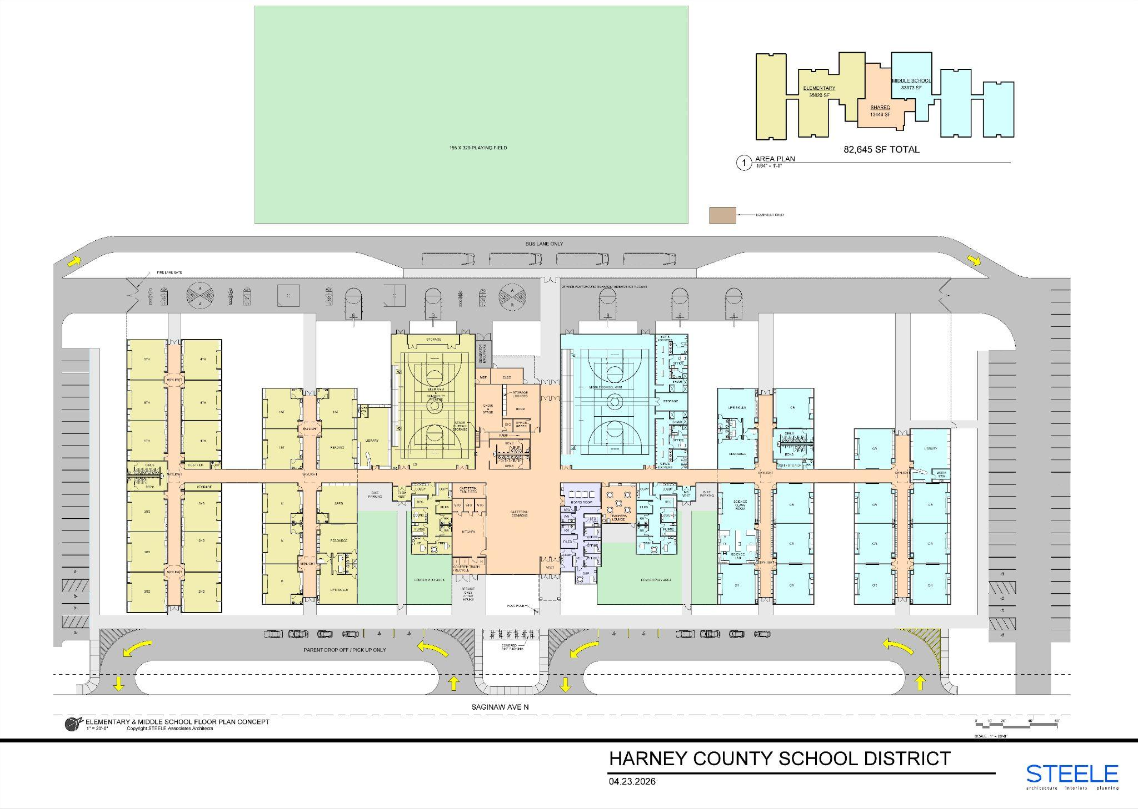
Floor plan, yellow is Elementary, blue is Middle School

