Name______________________________________________ Date: ______ Class Period:_____

AP World History PRE-CLASS Assignment - 2021-2022

Autobiographical Long-Essay-Question (LEQ): Changes and Continuities of Your Secondary Education, 2017-2021

Directions: You are to answer the following question for part of your AP World History summer assignment. This handout must be completed before you begin writing your essay. The purpose of this assignment is to help you familiarize yourself with the long-essay-question (LEQ) format and rubric, as well as the historical reasoning skill (HRS) of analyzing historical continuity and change over time.

Complete this outline and attach your essay to the back of this handout before turning it in on the first day of school.

Your essay may be typed or handwritten. There are no length requirements, but it should meet all of the requirements outlined on this paper to receive full points. Be aware that you do not need to share anything with me that you do not feel comfortable sharing! You are welcome to write only about academic changes/continuities if you feel more comfortable doing so.

IMPORTANT: It is OK (and somewhat expected) that you are unsure or unclear about the expectations of this essay. JUST DO YOUR BEST. I will be teaching you more about the rubrics throughout the school year, as well as sharing examples with you. There will be plenty of time to practice and grow. Don’t stress about not getting it right on this essay--this task is meant to expose you to the basic outline of the essay and give you some practice. Again, JUST DO YOUR BEST. That’s my primary expectation for this assignment. Any questions or uncertainties you have will be addressed in class, so please try to avoid asking me questions about the rubric over the summer.
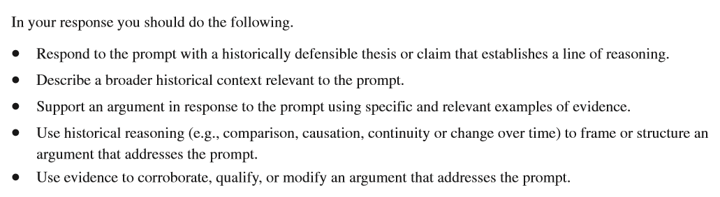
Essay Prompt:
Middle school and high school are often seen as periods of growth and development for young people in the United States. The transition from elementary to middle school and subsequently middle school to high school often present unique personal and academic challenges and opportunities.

Develop an argument that evaluates the degree to which you experienced personal and/or academic changes during the 2017 to 2021 time period.

STEP 1: DETERMINE CHANGES and CONTINUITIES
Brainstorm THREE (or more) personal and/or academic changes that occurred in your life from 2017-2021.

Changes

Brainstorm ONE or MORE academic and/or personal continuity that has spanned your life from 2017-2021.

Continuities

STEP 2: Provide CONTEXT for your essay.

Context is one point on the long-essay-question (LEQ) rubric. It also appears on your document-based-question (DBQ) rubric. From your knowledge of this time period in history, what do you know that could help you analyze (or put into context) how your personal/academic life has changed? You must situate the argument by explaining the broader historical events, developments or processes immediately relevant to the question.

Think of context as “setting the scene” for your essay. I often explain it in class as the opening “crawl” (yellow text) at the beginning of a Star Wars movie, or the “previously on...” you see at the beginning of shows to summarize what happened on a previous episode or season of your favorite TV show. Contextualization is NOT awarded for merely a word or phrase, but instead requires an explanation typically consisting of multiple sentences. Context appears in the introduction to your essay. There are no length requirements, but good contextual statements are usually around 4-5 sentences long. So, set the scene for your life. Give some background information about yourself before diving into the prompt topic and your thesis. Write a rough outline of your context here.

________________________________________________________________________________________________________________________________________________________________________________________________________________________________________________________________________________________________________________________________________________________________________________________________________________________________________________________________________________________________________________________________________________________________________________

STEP 3: Outline Your Changes & Continuities
What changed in your life from 2017-2021? | 1) | 2) | 3)
Analysis: Why did the change occur?

What continued in your life (what has remained constant?) | Continuity 1: | Continuity 2:
Analysis: Why did the continuity span your life from 2017-2021?

STEP 4: WRITE YOUR THESIS – The thesis of an essay is your main point or argument. It is essentially a 1-3 sentence “roadmap” or summary of what you will discuss in your essay. It will come after the context statement in your introductory paragraph. Start off by using the same words from the prompt. I often refer to this as using “the language of the prompt” -- get used to it because I will be saying it all year! Answer the question and add some specific details as a summary of what you will be writing about in your essay. DO NOT simply write “There were many changes and continuities in my personal and academic life.” That is too vague and will not earn you the thesis point. Give specific examples of changes/continuities in your life. For example, “There were many changes and continuities in my personal and academic life. I experienced changes such as …. However I still experienced continuities, for example . . . .”
________________________________________________________________________________
________________________________________________________________________________
________________________________________________________________________________
________________________________________________________________________________
________________________________________________________________________________
________________________________________________________________________________
________________________________________________________________________________
STEP 5: WRITE THE ESSAY!
This is essentially a four paragraph essay, but of course you can write more paragraphs if it is fitting or if one of your paragraphs can logically be split. Remember, it can be typed or handwritten. There is no length requirement.

INTRODUCTORY PARAGRAPH (Context + Thesis)
Criteria | Description | Questions to consider
Context | The context “sets the scene” or provides historical background for events described in the prompt. This should be | Does your historical context tie into the prompt?
Thesis Statement | Responds to the prompt with a specific historically defensible claim that establishes a line of reasoning. | Did you mention specific continuities/changes in your thesis statement?

BODY PARAGRAPH #1 - CHANGES
Criteria | Description | Questions to consider
Historical Reasoning: Topic Statement | Start the paragraph by summarizing the major changes that have taken place in your life. Get more detailed and provide specific examples further on in this paragraph. | What are the changes? Did you give specific examples of the changes and analyze WHY they occurred?
Cite supporting evidence | Provide evidence to support the changes. | What specific examples of evidence support the topic statement? (be descriptive)

BODY PARAGRAPH #2 - CONTINUITIES
Criteria | Description | Questions to consider
Historical Reasoning: Topic Statement | Start the paragraph by summarizing the major continuities that have taken place in your life. Get more detailed and provide specific examples further on in this paragraph. | What are the continuities? Did you give specific examples of the continuities and analyze WHY they occurred?
Cite supporting evidence | Provide evidence to support the continuities. | What specific examples of evidence support the topic statement? (be descriptive)

CONCLUSION PARAGRAPH: Bring it all together for the reader
Criteria | Description | Questions to consider
Conclusion | Reaffirms your argument (thesis) by explaining how the evidence presented throughout the essay supports each claim (topic sentences). Summarize for the reader, how you supported the argument throughout the essay. Does not merely restate the thesis. | How did the evidence presented throughout the essay support your thesis? Did you answer the prompt fully?

LEQ Essay Writing Checklist
Use this checklist before finishing and turning in your essay!
- You completed this outline handout  - You start the essay with context or background which “sets the scene” for your essay.  - Your context flows into your thesis statement.  - The first paragraph contains the context and the thesis  - Thesis uses the same words as seen in the prompt  - Thesis answers the prompt and gives specific changes  - Thesis answers the prompt and gives specific continuities  - You have at least four paragraphs (you can write more!) | - The second paragraph addresses changes  - There are specific examples of changes given  - You provide some analysis, explaining WHY there have been changes in your life  - The third paragraph addresses continuities  - There are specific examples of continuities given  - You have a conclusion that summarizes your essay’s thesis and main points  - You capitalized all proper nouns: cities, religions, names of people, etc  - You are specific, direct, and clear  - Your evidence/examples tie back to the prompt  - You printed a copy of your essay and attached it to this handout to turn in on the first day of class  - YOU DID YOUR BEST

